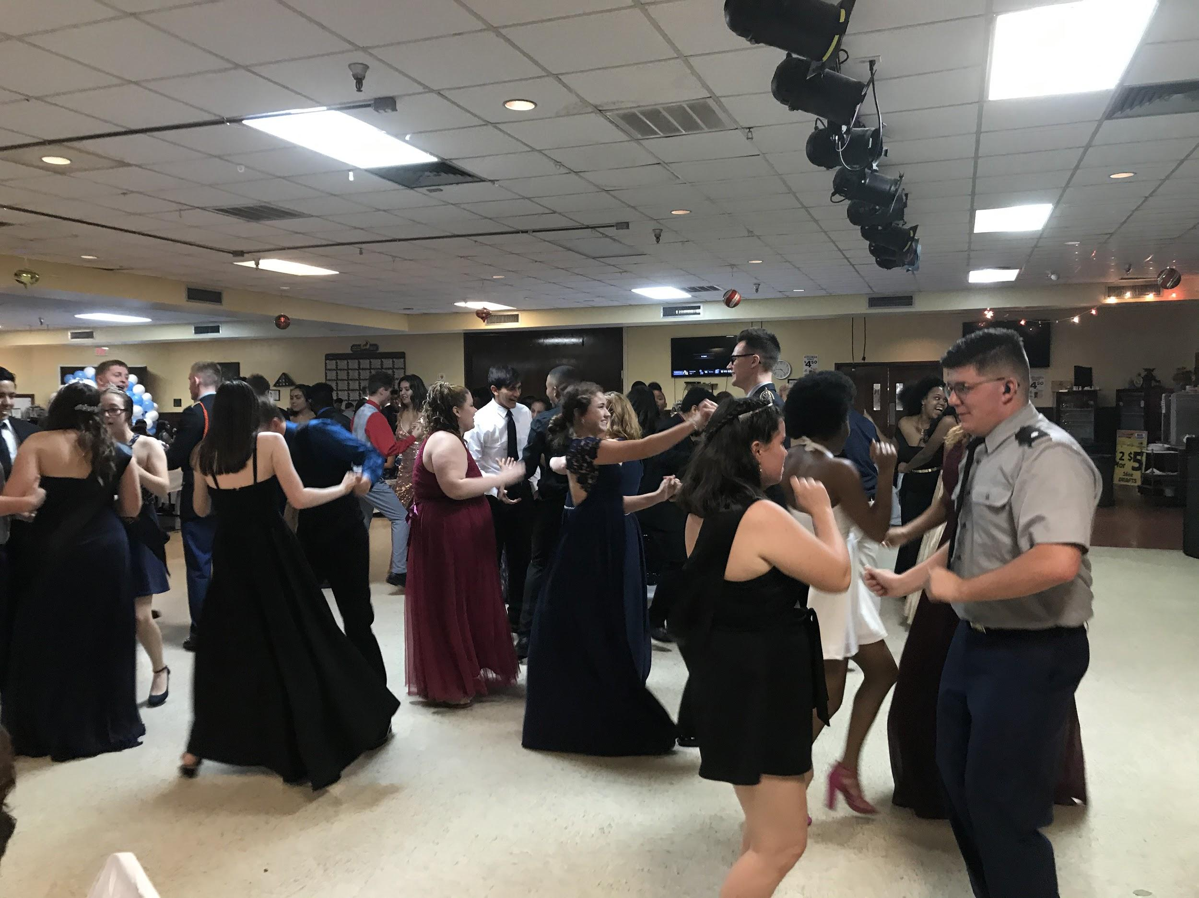
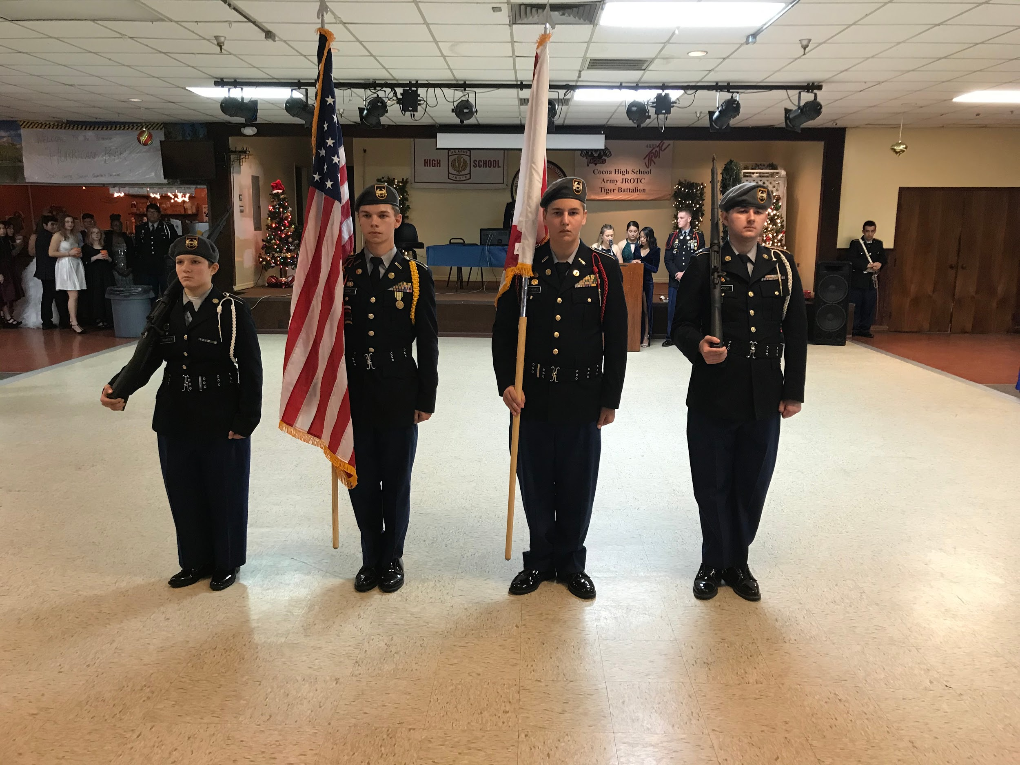
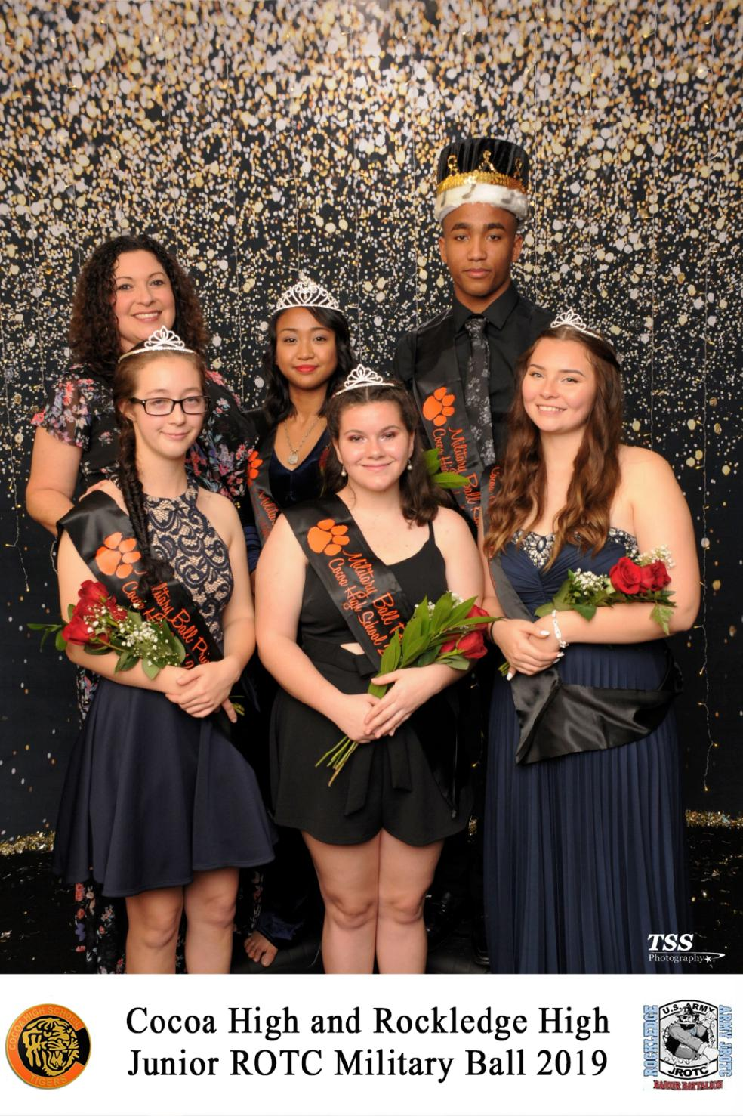
On December 13th, 2019, the Tiger and Raider Battalion held their annual Military Ball. This formal event is held every year for both battalions to express their pride and have a night to enjoy each other’s company. The Ball was held at the Merritt Island Moose Lodge from 19:00 to 23:00. There were a total of 107 Tiger Battalion Cadets that attended the ball. Cadets made sure to warmly welcome their guests to our instructors and staff. After all the Cadets arrived, the presentation of the colors was conducted and the ball commenced. A toast was inducted to acknowledge the gratitude for our country, cadets, and staff of each of the battalions. Following the toast was an extraordinary dinner starting with a salad appetizer, then Cordon Bleu Chicken with mashed potatoes and vegetables. After dinner was the recognition of the Military Ball Court consisting of one king, one queen, and three princesses. Congratulations to the following Cadets of the Tiger Battalion Military Ball Court: Matthew Stickle, king; Michelle Retig, queen; Kaitlyn Willhite, first princess; Tiffany Johns, second princess; Faith Presher, third princess. All of the winners looked delightful as they collected their crowns. As the night continued, the dance floor was open and began with the highly anticipated dance competition. There was a singles and couples dance competition and both battalions had amazing contestants. Everyone got to participate on the dance floor and it was astounding to see all Cadets be together and enjoy dancing with one another. Cadets got to interact with their dates, friends, and meet new people. Pictures were quick and efficient as all cadets received their photos right on the spot. They all turned out beautiful and fresh. It was a fantastic night for everybody. This event took a lot of time to organize, plan, and execute for both battalions. It was a student-run event so it required communication and teamwork from the Tigers and Raiders. Fundraising and support from our Cadets made this ball happen. In the end, the hard work and creativity paid off as it was another spectacular night to remember. The Tiger Battalion looks forward to another excellent Military Ball next school year.
Cocoa High School Tiger Battalion
BC: Cadet LTC Michelle Retig SAI: LTC Joseph Pavone
XO: Cadet MAJ Justinian Martin AI: SFC Freddy Moreno
Article By: S-5 Cadet 1LT Madison Bigger AI: SFC David Mercer

