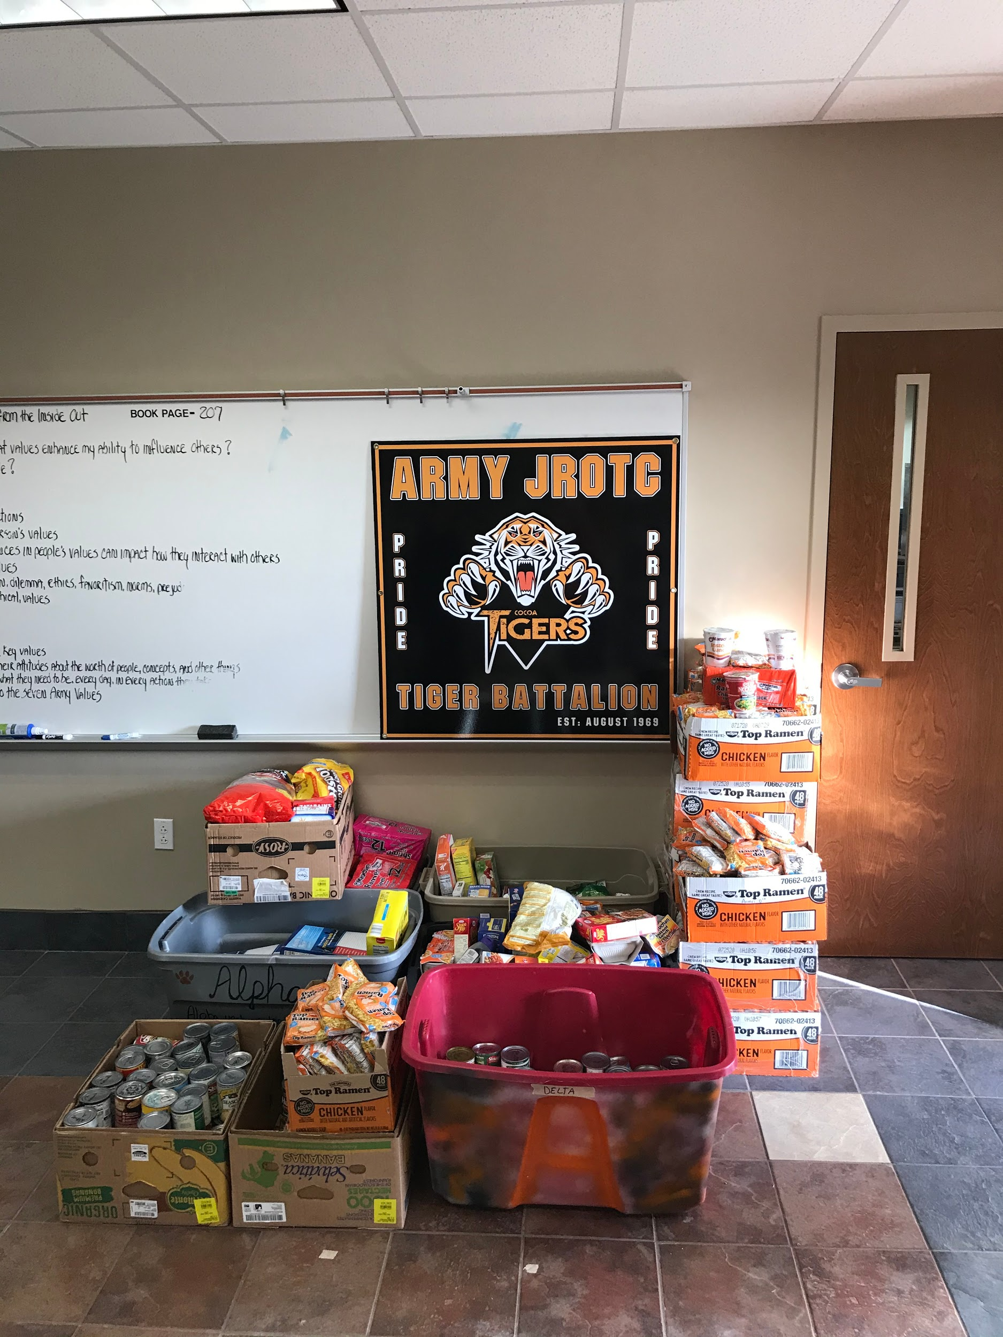
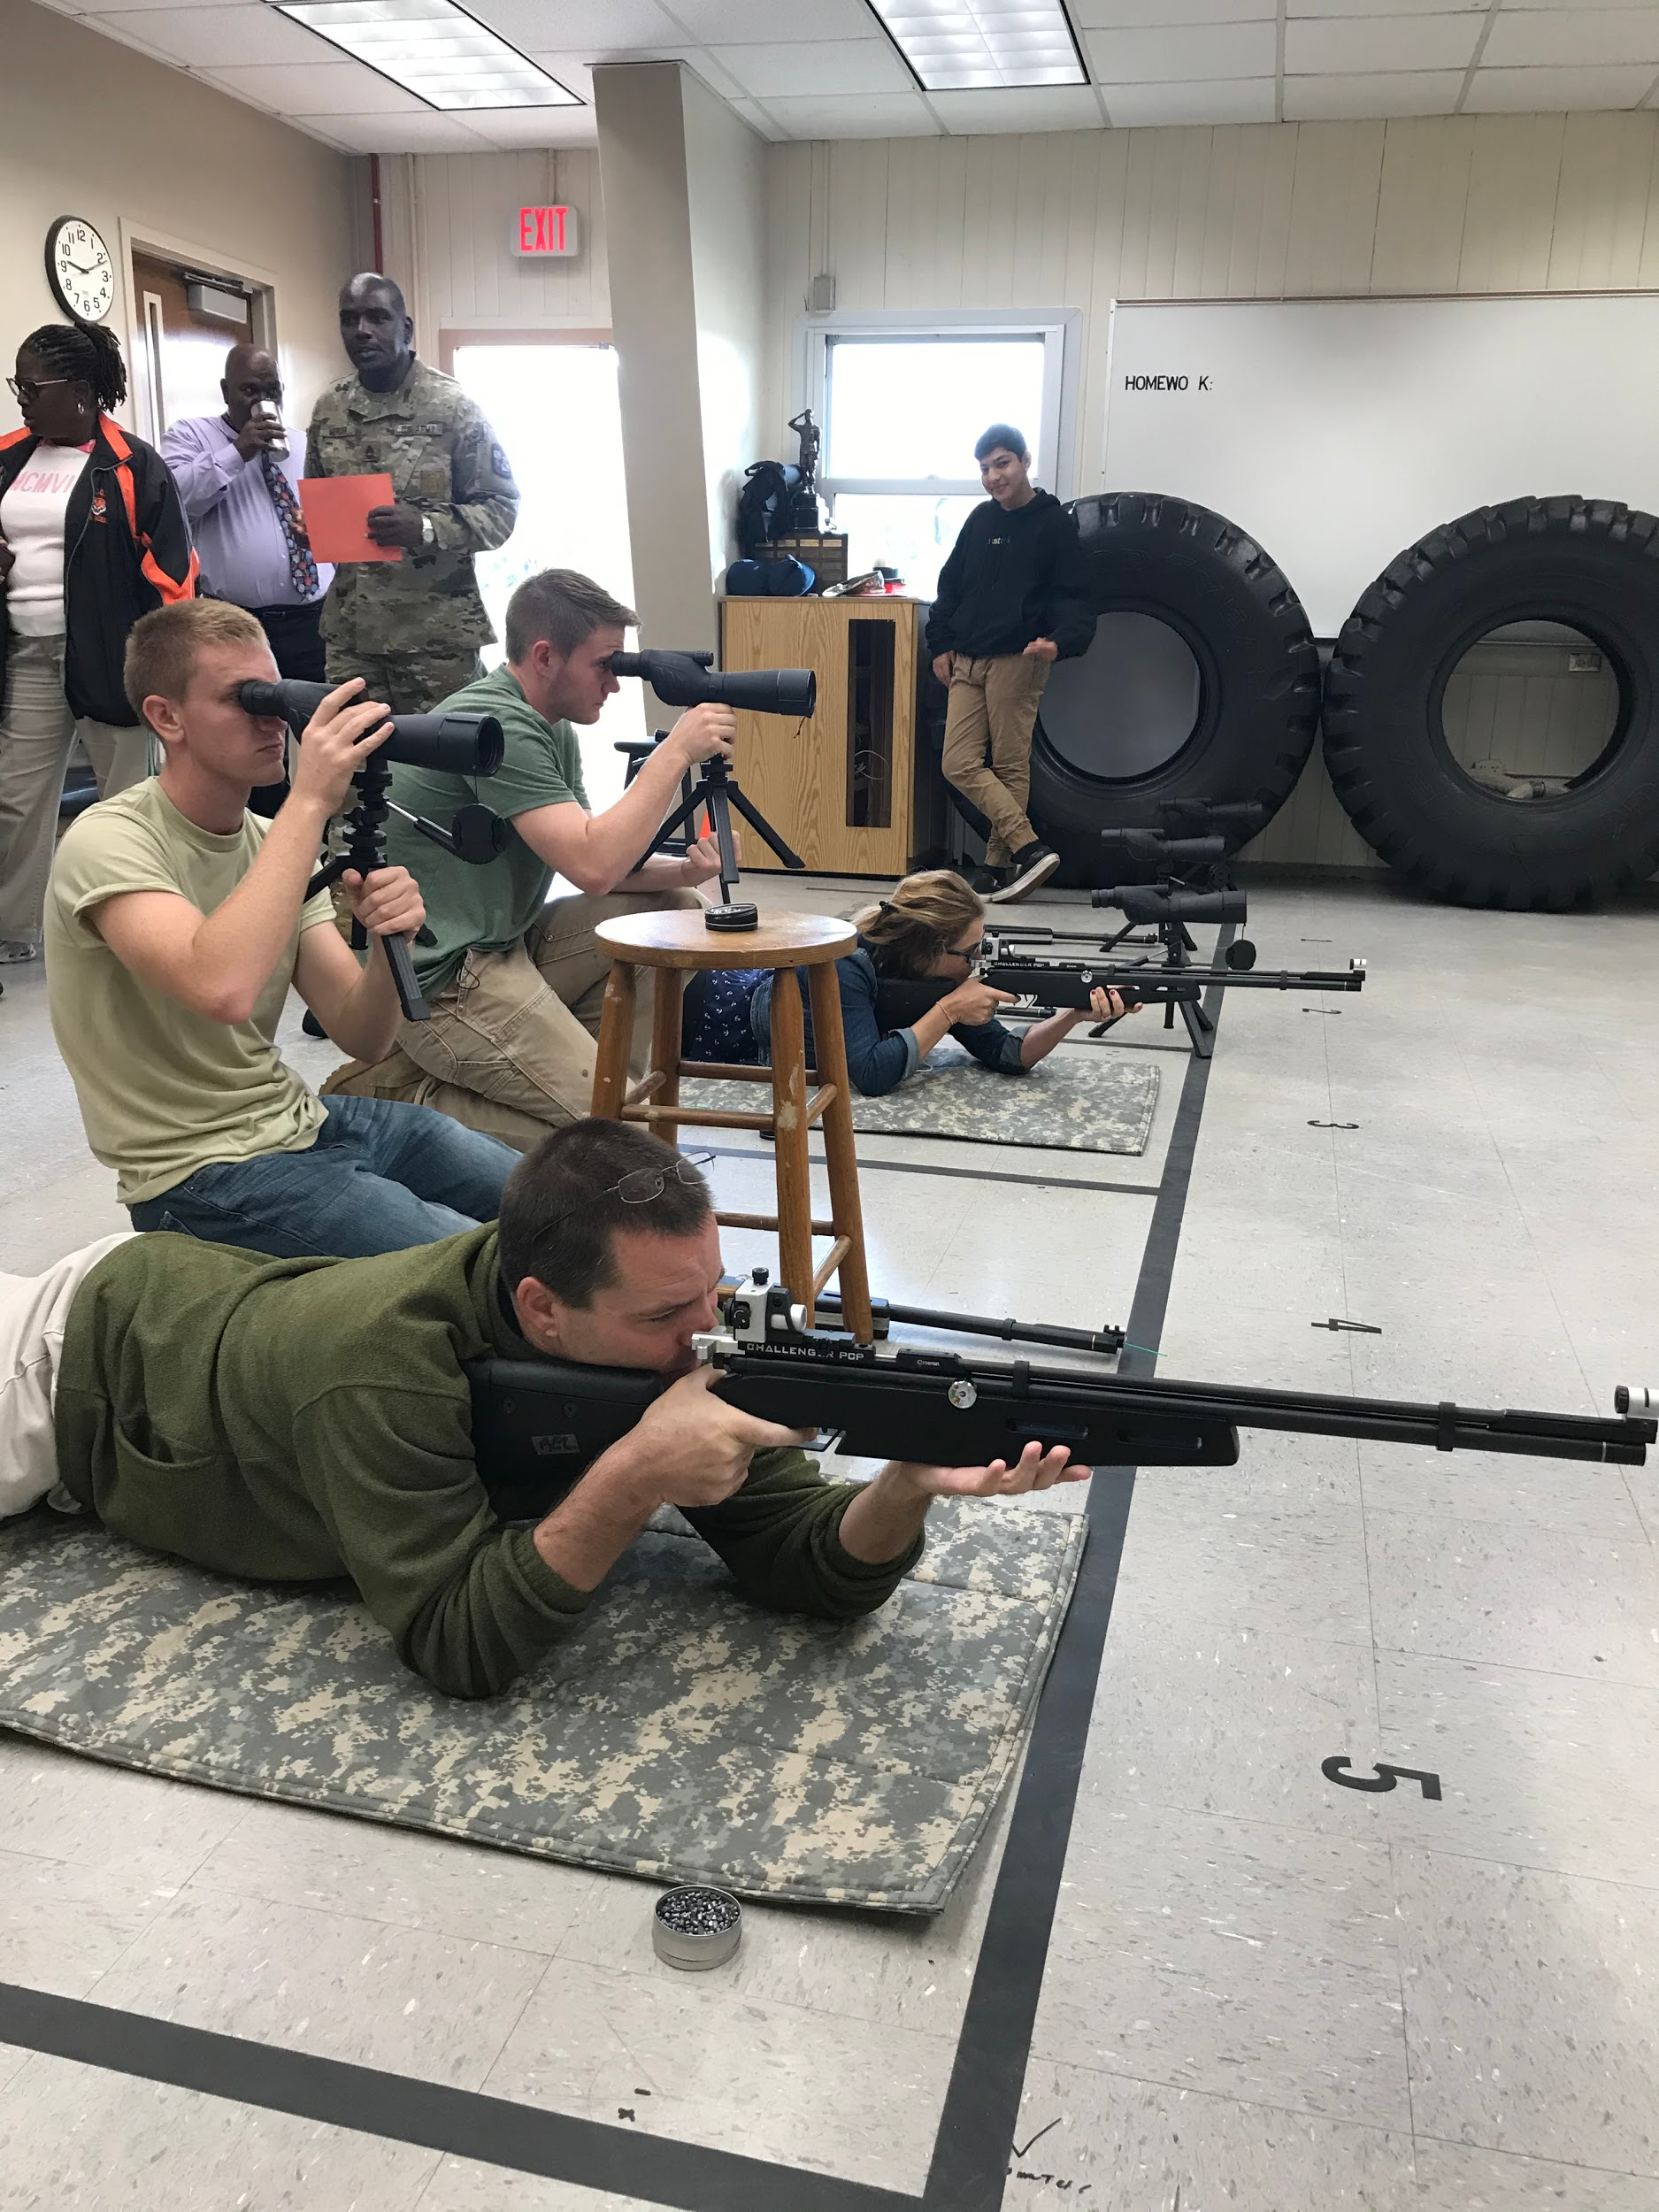
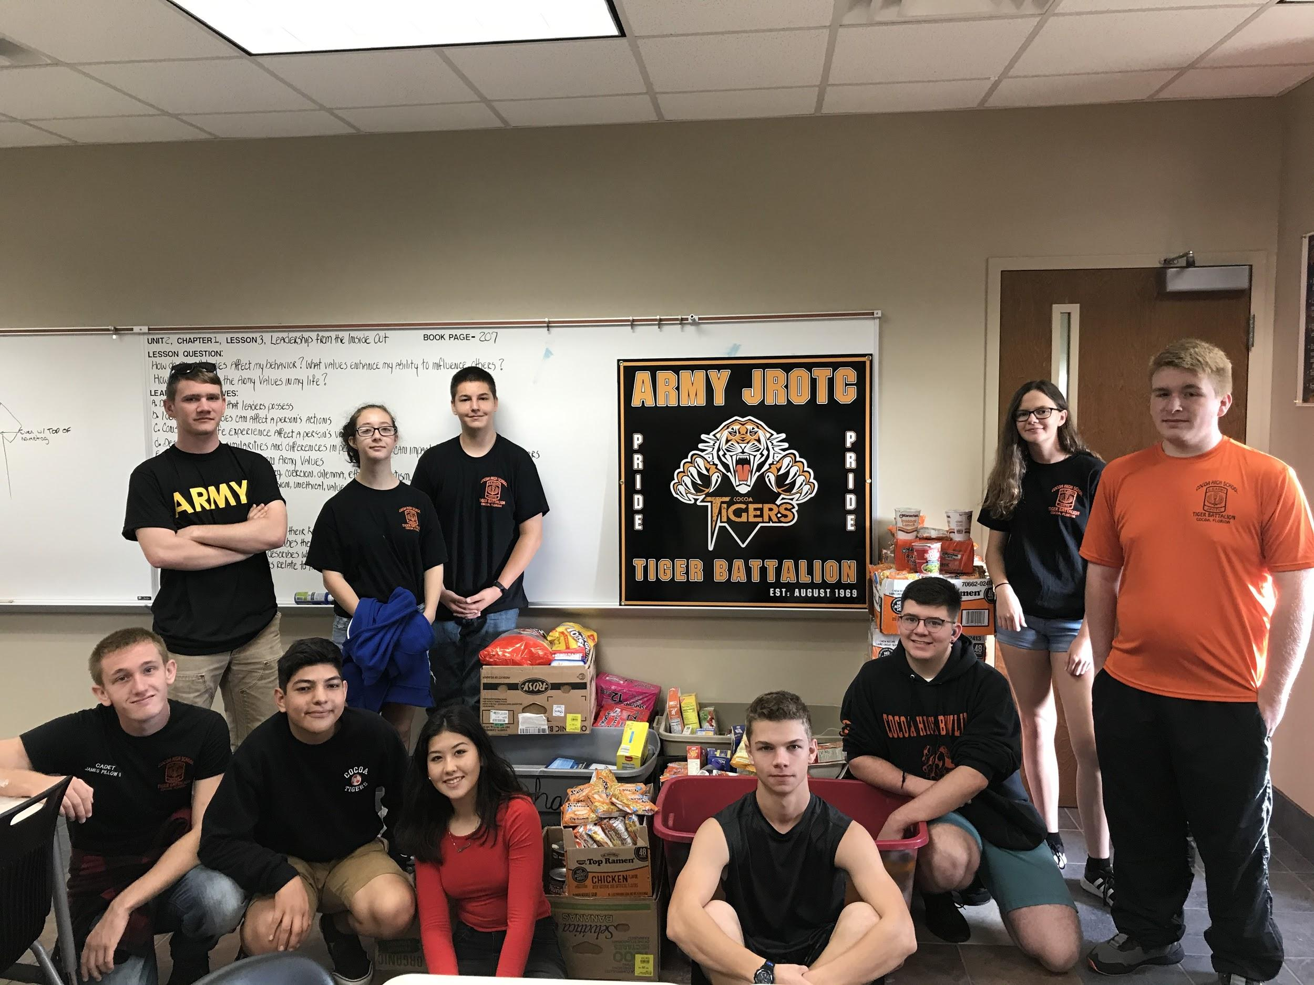
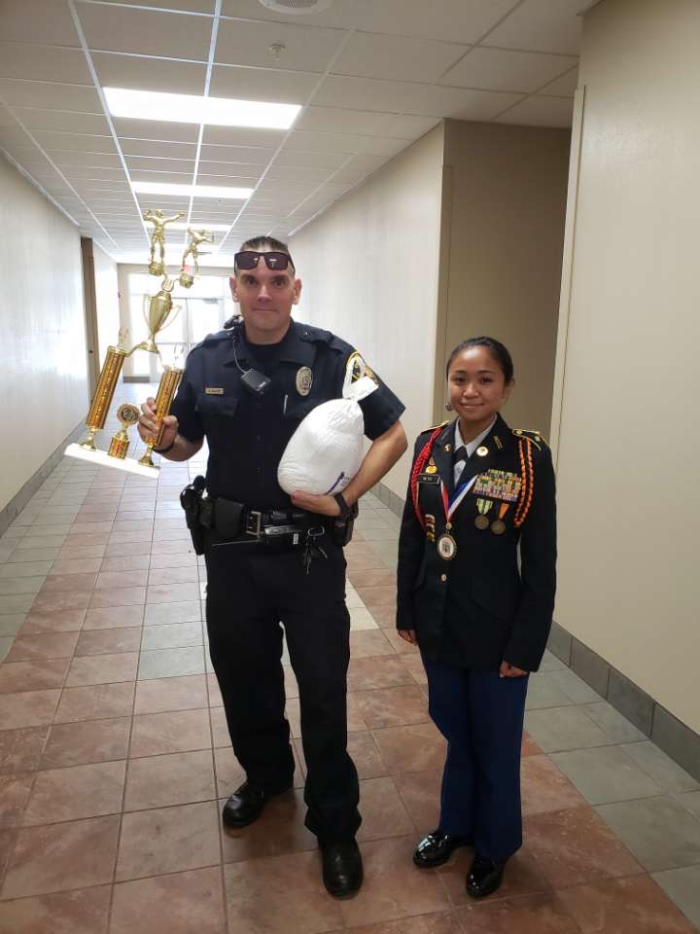
The Cocoa High School JROTC cadets showed their dedication to help our community for the holidays by feeding the less fortunate. The Tiger Battalion held their annual food drive as one of its service learning projects, which included the cadets bringing in donated food items to each of their companies. This “Feed the Need” service project began on October 1st and lasted through November 22nd. All of the food items that were collected from each company were donated to the Brevard Sharing Center. The total amount of food items donated was 1,298-canned food. The JROTC food drive was a great way to get cadets involved in helping the community and taught them how important it is to give back to people in the community during times of need. Cadets of the Tiger Battalion did a fantastic job participating in JROTC’s “Feed the Need” to help individuals and families in the community be able to enjoy a meal during the holidays. In addition to “Feed the Need”, JROTC also hosted the Turkey Shoot. During the Turkey Shoot, teachers and employees from our school were given the chance to shoot their best at a target seven times. Turkeys were donated to the top seven shooters with the best scores during this event. The top shooters of this year’s Turkey Shoot were Officer James Salley, Sarah Taylor, Maria Chandler, Donna Roberts, Kelissa Cooperwood, Richard Ley, and Patton Riffe. Congratulations to these Turkey Shoot winners!
Article By: S-5 Cadet 2LT Madison Bigger

Cocoa High School Tiger Battalion
BC: Cadet MAJ Michelle Retig SAI: LTC Joseph Pavone
XO: Cadet CPT Justinian Martin AI: SFC Freddy Moreno
AI:SFC David Mercer

