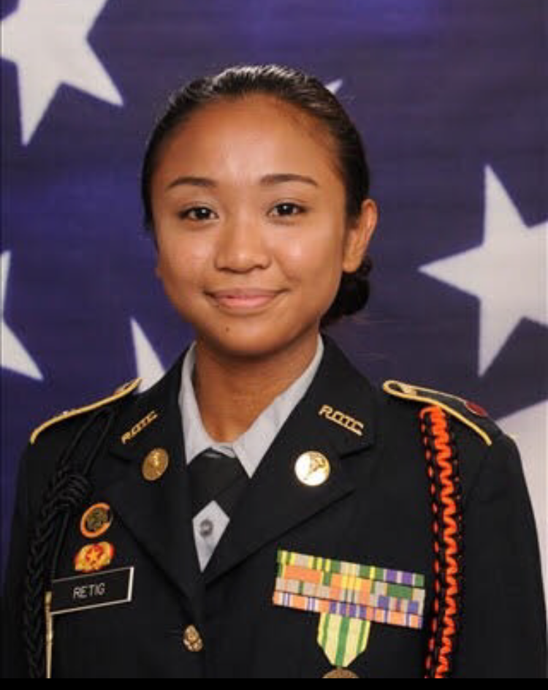
Hello, and welcome, Cadets of the Tiger Battalion of the 2019-2020 school year! I am Cadet Captain Michelle Retig, your new battalion commander, and I am honored to accept this amazing opportunity to lead this year’s Tiger Battalion. I will do my best to become a dependable leader for cadets of the battalion, and work hard to help guide Cadets into becoming the best students, leaders, and citizens for the school and community. Our battalion’s leaders will provide purpose, direction, and motivation throughout the semesters to ensure cadets will be able to grow as leaders. I look forward to witnessing the incoming upperclassmen and experienced leaders demonstrate their full potential as leaders. Every single Cadet playing their role is what forms the foundation of our Army Junior Reserve Officer Training Corps Program.
We want to welcome our new LET 1 Cadets to the Tiger Battalion. Our mission for this school year is to motivate LET 1 cadets to be better citizens as well as exceptional leaders. We also want to focus on our previous cadet leaders to continue to be a role model to our new LET 1 cadets and show them what JROTC is all about. Our special teams offer a variety of options for cadets to participate in and learn new or improve skill sets. This includes Honor Guard, Raider Team, Rifle Team, JLAB, and Drill Team. Each team provides opportunities for cadets to attain skills such as formal presentations of our nation’s colors at football games with our Honor Guard, to physical fitness during meets with our Raider Team.
Our cadets from school year 2018-2019 came back from JROTC Cadet Leadership Challenge (JCLC) also known as summer camp. Cadets left on the last day of school on May 30 and came back June 2. Every cadet returned with an amazing experience of leadership, teamwork, and new friendships.
Great news for the Tiger Battalion this month. We received the KBB Youth Litter Reduction Award. This is the 8th time our Battalion has won this award, more than any other civic organization within Brevard County. The Tiger Battalion amassed over 2300 hours of volunteer service in 2018/19. All community service events in JROTC count for volunteering hours that can help our cadets achieve the amount of hours they need for scholarships and more. This is a great way to start off the school year!

SAI: Lieutenant Colonel Joseph Pavone Upcoming Events
AI: Sergeant First Class Freddy Moreno Raider Tryouts: August 22, 23
AI: Sergeant First Class David Mercer Honor Guard Tryouts: August 27
BC: Cadet Captain Michelle Retig Publix Bucket Drop: September 7
XO: Cadet Captain Justinian Martin ASVAB: September 25
S5: Cadet Master Sergeant Madison Bigger PAFB: September 27

