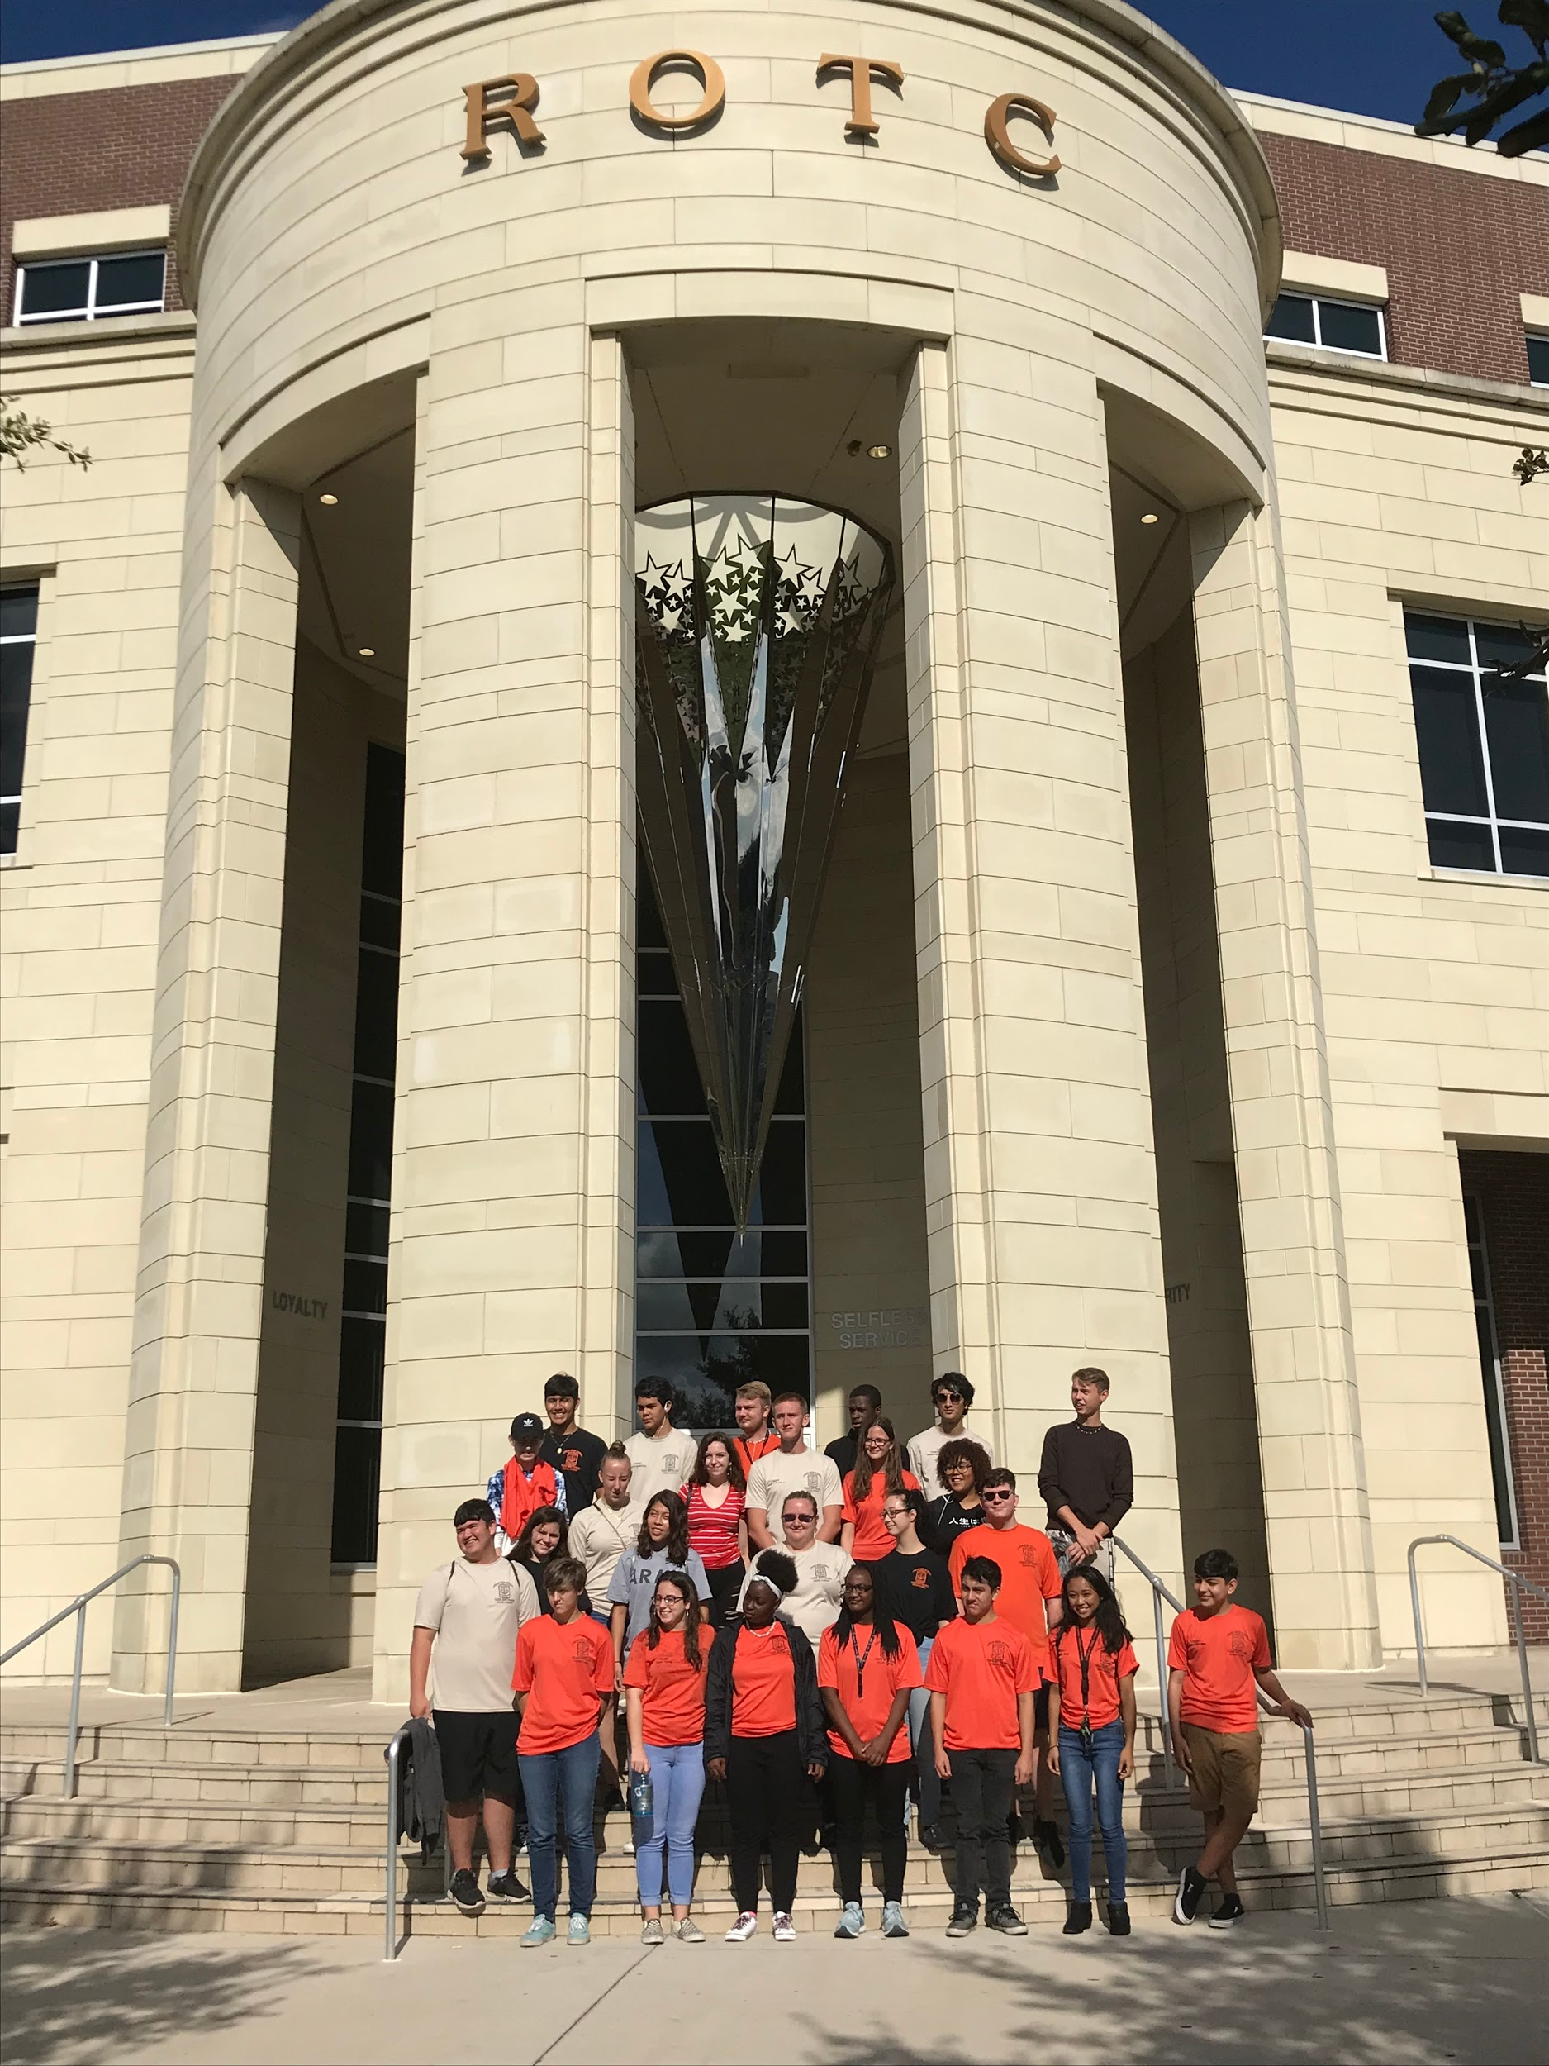
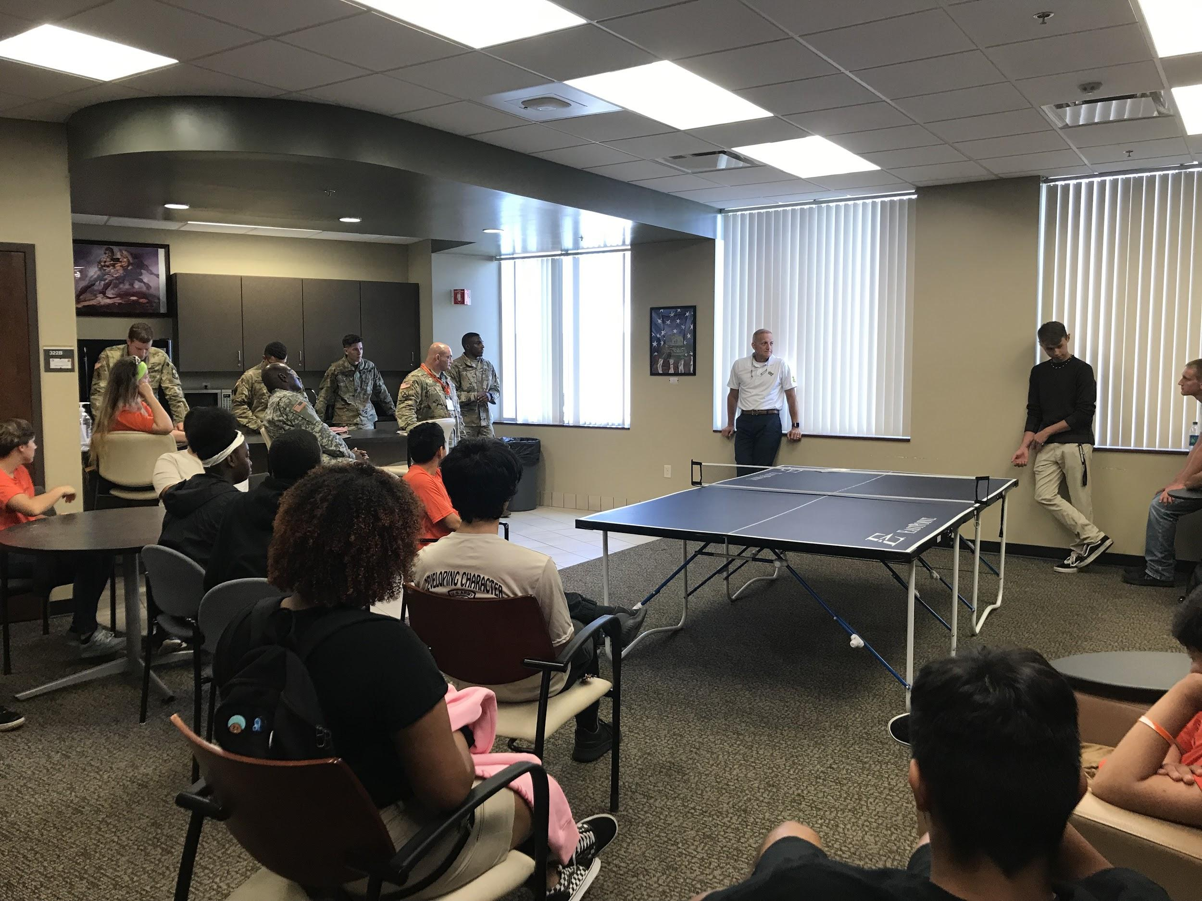
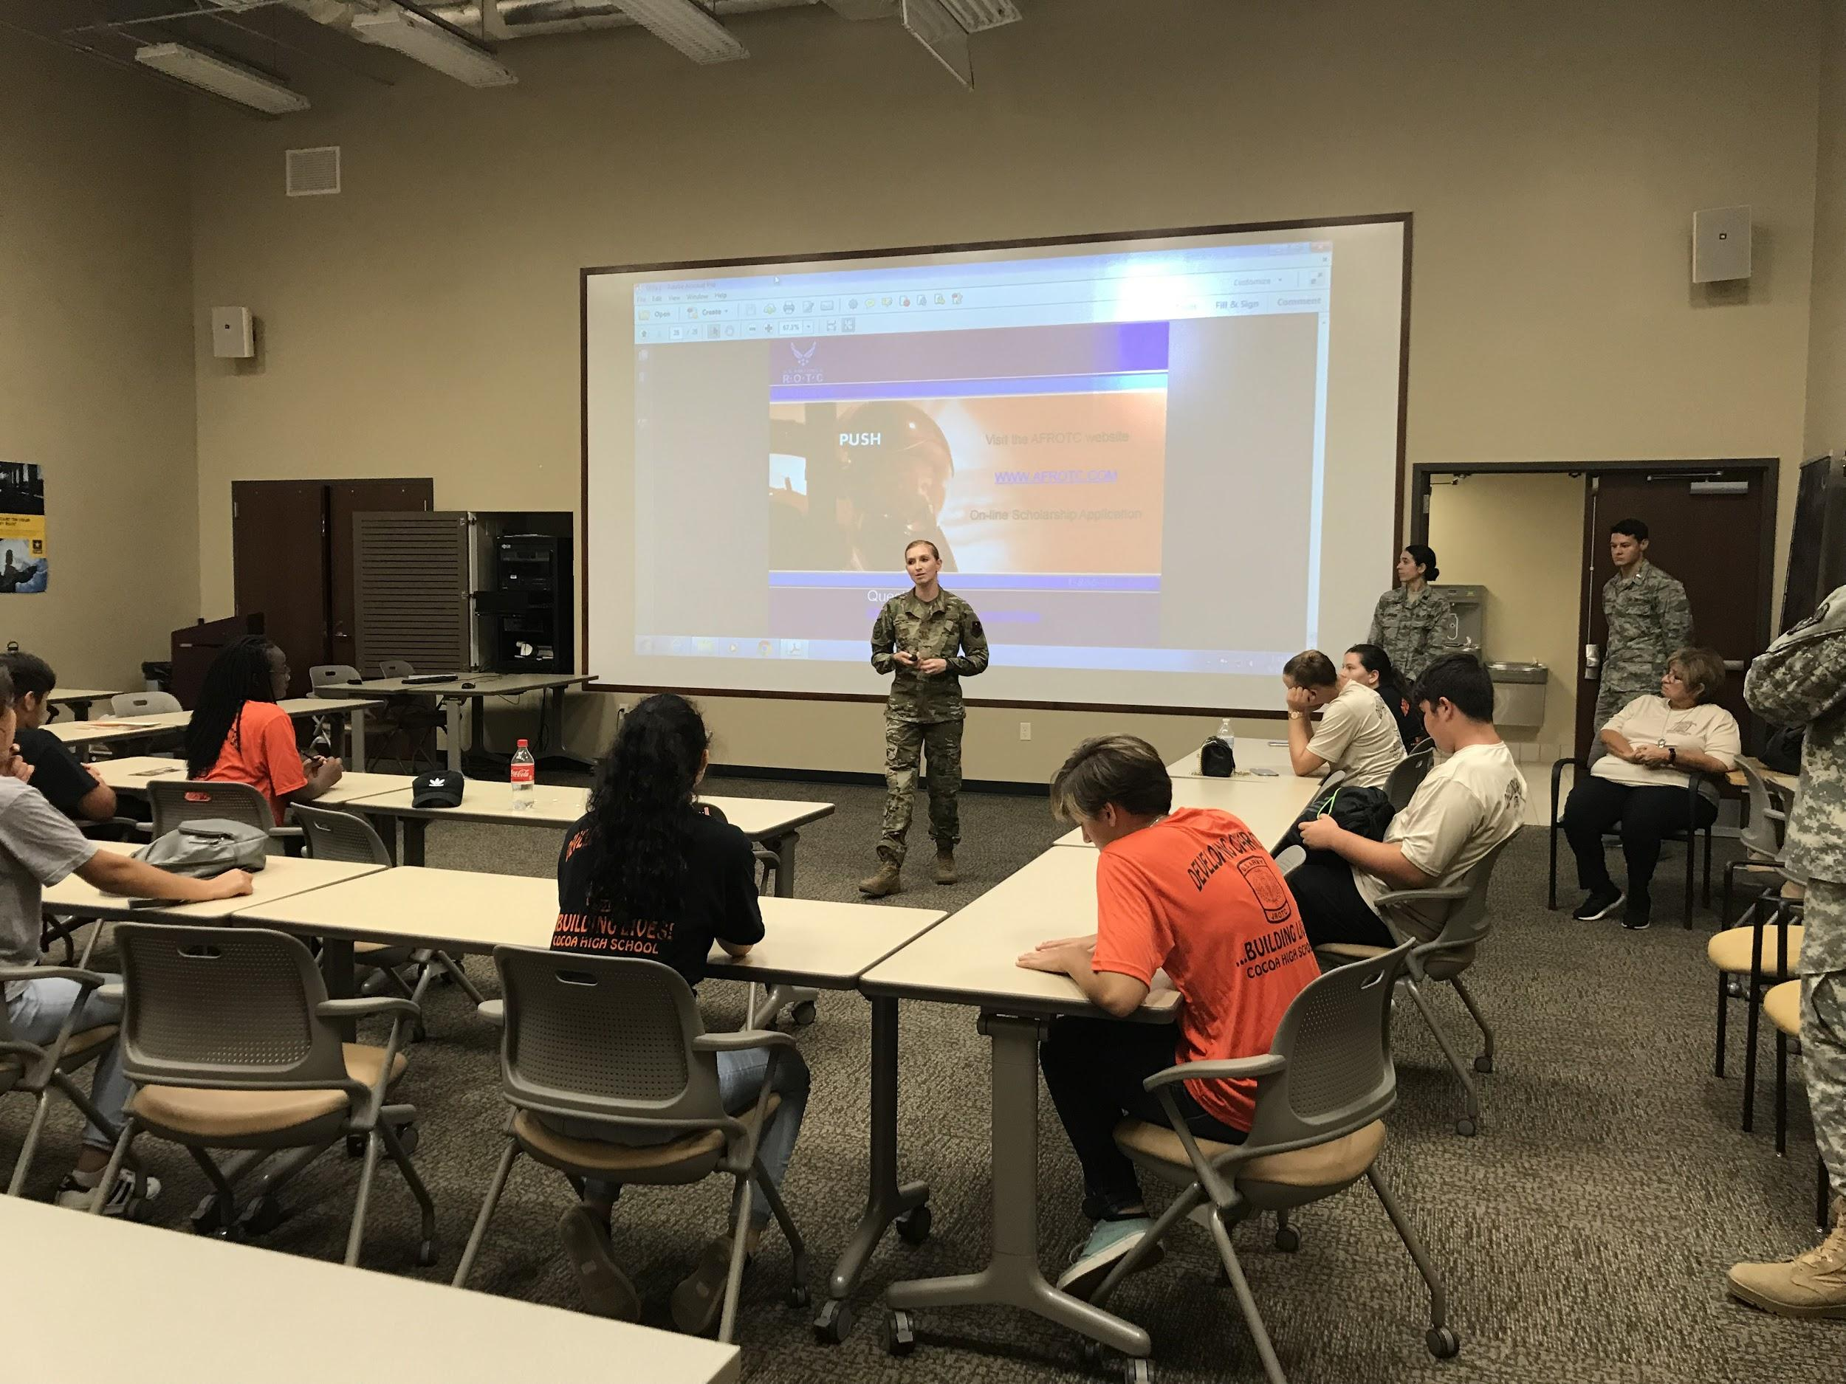
On September 10th, 2019, cadets got the opportunity to visit the University of Central Florida. This was the first time our JROTC program has visited a college as this and we plan on taking future tours so our cadets have the chance to experience college themselves and the options they have for the future. The twenty-six cadets that attended were given the chance to experience what Army and Air Force ROTC programs were like in a college setting. The goal of this trip was to motivate cadets into thinking about their future after high school, whether that be in an ROTC program, the military, or just attending college.
When cadets arrived at UCF, they were welcomed by one of the cadets in the Army ROTC program and brought to the campus’s impressive ROTC building. The cadets got firsthand information about life at UCF from senior and junior cadets in the program, including the Scholarship/Enrollment Officer. These UCF cadets did an impressive job in illustrating the different parts of the program from scholarships, financial aspects, daily life as a cadet, leadership obligations, and how being in ROTC or the military would help cadets for the future. After this, cadets went to lunch at a local buffet restaurant and enjoyed a meal with some of the UCF Army cadets. This gave cadets one-on-one time with them to ask any other questions they had about the school or program.
The tour continued after lunch around Memory Mall where cadets were shown where some of the college buildings were and where the track that cadets do PT on is located. Once the cadets returned to the ROTC building, the Air Force ROTC took over and gave us their presentation on their program. Similarly to the Army presentation, there were Air Force cadets that spoke about their own experiences so far in the program. The Air Force speakers had a slideshow presentation for our cadets on some of the scholarship requirements, job opportunities that could come after joining the ROTC program, and more college information. This college tour was a success and hopefully, these tours will continue to motivate cadets about their future and programs that will help them grow into great leaders.

Cocoa High School Tiger Battalion
BC: Cadet CPT Michelle Retig SAI: LTC Joseph Pavone
XO: Cadet CPT Justinian Martin AI: SFC Freddy Moreno
Article By: S-5 Cadet MSG Madison Bigger AI: SFC David Mercer

