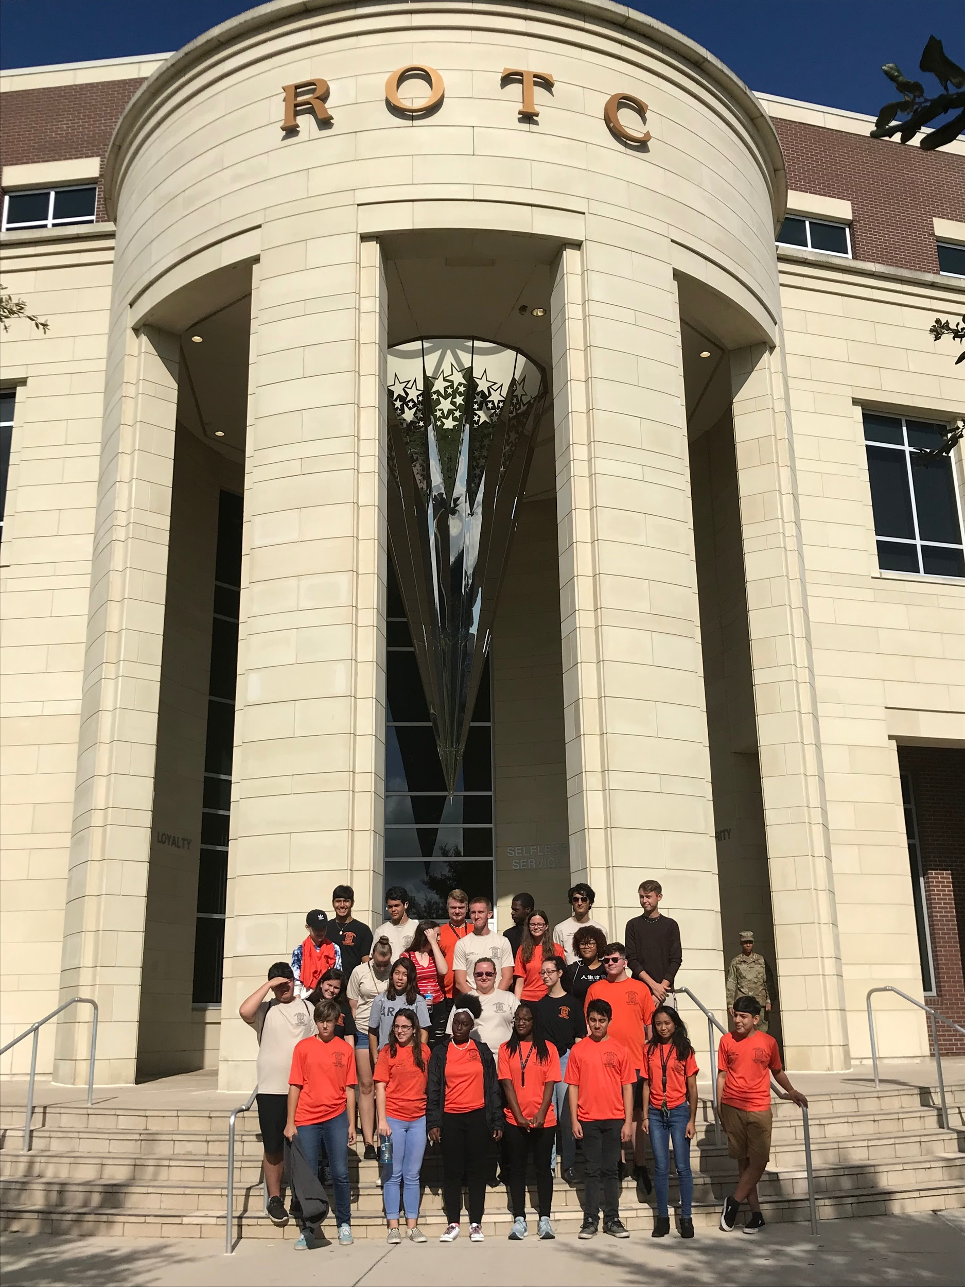
As the first quarter comes to an end and the second quarter begins, the JROTC program continues to focus on improving cadet knowledge and leadership. During the first quarter, a group of cadets got the opportunity to visit the University of Central Florida and experience how college life works. This trip was meant to give cadets more ideas about what they could do in the future after high school, whether that be in the military or attending college. The visit was successful, as the cadets that attended seemed motivated and educated by the presentations given to them by the UCF cadets.
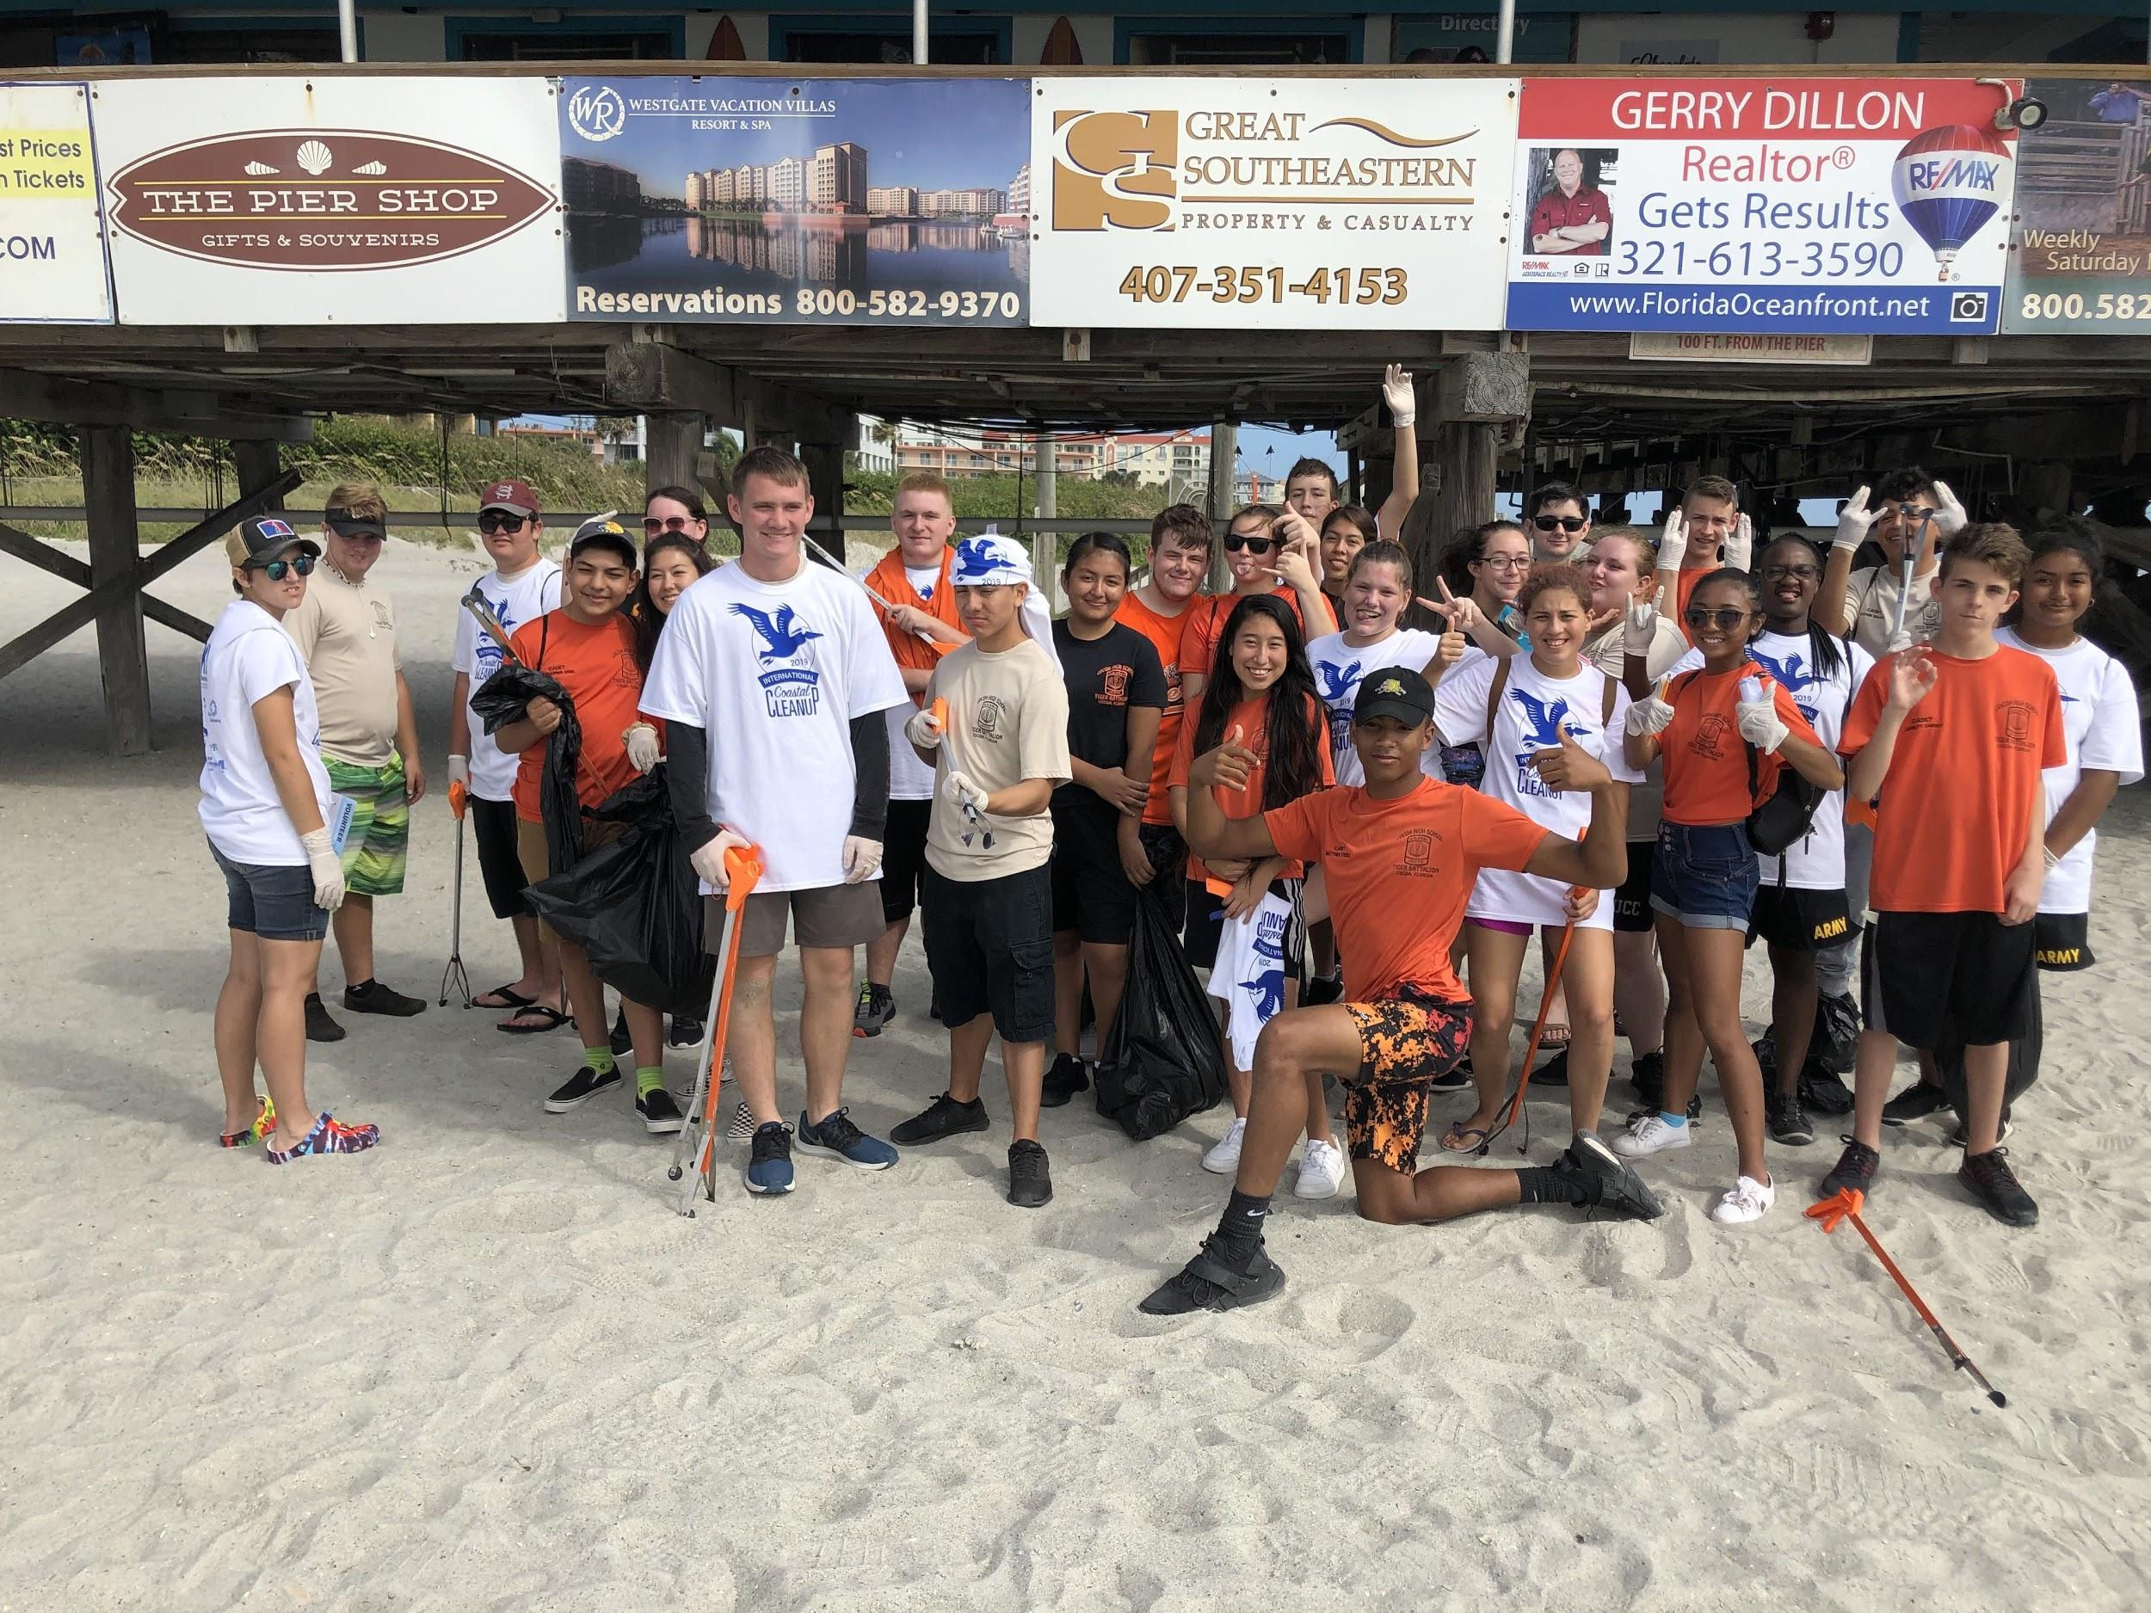
Our cadets also have the chances to participate in the first volunteer event of the quarter, the Beach Clean Up, on September 21st. Cadets had the opportunity to improve the safety and cleanliness of our community by cleaning up the beach and earning community service hours. The next volunteer event coming up in the second quarter is the JROTC Canned Food Drive. Throughout the next few weeks starting on October 1st, cadets are encouraged to bring in a canned, dry box, or any non-perishable food items. Once the food is collected, it will be brought to the Central Brevard Sharing Center for them to serve among members in the community who need it. Our battalion will also be putting a Thanksgiving meal basket together for a family of four at Cocoa so they can enjoy a holiday meal together that they might not have been able to before. The Boy Scout Canned Food Drive is another volunteer event that cadets will have the opportunity to be a part of in November.
Aside from community service, the JROTC Raider team has also begun their training for the season. This dedicated team practices hard on Mondays, Wednesdays, and Friday mornings to get themselves ready for the physical events they must partake in at the meets. They will be competing in their first meet on October 5th at the Brevard Veteran Center in Merritt Island. These cadets will continue to practice for future meets on October 19th and November 2nd.
As our cadets continue to improve upon their cadet knowledge and leadership skills during this new quarter, we also encourage them to be engaged with special teams and community service events to show initiative and motivation in the battalion.

Cocoa High School Tiger Battalion
BC: Cadet MAJ Michelle Retig SAI: LTC Joseph Pavone
XO: Cadet CPT Justinian Martin AI: SFC Freddy Moreno
Article By: S-5 Cadet 2LT Madison Bigger AI: SFC David Mercer

