4/1/2020 Visual Art (Family Document) - Google Docs

Visual Art (Family Document)
Instructional Plan for the Week of March 30-April 3, 2020

Use Launchpad to access all curriculum apps.
Davis Digital  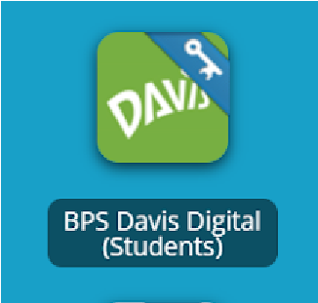 | All students have access to our online Visual Art Textbooks. Take a moment to explore and read!  Addi onal informa on for parents is available at h ps://www.davisart.com/
Visual Art  K-2 | - Explore Davis Digital Textbooks  - K: Exploring Color, Page 72  - 1: Elements of Art (Color), Page 187  - 2:Elements of Art (Color), Page 187  - Complete the following Lesson on Color  Color Wheel Adventure
Visual Art  3-6 | - Explore Davis Digital Textbooks  ○ 3-5: Color & Value, Page 187  ○ 6: Source of Color, Page 74  - Complete the following Lesson on Color  Color Wheel Adventure
Other Resources  For Art Enrichment | Contemporary Ar st of the Week: Richard Shilin g  Online Drawing Tutorials: Art Hub for Kid s  The Metropolitan Museum of Art: The Met Kid s  Explore Teaching Art through Art Work: Art Class Curato r  The Ge y Museum of Art: Art at Hom e
Supplemental Project | Create your own piece of Environmental Art inspired by Ar st  Richard Shiling
Note: Your teacher may assign additional lessons.
https://docs.google.com/document/d/1iesHKo5rGoEujpJL7ocWxHmpSrIJl_GKHJ2NiwoL3sw/edit 1/2 4/1/2020 Visual Art (Family Document) - Google Docs

https://docs.google.com/document/d/1iesHKo5rGoEujpJL7ocWxHmpSrIJl_GKHJ2NiwoL3sw/edit 2/2

