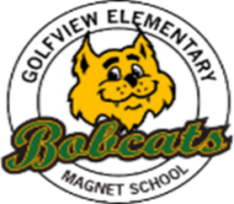

**Vendor: Brevard Team Sports**

**606 S. Cocoa Blvd**

**321-639-8326**

**Golfview Elementary**

**School Uniform Policy**

**2024 - 2025**

|  |  |  |  |  |  |
| --- | --- | --- | --- | --- | --- |
| **Grade Level** | **Upper Garments**  **Monday, Tuesday, Thursday** | | **Grade Level** | **Upper Garments**  **Monday, Tuesday, Thursday** | |
| **Pre K/**  **Kinder** | **Green or gray T-shirt or polo** with logo screen printed on front left chest. | | **1st – 6th** | **Green or gray polo shirt** with logo embroidered on the front left chest. | |
| **Lower Garments - Grades Pre-K to 6th** | | | | | |
| **Pants**  Khaki, Navy Blue, Black | | **Shorts**  Khaki, Navy Blue, Black | | | **Skirts/Skorts**  Khaki, Navy Blue, Black |
| * All lower garments must be worn at waist level at all times, undergarments must not be visible. * As a rule, no hoodies, sweatshirts, sweaters or jackets may be worn over the uniform. * Skirts must reach mid-thigh or below. * Short shorts are prohibited. Shorts must have an inseam that reaches mid-thigh or lower. * **No leggings, sweat pants, spandex shorts or pants with holes in them.** * **All clothing must be size appropriate!** | | | | | |
| **Spirit Day – Friday** | | | | | |
| **Friday** | | | | | |
| * Golfview Spirt Shirt or college shirt with jeans   or full uniform. | | | | | |
| **Shoes** | | | | | |
| * Shoes must be closed toe. **No Crocs, slides, slippers or flip flops.** * Shoes must have a back on them. * Athletic, casual wear or dress shoes are acceptable. | | | | | |
| **Headwear** | | | | | |
| * Unless weather dictates, students are prohibited from wearing any head coverings to include bandanas, baseball caps, knit caps, wave caps, hoodies, do rags or scarfs. | | | | | |

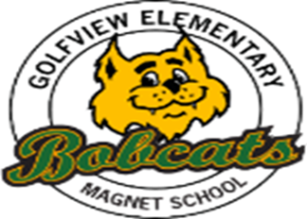

Dear Bobcat Families:

Our number one job at **Golfview Elementary Magnet School** is to provide your child with the best positive learning experience in a safe environment. We work each day to encourage students to be successful at their job of learning. We ask that you do the same by supporting our uniform policy. Uniforms are an important part of the school’s identity: It has a positive impact on students’ learning and behavior in and around the school, serves to unite students, increases student pride, and eliminates barriers where all students are treated equally.

**Golfview Elementary Magnet School** students are expected to participate in our school’s uniform policy daily.

The **DAILY** uniform is as follows:

**Monday - Thursday**

* **SHIRTS** - Students in grades **Pre K – K** may wear **forest green or gray T-SHIRTS** with the approved logo screen printed on the front left chest. Students in grades **1st – 6th may wear a forest green or gray POLO** with the approved logo embroidered on the left front chest.
* **BOTTOMS** – Students may wear **khaki, black** or **navy** shorts, pants, skirts, skorts or jumpers. **NO** leggings, sweatpants, spandex shorts, or pants with holes in them may be worn.
* **SHOES** - Students may wear their **choice** of shoes. However, they **must** be safe and appropriate to the learning environment and aligned with BPS Student Dress Code Policy**. NO Crocs, flip flops, slippers or slides may be worn**.

**Friday**

* **SHIRTS –** All students may wear their choice of school uniform shirt, college shirt or Golfview Spirit Shirt.
* **BOTTOMS –** All students may wear their choice of the approved school uniform bottoms or jeans.

Students may **NOT** wear hoodies, jackets or sweatshirts over their uniform.

School uniform shirts may be purchased from our vendor **Brevard Team Sports**. School uniform bottoms may be purchased from your favorite store, garage sales, etc. We will also hold uniform swaps and fairs toward the end of the school year. **Please send any clothing that your child has outgrown to the school for our uniform bank.** We will greatly appreciate your token of love.

Please see the back of this letter for a list of uniform shirts from our vendor. You must go to them directly and place an order. Please make sure that you place orders in advance as they do take time and the beginning of the year is a busy season for uniforms. Please direct any questions regarding uniforms to the Assistant Principal, Keltie Fernandez.

Thank You for Your Continued Support,

Jeff Coverdale

Principal