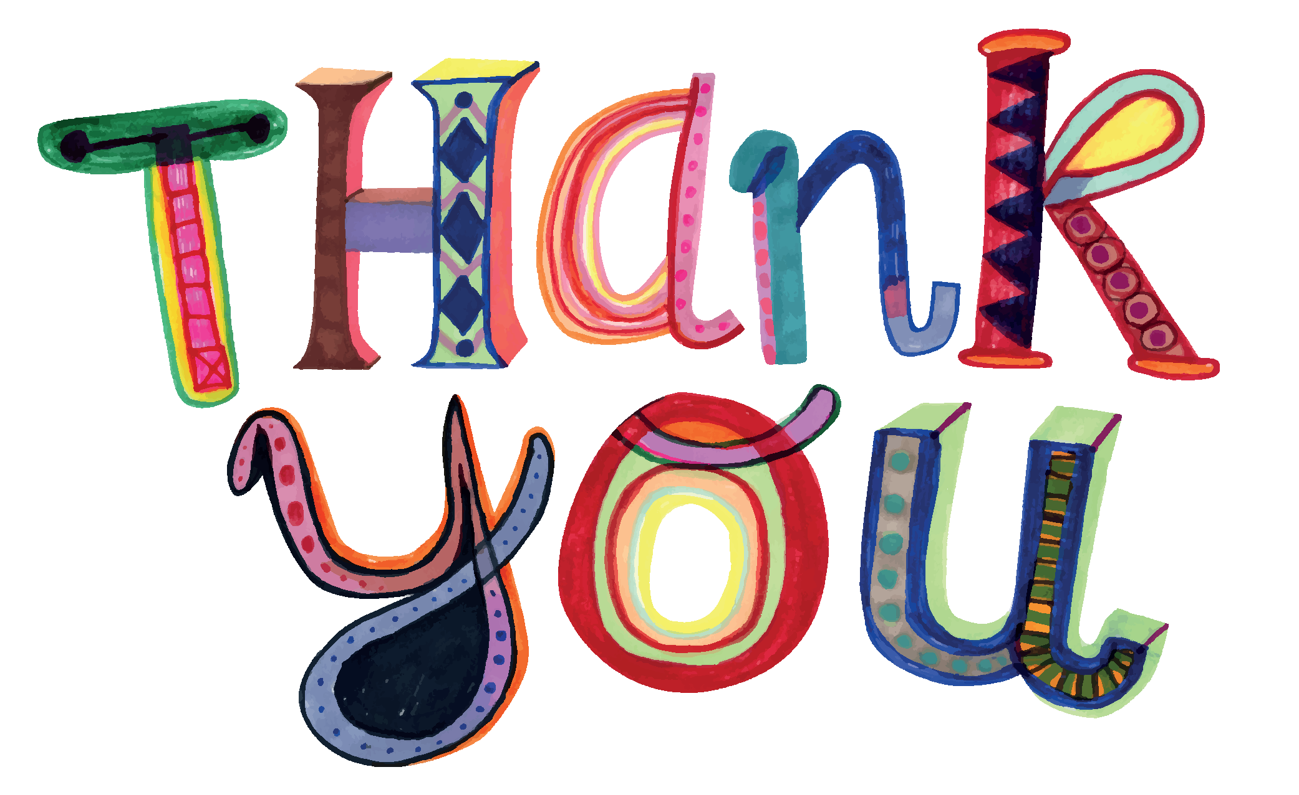

Words cannot express how my staff and I appreciate the many gifts we received during staff appreciation week.
I was personally overwhelmed with the generosity; from the homemade cards (my favorite!), flowers, to the big basket of candy and the awesome gift cards.
Working with your children is the best gift you can give us. Being through many generations of graduates as well as being able to assist with siblings and watch them grow into the responsible young children has been the highlight of my time here at Holland. It is with great sadness, joy, excitement and courage that I have accepted a position in another school that is closer to my home, starting the next school year. God Bless.

Have a Safe & Healthy Summer!
Stay Cool!

