2023 -2024 TRACK SEASON 1/16/23- 3/8/24
PRACTICE MON-THUR 4:30-5:30PM
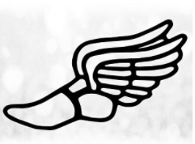
LAST DAY TO JOIN TRACK IS 1/26/24
- Pick up your Track Information packet from Coach Langlie, Jacobs, Waters, Walters, Graziano or at the front office.

