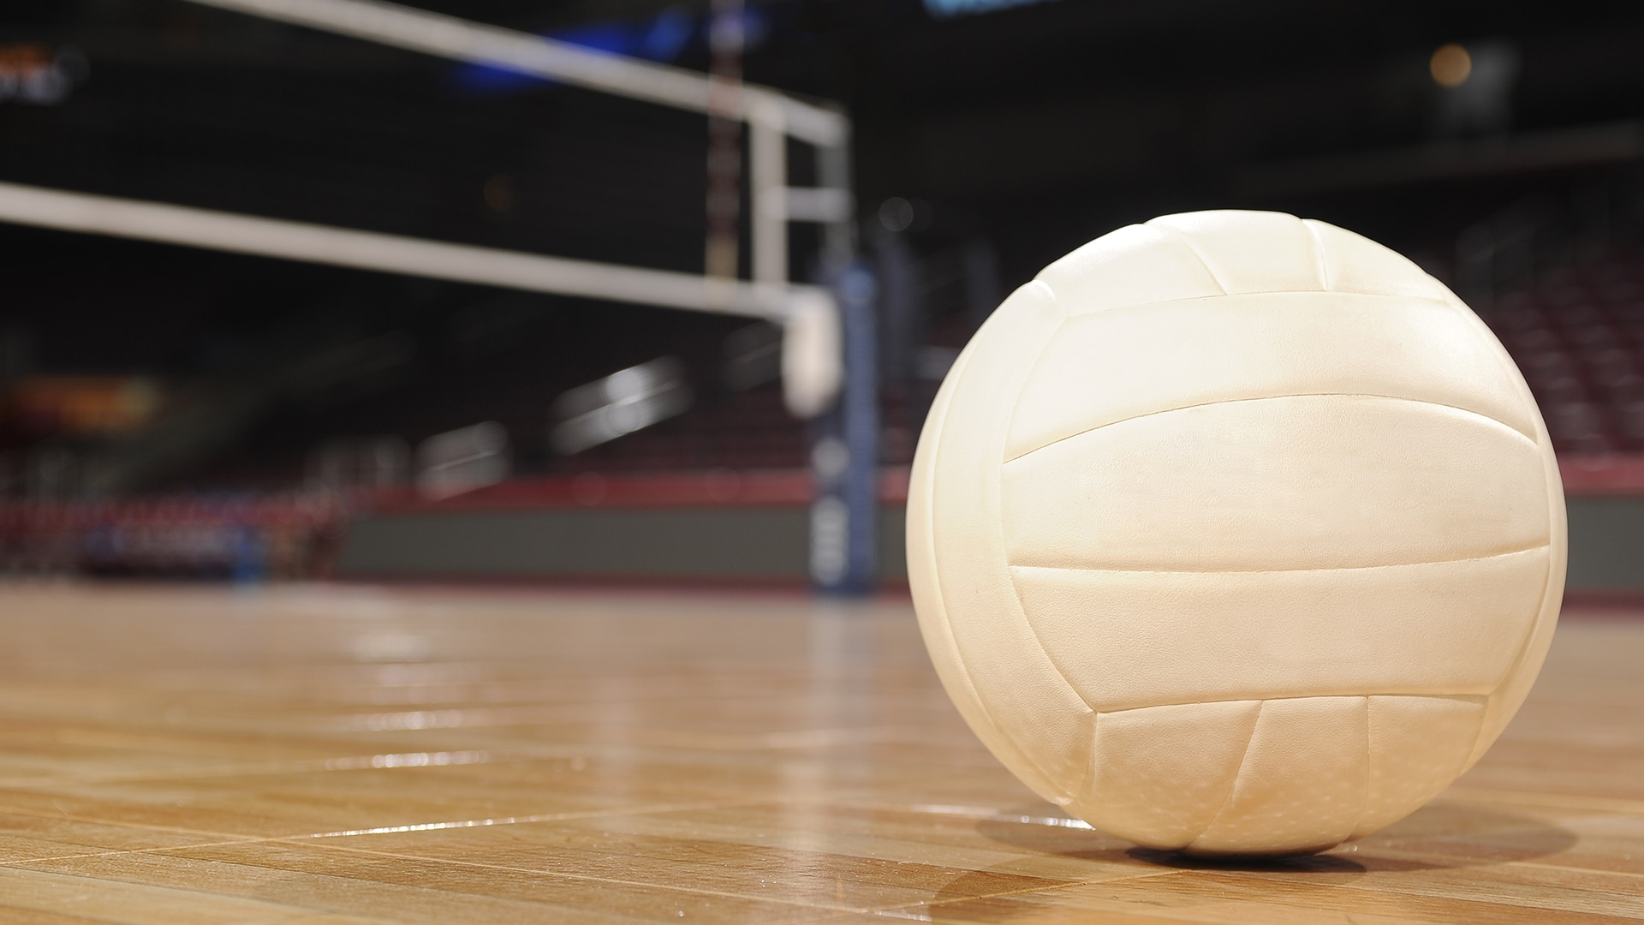

KMS

**Important Dates To Remember**

**Open Gym starts:**

**Saturday 1/20/24**

**10am- 12pm**

**January 27th**

**February 3rd, 10th, 17th , 24th**

**NO CROCS OR OPEN TOED SHOES. TENNIS SHOES ONLY**

**\*\*ALL PARTICIPANTS MUST HAVE COMPLETED PHYSICAL ON FILE\*\***

