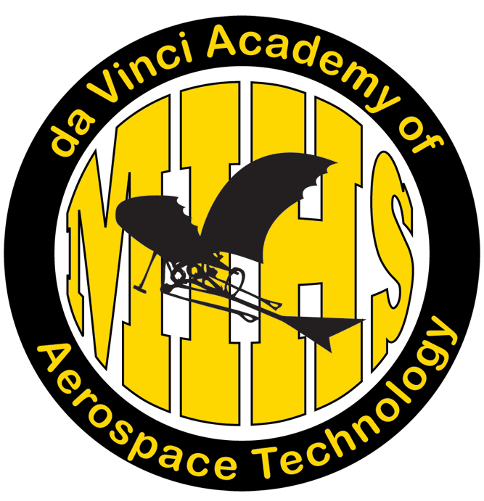

“For once you have tasted flight
you will walk the earth with your eyes turned skywards,
for there you have been and there you will long to return.” -- Leonardo da Vinci

Merritt Island High School

da Vinci Academy of Aerospace Technology

Handbook

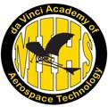

The Merritt Island High School da Vinci Academy of Aerospace Technology opened its doors in the Fall of 2009. The Academy is a collaborative effort between Brevard County Public Schools, the aerospace technology/engineering industry and the “Project Lead the Way” curriculum. Academy students have the opportunity to learn about careers in engineering and aerospace technology in addition to math/science specialties. Academy courses, projects, field trips, guest speakers and industry mentors prepare da Vinci students to enter the industry at the professional level.

The da Vinci Academy of Aerospace Technology offers training in:

Engineering Concepts...
Our da Vinci Academy is the only school in Brevard County to be selected
as a “Project Lead the Way” school with nationally-recognized
engineering curriculum and technology.

Technical Applications...
Our da Vinci Academy takes a hands-on approach to learning whereby
students experience engineering principles and aerospace technology
and simulation first hand.

Team-Building Frameworks...
Our da Vinci Academy prepares students to compete in the global market
of the 21st century with a team approach to learning math, science and
engineering concepts through projects and experiments.

Our Vision...
The da Vinci Academy of Aerospace Technology is committed to a high-quality education in the field of Engineering and Aerospace Technology through academic performance and technical coursework in preparation for the 21st century work force and the post-secondary educational arena.

Important people to know in our Academy...

da Vinci Academy of Aerospace Technology Advisory Committee

Ben Bryant | NASA | Ben.Bryant@nasa.gov
Javier Calderin | FAA | Javier.Calderin@faa.gov
Bob Crabbs | Florida Space Institute, UCF | rcrabbs@mail.ucf.edu
Phil Bryden | Craig Technologies | phil.bryden@craigtechinc.com
Mark Dowhan | United Launch Alliance | mark.e.dowhan@ulalaunch.com
Dr. Bob Duerr | Northrop Grumman | Robert.Duerr@ngc.com
Bonnie Dubrow | Flexure Engineering | bonnie.dubrow@flexureengineering.com
Edward Ellegood | Space Florida
Gary Hamm | Florida Tech | gary@fit.edu
Rick Horner | Lockheed-Martin Space Systems | rick.d.horner@lmco.com
Adrian Laffitte | Lockheed Martin Space System | adrian.laffitte@lmco.com
Wanda Luthman | Counselor, MIHS | Luthman.wanda@brevardschools.org
Erika McLaren | CTE Resources, Brevard Schools | McLaren.Erika@brevardschools.org
Krista Miller | Assistant Principal, MIHS | miller.krista@brevardschools.org
Dean Miyakusu | Florida Tech | dmiyakusu@gmail.com
Charles Parker | Academy Director, MIHS | parker.charles@brevardschools.org
Janice Schultz | CTE Director, Brevard Schools | schultz.janice@brevardschools.org
Mollie Vega | Principal, MIHS | vega.mollie@brevardschools.org
Dennis Soboleski | PLTW Liaison, Brevard Schools | Soboleski.Dennis@brevardschools.org
da Vinci Teachers

Charles Parker: Intro to Engineering, Engineering Design & Development
TBD: Digital Electronics
TBD: Principles of Engineering, Aerospace Engineering
Andrew Disney: English I Honors
Teresa Nick: Biology Honors
Janice Cheshire: English II Honors
Andrea Crowley: Chemistry Honors
Denise Stewart: English III and IV Honors
Diane Wallschlag: Physics Honors
Educational Environment

The da Vinci Academy of Aerospace Technology provides a specialized educational setting dedicated to the development of academic skills with a goal of creating responsible citizens. Teaching will take place in a structured classroom setting where limits are firmly established and understood.

Honesty and Integrity
Academy students have a wide variety of opportunities in the classroom, school, and community. It is extremely important that the students exhibit conduct acceptable in both an educational and professional environment. Academy students are to conduct themselves in a manner showing respect for all persons and must adhere to the school code of conduct. Honesty and integrity must be displayed in the classroom and in all school-related activities. Students should understand that a violation of these guidelines will jeopardize their status in the academy and their ability to participate in academy activities.

Grades
At the end of each 9-weeks, the Academy Director will review students’ grades and discipline records. If a student does not maintain a 2.5 grade point average overall and/or does not sucessfully complete an Academy class, s/he will be subject to probationary intervention whereby an academic contract will be developed and monitored. Participation in Academy activities will be limited until improvement is made.

Portfolio
Every academy student will design and develop an online portfolio as part of their “Project Lead the Way” coursework. This portfolio will be reviewed by a committee of at least one academy teacher and board member. To graduate with a da Vinci designation, the portfolio must be maintained through-out the entirety of the program.

Academic Assistance
Parents may call the Guidance Department at 454-1005 to schedule an appointment to meet with the student’s teachers or to learn more about the Career and Technical Education (CTE) curriculum pathway and the nationally-distinguished “Project Lead the Way” program.

da Vinci Academy Curriculum Pathways

The da Vinci Academy adheres to the National Academy Foundation’s “Six Core Principles”: personalized learning environment, academic engagement, empowered educators, accountable leaders, engaged community and integrated curriculum.

Each da Vinci student is part of a “small learning community.” Students enroll in a cohort of da Vinci classes that include Academy Honors English and Science and at least one “Project Lead the Way” elective. (Students must be in Honors English and Science or can phase up to AP or dual enrolment classes in either English or Science.) In addition, each Academy student must choose membership in Flight Club, Robotics, SECME, CubeSat or five hours of academy-related comunity service. MIHS Guidance Counselors help
da Vinci students map out an individualized curriculum pathway based on the “Career and Technical Education” (CTE) Program of Study with “Project Lead the Way” (PTLW) curriculum holding college weight.

PLTW Curriculum is delivered sequentially across the high school years: Introduction to Engineering- 9th
Principles of Engineering- 10th Digital Electronics - 11th or12th Aerospace Engineering- 11th or12th
Engineering Design and Development Capstone Project- 12th

National Standards of Practice for the Academy

1. The Academy’s mission focuses on college and career while increasing student achievement.
2. The Academy offers a cohort of classes across the curriculum throughout high school.
3. The Academy receives exceptional, specialized support from administration/school board.
4. The Academy secures highly trained teachers who embrace team teaching and the philosophy of the Academy.
5. The Academy provides professional development and common planning time for teachers, while including parents and the community in Academy efforts.
6. The Academy supports an active advisory board with representation from the community and mentors in the field.
7. The Academy delivers sequential, integrated and relevant curriculum to empower the student for career and college.
8. The Academy encourages community-based service learning whereby students intern and/or volunteer.
9. The Academy maintains records to show student growth including attendance, grade point average, state test scores and graduation rates.

10. The Academy reflects on its mission to continually improve its program.

da Vinci Academy Career Development Explorations
Information and Policy

Through field trips and guest speakers, the da Vinci Academy will expose students to careers and opportu- nities in the field of aerospace technology, engineering, math and science. These “career development explorations” will take place about twice a semester and will require parent permission, parent volunteers, and parent funds/fundraising to cover transportation and event costs.

In order to participate in field trips, guest speaker workshops and Academy events, students must have:
• acceptable academic standing (minimum 2.5 GPA)
• excellent conduct record
• appropriate seat time attendance (excused absences and school-related events are not exceptions)

All of the students’ teachers will be notified of upcoming Academy events to decide if the student is in good standing. Each upcoming event will be another opportunity for the student to participate if “good standing” is established. Ultimately, Academy events are an honor; only students who earn this honor will attend, based on Academy Director’s discretion.

Students must follow the etiquette policy and dress code of the Academy. School policy requires that students use approved transportation for field trips. For this reason, students are not allowed to drive themselves to da Vinci events. In addition, students are not allowed to be picked up from a field trip, but instead must depart from/arrive back to MIHS in all cases.

Possible “Career Development Exploration” Field Trips Include:

Behind-the-Scenes at Kennedy Space Center
U.S. Astronaut Hall of Fame U.S. Space Walk of Fame Museum NASA Astronaut Training Experience
Lockheed Martin Simulation and Flight Training
“Ropes” Training
Valiant Air Command Warbird Museum
National Flight Academy
Flight Simulation and Gaming, Orlando Embry Riddle Aeronautical University Robotics Expos
Space and Astronomy Lecture Series, BCC Planetarium Florida Institute of Technology Flight Program
Solar Energy Center
Northrop Grumman Simulation Center ARISS Contact with International Space Station United Space Alliance/United Launch Alliance Craig Technologies
Cocoa Beach Air Show
Voyager Aviation and Young Eagles Flight School, Merritt Island Airport

da Vinci Academy Behavior, Attendance & Etiquette Policy

Behavior Policy

While attending Merritt Island High School, an Academy student is subject to Brevard County
Public Schools rules for student conduct. Additional policies in the MIHS Student Planner (pages 6-
28) will also be enforced. Each student of the Academy should carefully read the Discipline Policies and Procedures starting on page 11 of the MIHS Student Planner.

Attendance Policy

All da Vinci students are expected to perform at the maximum level of their capabilities in all of their Academy classes as well as their other coursework. School attendance is the direct responsibility of parents/guardians and students. All students are expected to attend school regularly and to be on time for classes in order to benefit from the instructional program and to develop the habits of punctuality, self-discipline and responsibility. Even school-related events and excused absences are considered when determining if a student is eligible for a da Vinci “career exploration” since class seat time is critical. If students do not meet the required attendance standards, they will be up for review and put on probation by the Academy Director.

♦ Unexcused absences of 10 days or more will result in a course failure for the semester for absences.
♦ Students must submit documentation excusing the absence within 10 school days of the absence.
♦ Make up work is the student’s responsibility and must be made up within 3 days of the absence.
♦ Students may not attend career development explorations with 5 or more unexcused absences.

Etiquette Policy

In the da Vinci Academy of Aerospace Technology, students are exposed to all aspects of aerospace technology and engineering principles as part of their Academy culture. Students participate in performances, exhibits, discussions and debates. Academy students recognize the value of all works presented and demonstrate respect for all presenters. Students are expected to adhere to rules of etiquette during all performances, presentations, and exhibits:

♦ Remain quiet during every performance. Do not interact with presenters unless called upon.
♦ Arrive on time and remain seated for the entire performance with feet on the floor, hands to self.
♦ Restroom breaks should be taken at scheduled intermissions.
♦ Unless indicated otherwise, refreshments and gum are not allowed.
♦ Make sure cell phones are turned off and put away.
♦ During a presentation, hold applause until the presenter is finished; refrain from all shouting and whistling.
♦ Attire should coincide with the type and location of the event.

da Vinci Academy Dress Code Policy

Professional Business Attire

Academy students are expected to dress in academy attire on days when guest speakers are in the classroom, during field trips, and for special academy assemblies and functions where the community is invited. Appearance makes an important first impression. In addition to attire, body language
and manners should be a reflection of a respectful young person who desires to grow intellectually, emotionally and professionally.

♦ Academy polo
♦ Dress slacks, belt, socks and dress shoes
Male

♦ Eleventh and twelfth grade students should have a suit or dress jacket appropriate for a job inter- view, mentor meeting or career shadowing event.

Female

♦ Academy polo and slacks or skirt of appropriate length (no mini-skirts or tight fitting skirts)
♦ Closed dress shoes (may be flat)
♦ Eleventh and twelfth grade students should have a suit or dress appropriate for a job interview, mentor meeting or career shadowing event.

Remember

DO have clean, neat and appropriate hair style
DO have well-manicured, conservative nails
DO have clothing clean and neatly pressed
DO have shoes clean and professional

NO jeans
ΝΟ flip flops or clogs
NO t-shirts, tanks, or casual shirts
NO tight-fitting or see-through clothing

