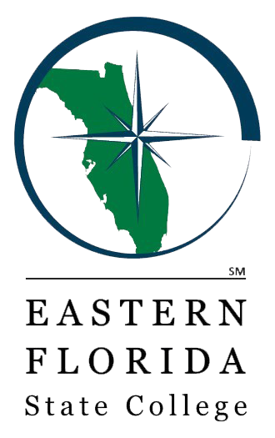
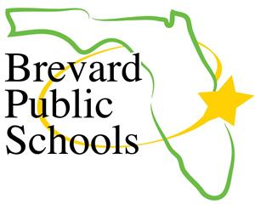
2023-2024 EFSC/BPS Early College Program
Getting Started

- Attend the EFSC/BPS Early College Program Information Session
Congratulations! You have been invited to consider participating in the Early College Program based on your GPA of 3.0 or higher.

- Scan the QR code and complete the Google Form to confirm your interest AND sign up for the PERT test at your school
If you are interested in pursuing the Early College program, scan the QR code to confirm your interest AND sign up for the PERT by Friday, January 27, 2023.

- Take the PERT at your school or EFSC
Score college-ready in Reading and Writing for acceptance into the Early College Program.
If you qualify, your school will give you a notification letter with information about next steps and how to pre-register for the MANDATORY in-person Early College Orientation for you AND your parent/guardian.
- If you do not score college-ready in Reading and/or Writing on the PERT, schedule a retest at an EFSC campus. You must wait 30 days to retest. There is a $10 fee for each subtest.
  - To schedule the PERT go to:
https://www.easternflorida.edu/admissions/placement-testing/registerblast.cfm
  - To submit a remote placement testing request form to take the ACCUPLACER NG, go to https://www.easternflorida.edu/admissions/placement-testing/college-credit-placement-testing/remote-process.cfm

- Complete your EFSC Online Application
Apply for admission to EFSC. You will need to know your Social Security Number (SSN) and your state unweighted high school GPA. Early College students should select AA for the Program of Study.
Go to the EFSC webpage at www.easternflorida.edu and click the “APPLY NOW” button.
When you receive your EFSC acceptance letter (email), complete the online Dual Enrollment Orientation (MANDATORY).

- Turn in the Early College Program Student/Parent Agreement by May 1, 2023

- Complete all Early College Program requirements by May 1, 2023
This includes applying to EFSC, completing the orientations, testing, retesting, and submitting the Student/Parent Agreement.

- Meet with your Early College Advisor to complete the EFSC Dual Enrollment Registration Form
Early College students may take 2 classes in the summer and up to 3 in the fall (11th/12th only).
Submit your completed form to Advising by logging into myEFSC and uploading the document.
Check your EFSC student Titan email for information about the status of your registration.

If you are interested in pursuing the next steps for the Early College Program, please scan the QR code and complete the Google Form in its entirety. Completion of the form will indicate your interest as well as act as registration for the PERT.

