MILA Elementary

2023-2024

School-Wide Positive Behavior Plan

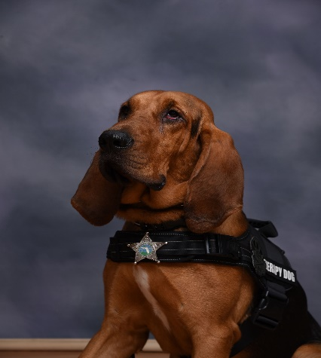 

MILA Elementary

School-Wide Behavioral Expectations

A Guide for Teaching School-Wide Behavioral Expectations

School-Wide Positive Behavior Interventions and Support is a set of strategies and systems to increase the capacity of schools to (a) reduce school disruption, and (b) educate all students including those with problem behaviors

* Clearly defined outcomes
* Research-validated practices
* Supportive administrative systems
* Use of information for problem solving

**Features of School-Wide Positive Behavior Interventions and Support Plan**

* Establish regular, predictable, positive learning & teaching environments.
* Educate school community to serve as positive models.
* Teach and model behavioral expectations.
* Create systems for providing regular positive feedback.
* Develop environments that support academic success.

MILA Elementary

School-Wide Behavioral Expectations

This guide provides specific goals, behavioral expectations, teacher and staff responsibilities, strategies for acknowledgement and specific routines to be followed.

**School Goal:**

Students at MILA Elementary have PAWSitive Behavior throughout the school day by following the behavioral expectations.

**MILA Expectations:**

**P.A.W.S.**

**P**ersonal Best

**A**ct Responsibly

**W**ork and Play Safely

**S**how Respect

**Teacher & Staff Responsibilities:**

* Teachers and staff will teach, model and practice each of the behavioral expectations throughout the year.
* Teachers and staff will acknowledge student behaviors that meet the P.A.W.S. expectations.
* Teachers and staff will teach, model and provide opportunities for practice for students not following P.A.W.S.



***Golden Paw Award***

***MILA’s Students Have PAWSitive Behavior!***

***At MILA, we believe in emphasizing and recognizing positive behavior. Students who consistently display the P.A.W.S. procedures are selected by classroom teachers for monthly recognition.***

***P****ersonal Best* -

***A****ct Responsibly* –

***W****ork and Play Safely* –

***S****how Respect* –

*Exhibit all 4 Expectations-*

**Teachers will recognize the students’ efforts through a four to five sentence personalized paragraph.**

**General Lesson Format for**

**Teaching School P.A.W.S. Behaviors**

**When introducing behavioral expectations, follow the basic steps:**

Step 1: Teach P.A.W.S. expectations for specific settings following implementation calendar.

Step 2: Model P.A.W.S. behaviors for specific setting through PBIS walk through. Review expectations of P.A.W.S. for specific setting i.e. cafeteria, restrooms, bus area, hallway, recess, breakfast, playground, arrival and dismissal.

* **P**ersonal Best
* **A**ct Responsible
* **W**ork and Play Safely
* **S**how Respect

Step 3: Review P.A.W.S. expectations daily for students.



Students receive recognition by receiving *“Paws”* for following P.A.W.S. procedures. Students will shop biweekly at the PBIS store to redeem paws.

**MILA’s School-Wide Expectations**

|  |  |  |  |  |  |  |  |
| --- | --- | --- | --- | --- | --- | --- | --- |
| **Expectations** | Cafeteria | Hallways | Restroom | Bus | Mandatory P.E. | Recess | Car Loop |
| Personal Best | Use kind and positive words and clean up your area. | Use kind and positive words and stay in line with your class. | Keep restroom neat, dry, and clean. | Pay attention to the bus driver and any adults on the bus. | Participate in the activity safe. | Use good sportsmanship. | Listen, follow procedures, walk to your destination. |
| **Act Responsibly** | Use table manners and clean up your area. | Speak quietly when necessary. | Wash your hands and throw away your trash. | Have belongings ready, listen and follow procedures. | Listen and follow procedures. Take care of materials. | Use equipment correctly. | Have belongings ready. Follow directions given. |
| Work and Play Safely | Stay seated at all times. Speak quietly. | Walk on the right side of the hallway and go directly to your destination. | One person at a time. Then go directly to your destination. | Keep hands to yourself and remain seated at all times. | Keep hands and feet to yourself. Play safe. | Keep hands and feet to yourself. | Walk in the hallways, keep hands to yourself, go directly to your destination. |
| **Show Respect** | Be considerate of other people’s space and their food. | Be considerate of others in line. | Keep restroom neat and dry. | Be considerate of other people’s space. | Use equipment correctly. Be a team player. | Listen and follow directions. Be a team player. | Be considerate of other people’s space. |