CAFETERIA PROCEDURES
The proper procedures for
cafeteria health and safety:

- Talk with inside voices
- Sit on benches correctly
- Remain seated at all times
- Keep hands/feet to yourself
- Clean table and floor area
- No sharing food
- No soda
- No food/drink taken back to class
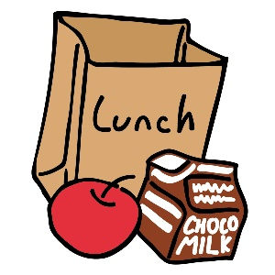
Monitors are in the cafeteria during all lunch periods. Students are expected to follow cafeteria procedures at all times to ensure health and safety for all. Parents and other family members may join their child/family member for lunch or breakfast. Please sign in with your driver license at the front office. Visitors should accompany the child through the cafeteria line to purchase a meal, snack, or drink. A family table is avalible in the lobby for lunch.

Breakfast
Free breakfast is served daily from 7:30 a.m. until 7:55 a.m. for all students. Parents and non-school aged children may enjoy breakfast as well for a nominal fee.

Lunch
Lunch may be purchased daily or advance payment may be made in the cafeteria before 8:00 a.m. at the beginning of each week. Parents may pay by credit or debit card online at: www.mypaymentplus.com. Refer to the Brevard County District website under Parents and Students > Food Menus for additional information and current prices.

Free and Reduced Lunch
Do you qualify? The annual income requirements have changed and many families are surprised to find out that they indeed qualify and are able to benefit from the program. Call or stop in the front office for more information or visit the food services department on the Brevard Public School District’s website.

