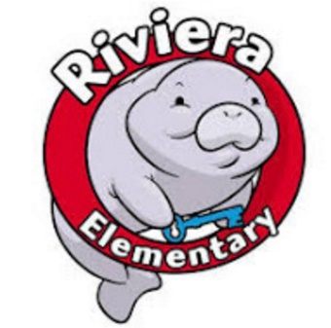

Riviera SAC Meeting Agenda
October 25, 2023

Outcomes: All members will receive information and provide feedback on School Report Card Grade, K-6 i-Ready Data, PBIS, Finlized School Improvement Plan

Welcome!
- Review of last meeting minutes: Daniela Brao Stephens

- New Business Daniela Brao Stephens

  - Share and Discuss I-Ready Data from Diagnostic 1
    - ELA
    - Math
  - Parent Family Engagement Plan
  - PBIS
    - Character Trait of the month and Student rewards
  - Fundraiser updates!
    - Harvest Festival
      - Profit
    - Dominoes Pizza
      - Profit
  - Share/discuss Riviera Updates Beth Myers
    - School Improvement Plan- Finlized
    - Staff appreciation days in December

Next Meeting will be Wednesday November 29th at 3 PM in the Media Center

