Brevard Edition

Understanding Florida Assessment of Student Thinking (FAST) Reports for Families

Florida Assessment of Student Thinking Scores
The FAST results are reported at the student, teacher, school, district, and state levels.

For the 2022–23 school year, the following information for grades 3–10 FAST ELA Reading and grades 3–8 FAST Mathematics will be reported the FAST grades 3–6 ELA Reading and 3–6 Mathematics assessments are computer-adaptive tests (C.A.T.s).:
- Provisional scores will be linked to the 2021-2022 score scale, as required by law.
- Students will receive an overall scale score and achievement level for the score on the linked scale.
- Students will receive reporting category
- After the close of each PM window, the Florida Department of Education (F.D.O.E.) will report percentile ranks at the student level for parents, schools, and districts, as well as comparisons at the school, district, and state level

PM1 and PM2 Scores
Each progress monitoring test covers the complete “test blueprint,” meaning that all content expectations for that subject and grade level are assessed. Therefore, for PM 1 and PM2, your student may not yet be at grade level; however, this does not necessarily indicate that a student is not on track to succeed. Teachers and families must understand that score information provide baseline and mid-year results for PM1 and PM2, respectively. These results are for informational purposes only and should be used to identify areas that may need additional instruction and support. These results should not be considered student achievement designations.

PM3 Scores
PM3 provides a summative score at the end of the year to measure student mastery of the grade-level content standards. In addition, the PM3 student report would show a student’s performance for all three windows for comparison if the student participated in each PM opportunity.

Family Portal
The FAST Family Portal will be available in Fall 2022, after the close of the first PM window. You can access your student’s FAST results in the portal using the login information provided by your school. Once the portal is available, this guide section will be updated.

Individual Student Reports
The top of the Individual Student Report contains student, school, and district information and the grade-level/subject test the student took. The example shown is for a Grade 4 FAST ELA Reading test.
- Score information: The LEFT-SIDE area displays the student’s scale score, achievement level, and a chart indicating the student’s scale score and where it falls in the achievement level.
- Notes for families: The RIGHT-SIDE area contains essential notes for families.
  - 2022-23 FAST scores are reported on the 2021-22 score scale.
  - Percentile Rank (displayed in the blue-shaded area) is not calculated until the close of each PM window (PM1 10/1) and will show your student’s performance compared to all other students who took the same test in this PM window.
- Performance by Reporting Category: The BOTTOM section displays the student’s achievement level (below, at/near, above the standard) for each reporting category in the test. These classifications indicate a student’s level of success with items that assess the benchmarks within each category.

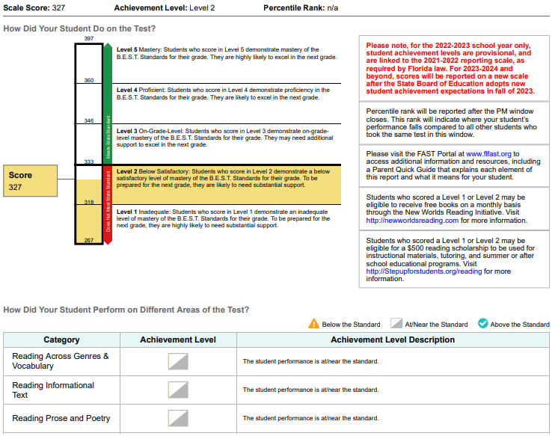

Achievement Levels
The images below describe each level and provide the scale score ranges for each level by grade level/subject test. Please remember that these levels are from the 2021-22 performance scale. New achievement levels for the FAST scale will be available in summer of 2023. Achievement levels range from Level 1 to Level 5. For all assessments, Level 3 indicates on-grade-level performance.

Achievement Levels
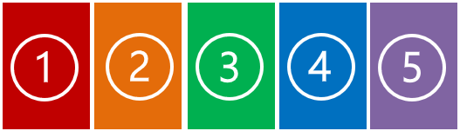

Inadequate:

Highly likely to need substantial support for the next grade/course
Below Satisfactory:

Likely to need substantial support for the next grade/ course

On-Grade-Level:

May need additional support for the next grade/ course

Proficient:

Likely to excel in the next grade/ course

Mastery:

Highly likely to excel in the next grade/ course

Scale Score Ranges for Each Achievement Level

Assessment | Level 1 | Level 2 | Level 3 | Level 4 | Level 5
Grade 3 ELA. Reading | 240–284 | 285–299 | 300–314 | 315–329 | 330–360
Grade 4 ELA. Reading | 251–296 | 297–310 | 311–324 | 325–339 | 340–372
Grade 5 ELA. Reading | 257–303 | 304–320 | 321–335 | 336–351 | 352–385
Grade 6 ELA. Reading | 259–308 | 309–325 | 326–338 | 339–355 | 356–391
Grade 3 Mathematics | 240–284 | 285–296 | 297–310 | 311–326 | 327–360
Grade 4 Mathematics | 251–298 | 299–309 | 310–324 | 325–339 | 340–376
Grade 5 Mathematics | 256–305 | 306–319 | 320–333 | 334–349 | 350–388
Grade 6 Mathematics | 260–309 | 310–324 | 325–338 | 339–355 | 356–390

Reporting Categories

ELA Reading assessments measure student performance of the B.E.S.T. content standards. The difficulty of the concepts assessed on the ELA Reading tests progresses systematically from grade to grade, as does the complexity of the text presented to the student at each grade level.

Grades 3–10
- Reading Across Genres and Vocabulary
- Reading Informational Text
- Reading Prose and Poetry

Mathematics assessments measure student performance of the B.E.S.T. content standards. The difficulty of the concepts assessed on the mathematics tests progresses systematically from grade to grade, as does the complexity of the numerals and mathematical operations included at each grade level.

Grade 3
- Fractional Reasoning
- Geometric Reasoning, Measurement, and Data Analysis and Probability
- Number Sense and Additive Reasoning
- Number Sense and Multiplicative Reasoning

Grade 4
- Geometric Reasoning, Measurement, and Data Analysis and Probability
- Number Sense and Operations with Fractions and Decimals
- Number Sense and Operations with Whole Numbers

Grade 5
- Algebraic Reasoning
- Geometric Reasoning, Measurement, and Data Analysis and Probability
- Number Sense and Operations with Fractions and Decimals
- Number Sense and Operations with Whole Numbers

Grade 6
- Algebraic Reasoning
- Geometric Reasoning, Data Analysis, and Probability
- Number Sense and Operations

