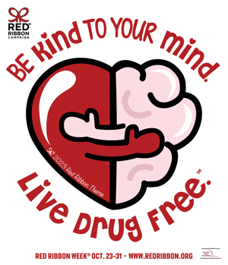
RED RIBBON WEEK ‘23

October 23rd-27th

Monday: “Wake Up Drug Free!”
- Wear your pajamas to support a new day Making Healthy Choices!
Please continue to follow dress code rules (NO slippers, spaghetti straps,
flip flops, etc.) Wear sneakers.

- Sign the banner in the commons to Pledge to be Drug Free
Parents- Can take pledge with students online @ www.redribbon.org/pledge

Tuesday: “Catch the Wave to a Drug Free Life”
- Wear Hawaiian or beachy attire
Dress code appropriate

Parents- Can visit The 2023 RRW Guide.pdf (hubspotusercontent-na1.net)for ongoing resources

Wednesday: “Take a Stand Against Drugs.”
- Wear as much RED from head to toe as you can today.

RRW Faculty/Staff vs. 6th Grade Volleyball Game 1:00 PM

Teens who talk to their parents about drugs are 42% less likely to use.

Thursday: “It’s NOT crazy to say, ‘NO’ to drugs!”
- Wear crazy socks

Parents can visit www.naturalhigh.org with your student and watch some of the informative videos.

Friday: “Our School Chooses to Be Drug FREE.”
- Team up with your grade level to support being drug free by wearing a grade level COLOR.

K: White *1st: Blue *2nd: Yellow *3rd: Green
4th: Orange * 5th: Black *6th: Red

