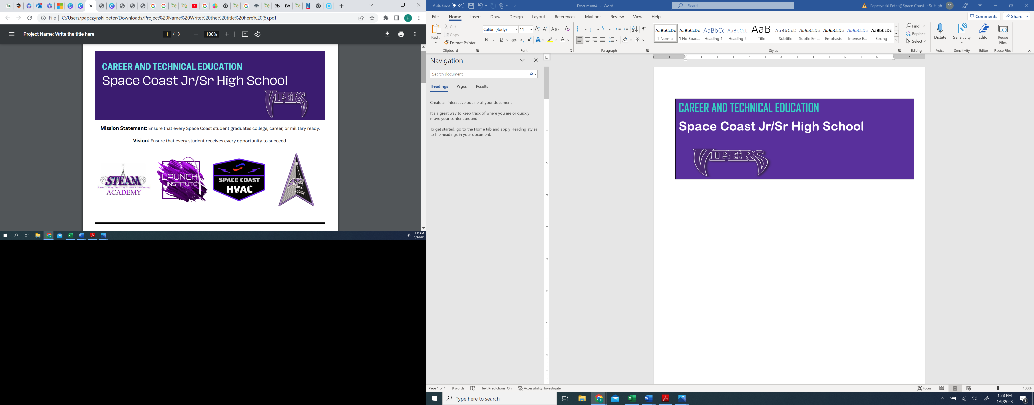

Program Scopes and Industry Certifications
STEAM Academy | LAUNCH Institute | HVAC Program | Space Force JROTC
CTE Pathways include Engineering and Drafting | CTE Focus is on Digital Design and Business Analysis | CTE Focus is on Heating Ventilation and Air Conditioning | Focus is on promoting strong citizenship and community engagement
Industry Certifications:  Drafting:  - AutoCad  - Inventor  - Revit Architecture  Engineering:  - Solidworks | Industry Certifications:  Digital Media:  - Adobe Visual Design  - Adobe Web Design  - Adobe Video Design | Industry Certifications:  - EPA  - SP 2 Safety  - HBI PACT Core  - OSHA 10 | Skills Taught:  - Aerospace Science  - Leadership  - Health and Wellness

STEAM Academy | LAUNCH Institute | HVAC Program | Space Force JROTC
Space Coast Jr/Sr High School had 2 teams travel to Houston Texas compete at NASA Hunch (High schools United with NASA to Create Hardware) this past year. Steam Academy and engineering students will create and problem solve a variety of items given to them directly from the astronauts’ needs on the International Space Station. Selected prototypes are fabricated by NASA and sent up to the International Space Station. Students also have the ability to Dual Enroll with Eastern Florida State College for CNC Machining and gain employment with business partners such as Knight's Armament. | Through the rigor of LAUNCH and skills gained from project-based learning, students excel in their courses on campus and also earn industry certifications. Space Coast Jr/Sr High students have abundant opportunities to gain paid and unpaid internships with local business partners once they have completed 3 years of a CTE track. | With their hands-on experience and industry certifications, HVAC students have opportunities to obtain paid internships with local business partners as well as with the School Board of Brevard Public Schools to work as HVAC technicians while also finishing their High School education. Additionally, students have opportunities to Dual Enroll with Eastern Florida State College to earn higher certifications while enrolled at Space Coast. | The sky is no longer the limit for Space Coast Jr/Sr High students as they took a step toward space when they officially transitioned into one of only ten United States Space Force JROTC units in the world. Guardians who participate in the Space Force JROTC at Space Coast Jr/Sr High School are taught and held to the highest standard. Space Coast Jr/Sr High School had a J-100 Scholarship recipient in the 2022-2023 School year which placed the cadet in the top 100 in the country. Space Coast Guardians can enlist as an Airman 1st Class (E-3) with 3 years of SFJROTC experience.
 |  |  | 
Post-Secondary Pathways



