I use the book [*How to Take the Grrrr Out of Anger*](http://click.linksynergy.com/fs-bin/click?id=OPV30MSS5Z4&subid=&offerid=239662.1&type=10&tmpid=8432&RD_PARM1=http%253A%252F%252Fwww.barnesandnoble.com%252Fw%252Fhow-to-take-the-grrrr-out-of-anger-elizabeth-verdick%252F1103775181%253Fean%253D9781575421179)to assist me with helping students talk about their anger and what strategies they could use to handle it. However, many of these tips are universal from one anger management book to another.  
[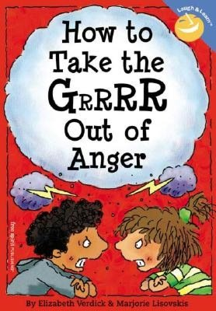](http://click.linksynergy.com/fs-bin/click?id=OPV30MSS5Z4&subid=&offerid=239662.1&type=10&tmpid=8432&RD_PARM1=http%3A%2F%2Fwww.barnesandnoble.com%2Fw%2Fhow-to-take-the-grrrr-out-of-anger-elizabeth-verdick%2F1103775181%3Fean%3D9781575421179)

The 12 anger management strategies are:

* Count backwards from 10.
* Take 3 deep breaths.
* Exercise or play to let off some steam/energy.
* Find a quiet place.
* Vent!  Talk to someone!
* Tell yourself calming statements. (It’s okay.  Keep calm.  Relax.)
* Lie down and relax.
* Tense your body- then relax it. (Repeat)
* Use an I-Message. (I feel angry when you ___.  I want you to ___.)
* Think peaceful thoughts. (relaxing by the pool, holding your pet, hugging a parent)
* Walk away.
* Avoid anger triggers.