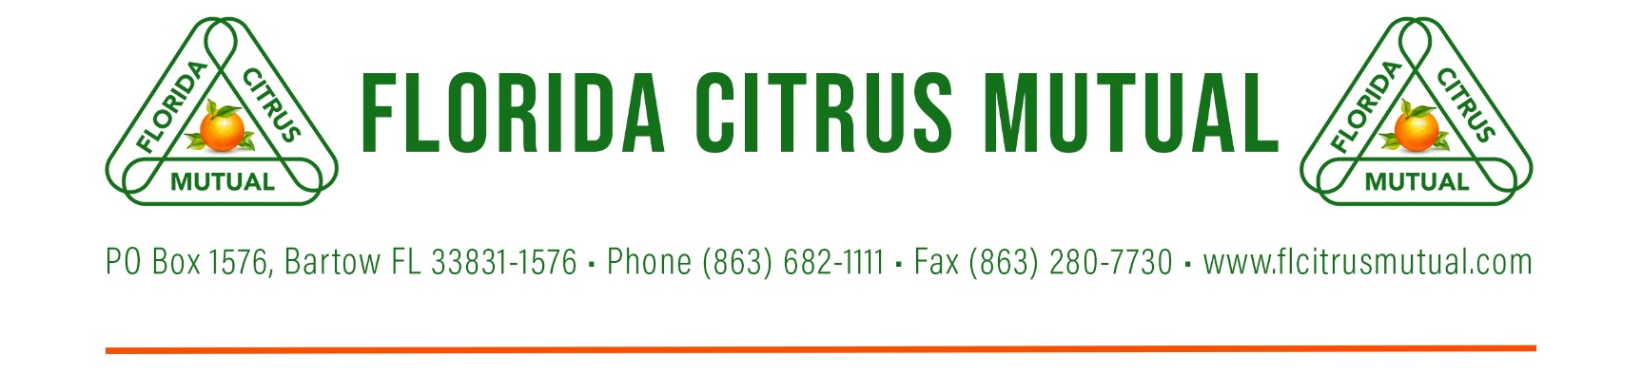

Julia C. Black Memorial Speech Contest & Scholarship

Rules and Details of Competition

- Contestants must be students in 9th – 12th grade for the 2024-25 school year.

- Contestants must be residents of the FCM District they are representing (see FCM Districts).

- The speech must be the original work of the contestant.

- The topic for the speech is: Identify a pivotal moment in the Florida Citrus Industry, and how it has shaped the industry today. These moments can include catastrophic events, significant legislation, etc. The purpose of this contest is to promote a better knowledge and understanding of Florida’s citrus industry and to help promote the industry’s many values and virtues.

- Speaking order will be randomly determined by event officials. Contestants will be permitted to use notes while speaking, but deductions in scoring may be made if it detracts from the effectiveness of the presentation. Visual aids are not allowed.

- Speeches must be a minimum of four minutes and a maximum of six minutes in length. Short/long speeches will face point deductions; no time warnings will be given.

- There will be a question-and-answer session at the end of each speech, maximum 3 minutes.

- Each judge will individually rank the contestant and then rankings from all judges will be averaged to determine the final placings.

- The contest has two levels: district and state. Winners of the District competitions will come together to compete in the State competition. The winner of the State Competition will be invited and must be available to attend the Florida Citrus Industry Annual Conference to present their winning speech at the banquet Thursday night, June 12th, 2025.

- Application window runs from November 1 – December 30, 2023; first come-first served basis for a total of 15 contestants per District.

- District competitions will take place during the month of January 2025. The State competition will take place in March 2025.

- District prizes are as follows:
  - 1st Place - $100
  - 2nd Place - $75
  - 3rd Place - $50.

- State prizes are as follows:
  - 1st Place - $1,000 (Plus hotel accommodations (2 rooms for 2 nights) at the FCIAC and seating for up to 6 people, for at the Thursday night banquet June 12, 2025
  - 2nd Place - $500
  - 3rd Place - $250

