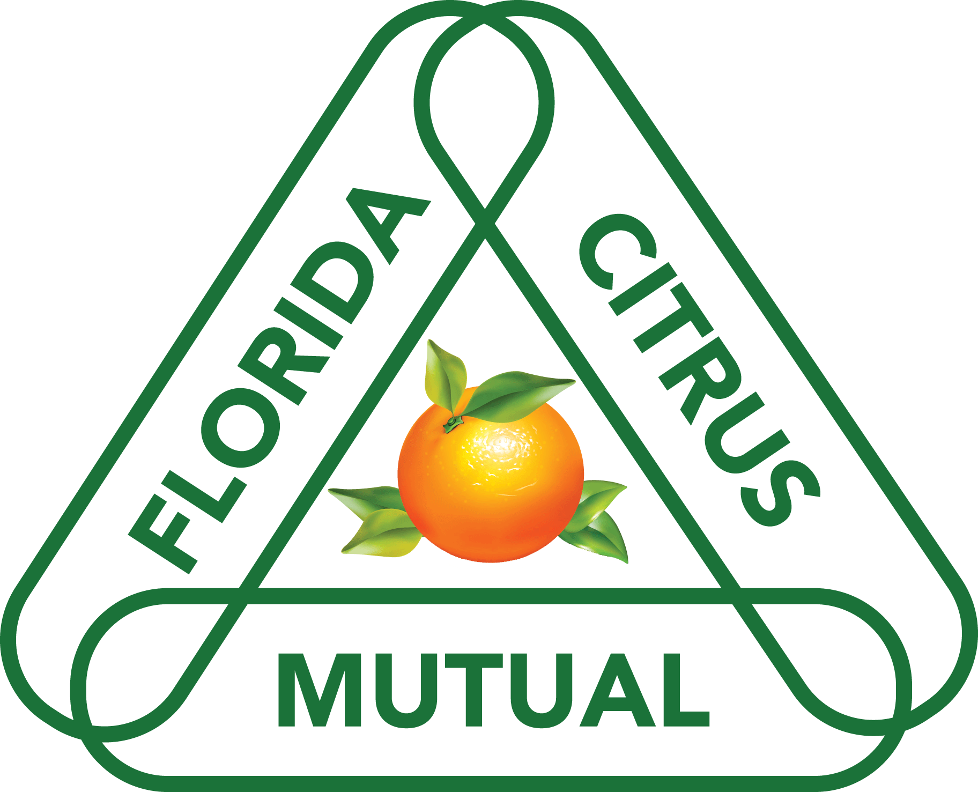
Julia C. Black Memorial
Speech Contest & Scholarship Application
2024-25

Student Name
Parent/Guardian
Street address
City/Zip
County
Phone number
Email
School/Club
Grade

DO YOU HAVE ANY IMMEDIATE FAMILY MEMBERS IN THE CITRUS INDUSTRY? Yes _______ No ________
IF Yes, What is their name and relation to you? _____________________________________________________________________________________
(This will NOT affect your acceptance into the competition)

Return completed form no later than December 30, 2024 to:
Florida Citrus Mutual
Attn: Melanie Burns – Speech Contest
PO Box 1576
Bartow FL 33831

Or scan and email to: melanieb@flcitrusmutual.com
Questions: Contact Melanie Burns at 863-682-1116.

