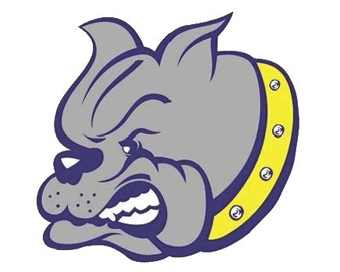 | BREVARD PUBLIC SCHOOLS  Titusville High School Athletics  150 Terrier Trail  Titusville, Florida 32780  (P) 321-264-3100 (F) 321-264-3103  Jennifer Gonzalez, Principal ▪ gonzalez.jennifer@brevardschools.org  Jason Berley, Athletic Director ▪ berley.jason@brevardschools.org
2022 – 2023 Swim & Dive
HEAD COACH Natasha Kremer coachtasha1@aol.com
ASSISTANT COACH Crissy Caswell crissyh66@hotmail.com
DIVE COACH Kelly Fredericks mkfredericks88@gmail.com

DATE | DAY | OPPONENT | SITE | LEVEL | TIME
*Aug 23 | Tues | Blue-Gold Intrasquad | THS POOL | All | practice
Aug 30 | Tues | Harmony @ THS | THS POOL | All | 4:15pm
Sept 6 | Tues | THS @ Cocoa Beach | CB Aquatic Center | All | 4:30pm
Sept 8 | Thus | THS @ Sebastian River | North County Aquatic | All | 4:30pm
Sept 13 | Tues | Holy Trinity @ THS | THS POOL | All | 4:30pm
Sept 17 | Sat | Spruce Creek Invite | Port Orange YMCA | All | 8-12ish
Sept 20 | Tues | Astronaut @THS | THS POOL | All | 4:30pm
Sept 24 | Sat | FSPA Invite | Stuart Sailfish | Qual times swim only | All day
**Sept 27 | Tues | Space Coast @ THS (SRN) | THS POOL | All | 4:30pm
Oct 6 diving  Oct 7 swim | Th/F | CCC Championships | CB Aquatic Center | Post season team | All day
Oct 15 | Sat | Satellite @ THS | THS POOL | Post season team | 9:30am
TBA |  | District |  | Post season team
TBA |  | Regional |  | Qual
Nov 12 | Sat | State | Stuart Sailfish | Qual | All day

*Team picture
**Senior Night meet

