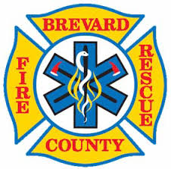

Brevard County Fire Rescue is once again accepting applications for our Firefighter Sponsorship!

The BCFR Recruit Sponsorship will provide funding to attend Eastern Florida State College EMT & Fire Academies. Sponsorship recipients then enter into employment with BCFR as a Firefighter/EMT.

This is a great opportunity for BPS seniors, as these limited access programs are not eligible for financial aid. Within one year of graduation, recipients will obtain two State of Florida certifications and have full-time employment serving our community.

I am excited to share that since the program’s inception in 2021, BCFR has now hired eight sponsorship recipients that are graduates of Brevard Public Schools. We are now hoping to add recipients from the Class of 2023!

Please share this opportunity with your seniors and encourage them to contact me for information about this great opportunity!

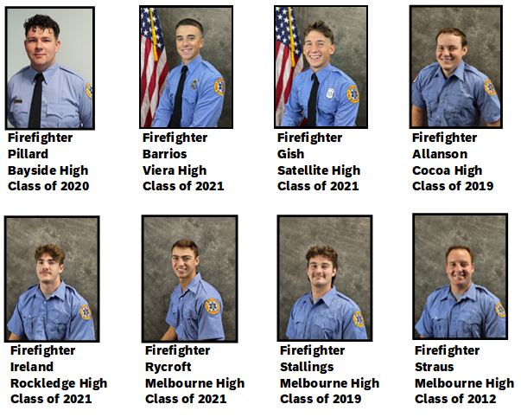

[**https://brevardfl.gov/firerescue/firerescuecareers**](https://brevardfl.gov/firerescue/firerescuecareers)