**Countdown to Kindergarten 2022!!!**

**Tip #1**

**Establish bedtime routines**. Resume the regular bedtime routines before school starts to help ease the kindergarten transition. If you let your child stay up a little later during the summer, for example, gradually get back to the bedtime you will expect when kindergarten starts. Talk to your child about why you are doing this and how it will help his/her back-to-school transition.

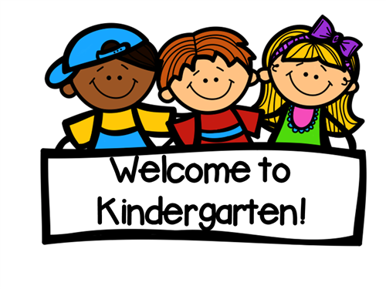

**Tip #2**

**Establish a morning routine**. Do a “dry run” of the new morning routine, whether it is walking to the bus stop with your child, driving to the new school, walking together to the new classroom, etc. to see how much time it will take. Remember, school preparation almost always takes more time than you think, especially when the unexpected happens (you have to go back for lunchboxes, sneakers, etc.).

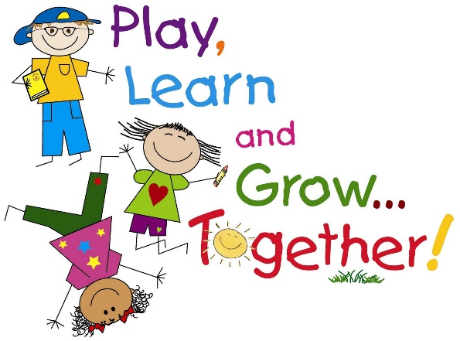

**Tip #3**

**Plan time for breakfast**. Having a good breakfast each day is an important way to start the day. Be sure to adjust your morning schedule to account for the extra time for your child to enjoy breakfast, whether it be at home or at school. Breakfast is available for all students and is served from 7:30-8:00 each morning through our school cafeteria.

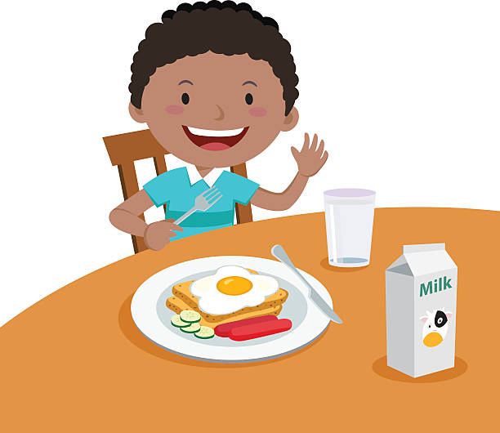

**Tip #4**

**Create a lunch plan**. If your child will take lunch to school, "rehearse" opening and closing lunch items (ziplock baggies, Tupperware containers, thermos lids, etc). Set a timer for 20 minutes and talk about how they may not finish everything in their lunchbox and that’s okay. Practice packing everything back up and talk about what is trash and what should come back home in their lunchbox.

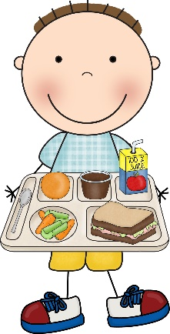If your child will buy school lunch, talk about some of the healthy choices they will get to make when they go through the lunch line. Practice saying their first and last name loudly and clearly for the cashier to hear. Remind them that their teachers and friendly Falcon staff will be there to help them through this process.

**Tip #5**

**Create a snack plan.** Each day, students will be given an opportunity to have a small snack. We recommend packing 1-2 healthy items in a separate bag or container for your child to enjoy at school. Place the snack in a separate pocket in the lunchbox or backpack away from your child’s lunch to avoid any confusion about what to eat for lunch and what to eat for snack.

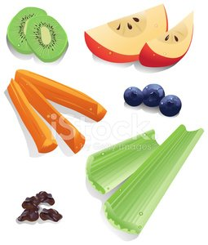

**Tip #6**

**Exploring unfamiliar foods** develops observation skills, curiosity and sensory awareness. Explore an unfamiliar fruit or vegetable together and talk about its smell, feel, taste. When your child sees different fruits and vegetables in the lunch line, he/she might want to try them!



**Tip #7**

**Practice fastenings on clothing items.** In kindergarten, students will have the opportunity to go to the restroom whenever they need to, as each classroom has its own restroom. Before coming to kindergarten, students should practice buttons, zippers, or other fasteners on clothing items so that restroom breaks run smoothly at school. This is also a great way to build fine motor skills!

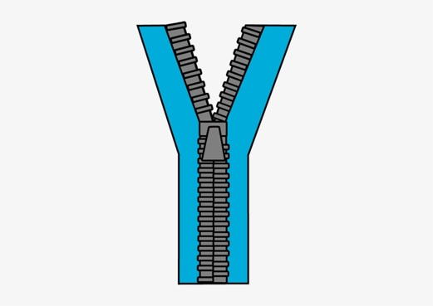

**Tip #8**

**Make a plan for after-school**. Make sure you and your child know the routine for after-school dismissal (car rider, golf cart, bike rider, After School Care, etc.). Your child’s teacher will also have this information and will review it with students, but the first few days of school are going to be full of fun and new information, so discussing your child’s specific afternoon dismissal routine will be helpful.

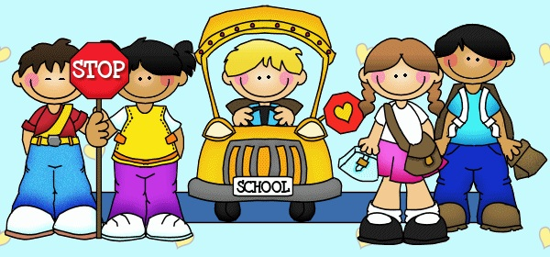

**Tip #9**

**Create a routine for checking school backpacks each day.** Each student will have a binder or folder that will travel to and from school daily. Behavior reports, school information, graded papers, artwork, or other important papers will be placed in these binders and folders. Students should develop a daily routine of emptying backpacks out and returning the binder or folder to school the next day.

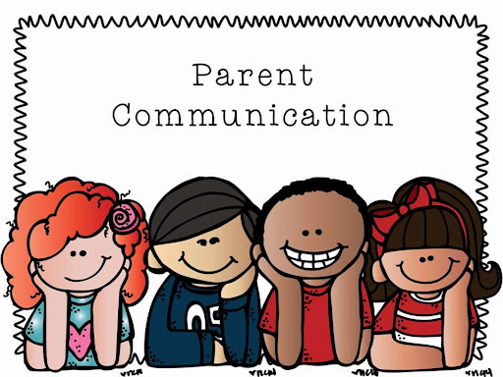

**Tip #10**

**Help build a foundation for reading.** Nursery rhymes help children hear the smaller sounds that make up words. This is important for learning to read. During your daily reading, try to include reading, singing or listening to nursery rhymes.

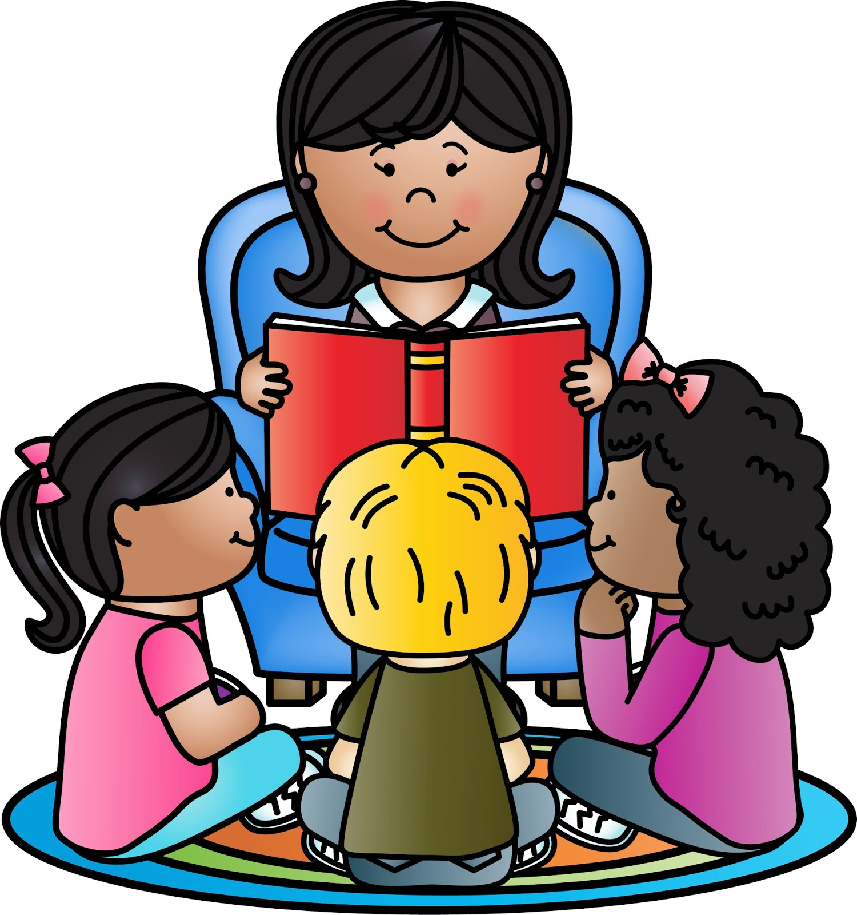

**Tip #11**

**Help to develop large motor skills.** Bouncing a ball develops finger muscles, eye-hand coordination, body control and visual tracking skills. Encourage your child to practice bouncing a ball with you.

**Tip #12**

**Learning to identify and express emotion in a healthy way** helps lay the foundation for future success and well-being. Talk about positive (and not-so-positive) ways of expressing emotions. Talk with your child about his/her feelings as the start of the school year nears. Remind them that at school, there will be many friendly adults there to help all students navigate through their emotions in a healthy way.

