Color Wheel Cookies
A yummy art activity
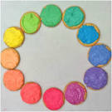

Goal: To introduce or reinforce students’ understanding of color mixing and color theory.
Objectives: children will produce an edible color wheel.

Materials you will need:
Vanilla wafers or baked sugar cookies
Pillsbury Vanilla Frosting
2 Packages of food coloring
Styrofoam bowls/plates/dixie cups
Napkins/paper towels
Plastic knives/craft sticks/spoons

For younger children mix primary colors to create secondary colors
For intermediate and above create secondary and tertiary colors
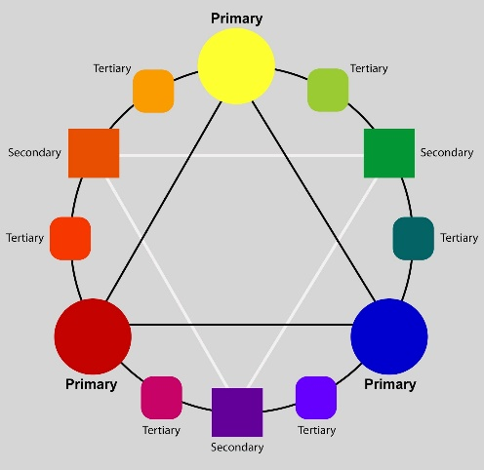
Procedure:

1. Scoop frosting into three bowls and use food coloring to dye one each red, yellow, and blue. Red will need the most drops!
2. Review color theory by asking them to name the three primary colors. Once they have correctly identified these, use the chart above to help identify colors
3. Using a spoon, scoop frosting of each color onto a Styrofoam plate or dixie cups
questions you might ask (i.e. "what are the secondary colors and how do you mix them?" etc. Adapt questions according to age group and prior exposure to color theory concepts.)
4. Use 6 vanilla wafers or sugar cookies. 13 cookies for older children creating tertiary colors. Place cookies on empty plate or paper towel.
5. MIX - Step One: Put food coloring in each one of the cups. .Stir then frost 3 cookies for your primary colors and place them on one of the plates.
Step 2: Now mix secondary’s. Have the kids mix them on the extra plate that they aren't using for the cookies to make the secondary color palette. Leave some extra yellow because they will need that more than any color.
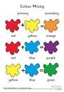

Step 3: Now the kiddos have got the hang of it, hopefully. You now will need to remind them how to make tertiary colors. Its basically a color with a little more of the primary it starts with. Example... Red orange. Orange with a lot more red in it.
Step 4: Now with whatever remaining frosting they have left they will mix together to form their "neutral" color. This is where you will hear a lot of ewws and it looks like like baby poop. Embrace it!
6. Once the color wheels are finished and have been checked for color accuracy and correct placement, students may eat their work! Enjoy!

Don’t forget you can email me pictures of your color wheels, messy hands and colorful faces!

