Artsonia Class Portal
PARENTS – Our school is offering a way for students to submit their artwork to their Artsonia portfolio from home.
Your child can use iPads or similar devices (or even a browser) to photograph their own artwork, make edits and enter artist statements - all on their own! The artwork will be reviewed by the art teacher prior to being published.
Download the Artsonia 6.0 app in the Apple or Android app store, select the "Students" option, then scan the Access Code below (or manually type in the code). You can also go to www.artsonia.com/class on a browser if you don't have a compatible device.
Access Code: HTPT-TBCX
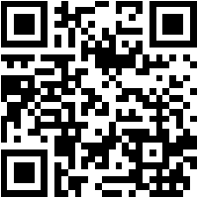
You can view a short tutorial video by going to www.artsonia.com/videos/classportal-students
If you have any questions, please contact Artsonia at 800-869-9974 or info@artsonia.com

