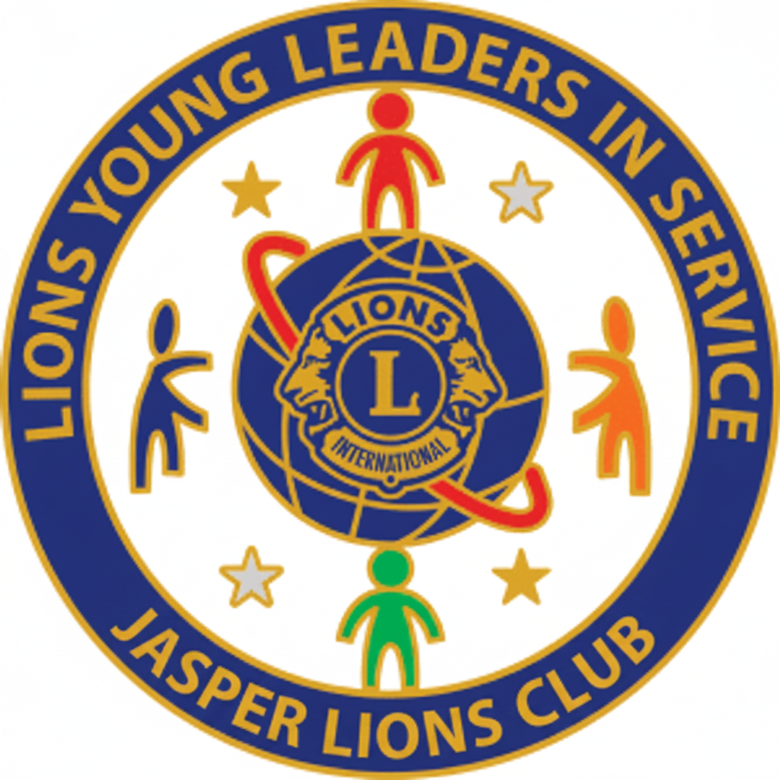

LIONS CLUBS INTERNATIONAL
Young Leaders in Service Awards
CHALLENGING YOUTH TO SERVE

YOUNG LEADERS IN SERVICE AWARDS DESCRIPTION:

Thank you for your interest in becoming one of our ‘Young Leaders in Service’. Young Leaders in Service are people (9th-12th grades) who love volunteering and helping others. You can be awarded either a Silver Award for completing 50 – 99 hours or a Gold Award for 100 hours or more. You can take part in different types of volunteering and all the hours you complete should be entered onto the volunteer hours log pages and signed to confirm that you took part. The categories are: Environment, Literacy and Education, Help children, Help family and friends, Public health, Disaster relief, Help elderly people, Safety, Community Improvement, Helping homeless or hungry people, or any other service activity of your choice.

Please complete the attached pages in which to record your time until December 18, 2026. It can be back dated until January 1, 2026 as long as it can be verified by an adult with a church or organization. *Please note: The max time that can be awarded per day is 8 hours even if you worked longer than that.

Jasper Lions Club will be recognizing two levels of service:
Community service of 50 – 99 hours-a congratulatory letter, certificate, & 50 hr. pin
Community service of 100 or more hours-a congratulatory letter, certificate, & 100 hr. Pin

Benefits for young people
Experience the rewards of community service
Become involved in their community and with local Lions clubs
Receive an international award
Great to list for scholarships and college application

In order to receive this award, you simply submit the cover page and all log sheets with proper signatures to the PHS Graduation Coach, Ms. Champion, in PHS Room 410. The Lions Club will physically pick up documentation August 31, September 30, October 31, & Nov. 30. If it is on a weekend, we will pick up the following Monday. We will not do pickups in December. You will need to scan and email those to safimid2019@gmail.com

COVER PAGE

*You will be notified via email that you have earned the international title of Young People in Service via email as soon as your log sheet is verified. You can start using this title as soon as you receive notification (not just when you submit the paperwork.) The ceremony will be held at a later date. Please write this information neatly, so that notification can be made easily.
You may type the information on the document, but all signatures must be done by hand.

Name____________________________________________________________
Contact details: We would like your contact details so we can invite you to an Award presentation on the successful completion of your voluntary service.

Address_____________________________________________________________

School: ______________________________Grade:__________________________

Tel:_________________________

Email: ._____________________________________ (not school email)

I confirm that the above information and time logs are accurate and that I wish to become a Lions Young Leader in Service.

Young Leader’s Signature___________________________________
Date __________________________________

Parent/Guardian’s signature ___________________________________ Date__________________________

Award Certification
Please complete the following information to receive a Lions Young Leaders in Service Award on completion of 50 or 100 hours service to your community. Make additional copies of this page as needed. The least amount of time to be recorded is 0.5 hours with the most be 8 hours per day (like for a mission trip).

Student name:
What you did | Date | Hours | Adult Signature  Contact Phone  Organization

Student Signature: ____________________________Hours on this page:________
TOTAL HOURS:____________

