
St. Marys Elementary School Parent and Family Engagement Plan for Shared Student Success

2026-2027 School Year
St. Marys Elementary School Mrs. Sykora Cobb, Principal 600 Osborne Street
(912)882-4839
www.smes.camden.k12.ga.us

Plan Revised September 17, 2026

What is Title I?
St. Marys Elementary School is identified as a Title I school as part of the Every Student Succeeds Act (ESSA). Title I is designed to support State and local school reform efforts tied to the challenging State academic standards to improve teaching and learning for students. Title I programs must be based on effective means of improving student achievement and include strategies to support family engagement. All Title I
schools must jointly develop with
parents and family members a written parent and family
engagement plan.

School Plan for Shared Student Achievement

What is it?
This is a plan that describes how St. Marys Elementary School will provide opportunities to improve family engagement to support student learning.
SMES values the contributions and involvement of parents and
family members to establish an equal partnership for the common goal of improving student achievement. This plan describes the different ways that SMES will support family engagement and how parents can help plan
and participate in activities and events to promote student learning at school and at home.

How is it revised?
St. Marys Elementary School invited all parents to attend our Stakeholder Input Meeting this fall to review and revise this parent and family engagement plan, as well as our school-parent compact, and the family engagement budget. Additionally, parent input and comments regarding this plan are welcome during the Parent and Family Engagement online survey window, which takes place in the spring. The plan is posted on our school website for parents to view and submit feedback throughout the year. All parent feedback received during the year will be used to revise the plan for the next school year. Parents and family members can also give feedback during several parent nights and activities during the school year.

Who is it for?
All students participating in the Title I, Part A program, and their families are encouraged and invited to participate in the opportunities described in this plan fully. St. Marys Elementary School will provide a full opportunity for the participation of parents and family members with limited English proficiency, disabilities, and migratory children.

Where is it available?
At the beginning of the year, the plan is included on the website. We will also share the plan through ClassDojo and Facebook. A paper copy can be found on site with Assistant Principal, Mr. Reginald Booker.

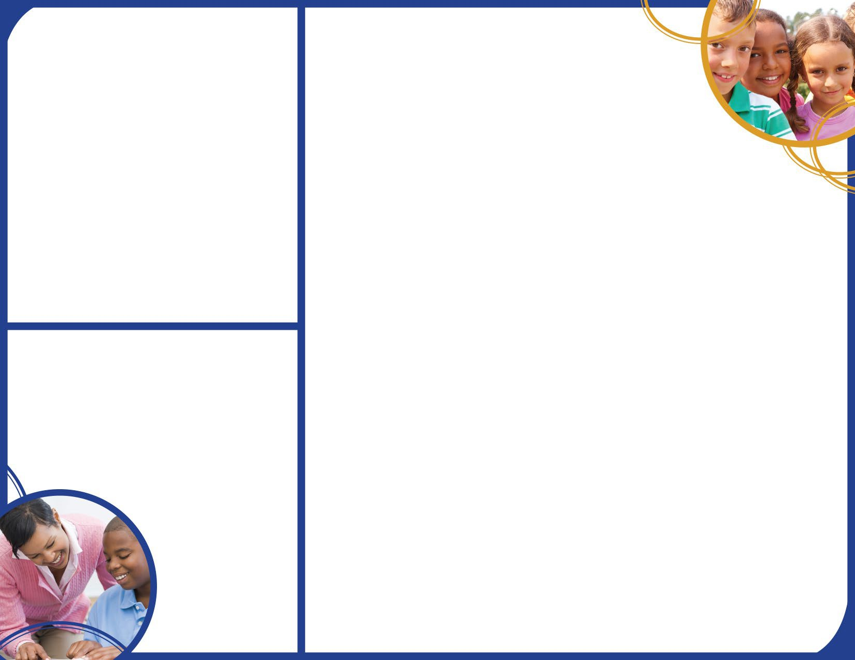
2026-2027 District Goals
Reading: If we increase the content master of essential knowledge and skills in reading, then, there will be an increase in Lexiles and students meeting state expectations.
Math: If we increase the content mastery of essential knowledge in math, then there will be an increase in students demonstrating growth and meeting state expectations in levels 2-4 for Math.

2026-2027 School Goals
Reading: If we ensure that students demonstrate academic growth in ELA, then, we will move students from beginning to developing learners to proficient and distinguished learners on the spring GMAS.
Math: If we ensure that students demonstrate academic growth in Math, then, will move students from beginning to developing learners to proficient and distinguished learners on the spring GMAS.

School-Parent Compacts
As part of this plan, St. Marys Elementary School and our families have developed a school-parent compact, which is an agreement that parents, teachers, and students have developed that explains how parents and teachers will work together to make sure all our students reach grade-level standards. The compacts will be reviewed and updated annually based on feedback from parents, students, and
teachers during the Stakeholder Input Meeting and the Parent
and Family Engagement online survey.

Let’s Get Together!
St. Marys Elementary School will host the following events to build the capacity for strong family engagement to support a partnership among the school, parents, and the community to improve student academic achievement. Some meetings will be held during the day and some meetings will be held in the evenings based on parent responses to the online survey.

Storybook Pumpkin begins on October 13, 2026
Annual Title I Meeting, October 22, 2026
Join us to learn more about Title I and how it supports SMES.

Pumpkin Palooza, Friday, October 23, 2026, 5 PM-7 PM PK-2 Grade Thanksgiving Lunch, November 19
Parents of students in Pre-K through 2nd grade are invited to join their children for a Thanksgiving meal, provided by our excellent cafeteria staff.

3rd-5th Grade Thanksgiving Lunch, November 20
Parents of 3rd- to 5th-grade students are invited to join their children for a Thanksgiving meal, provided by our excellent cafeteria staff.

PTO Sponsored Santa Visits SMES, December 11, 2026
A permission slip will be sent home for students who wish to have their picture taken with Santa.

PTO Sponsored Santa Shop, December 14-17, 2026
Students can shop for family and friends at the Santa Shop, which will be open during the school day.

Singing Sharks Concert and Art Show, December 15, 2026
Come out and see and hear the wonderful music and art our students have created.

Parent Night “Winter Wonderland”, January 28, 2027
A celebration of family engagement and the recognition of its impact on school and student success.

Spring Parent Night, March 4, 2027
Time to be determined

Title I Spring Input Meeting, Thursday, May 13, 2027, 4:00 PM

Please stay tuned for the Parent and Family Engagement Events for the 2027-2028 school year!

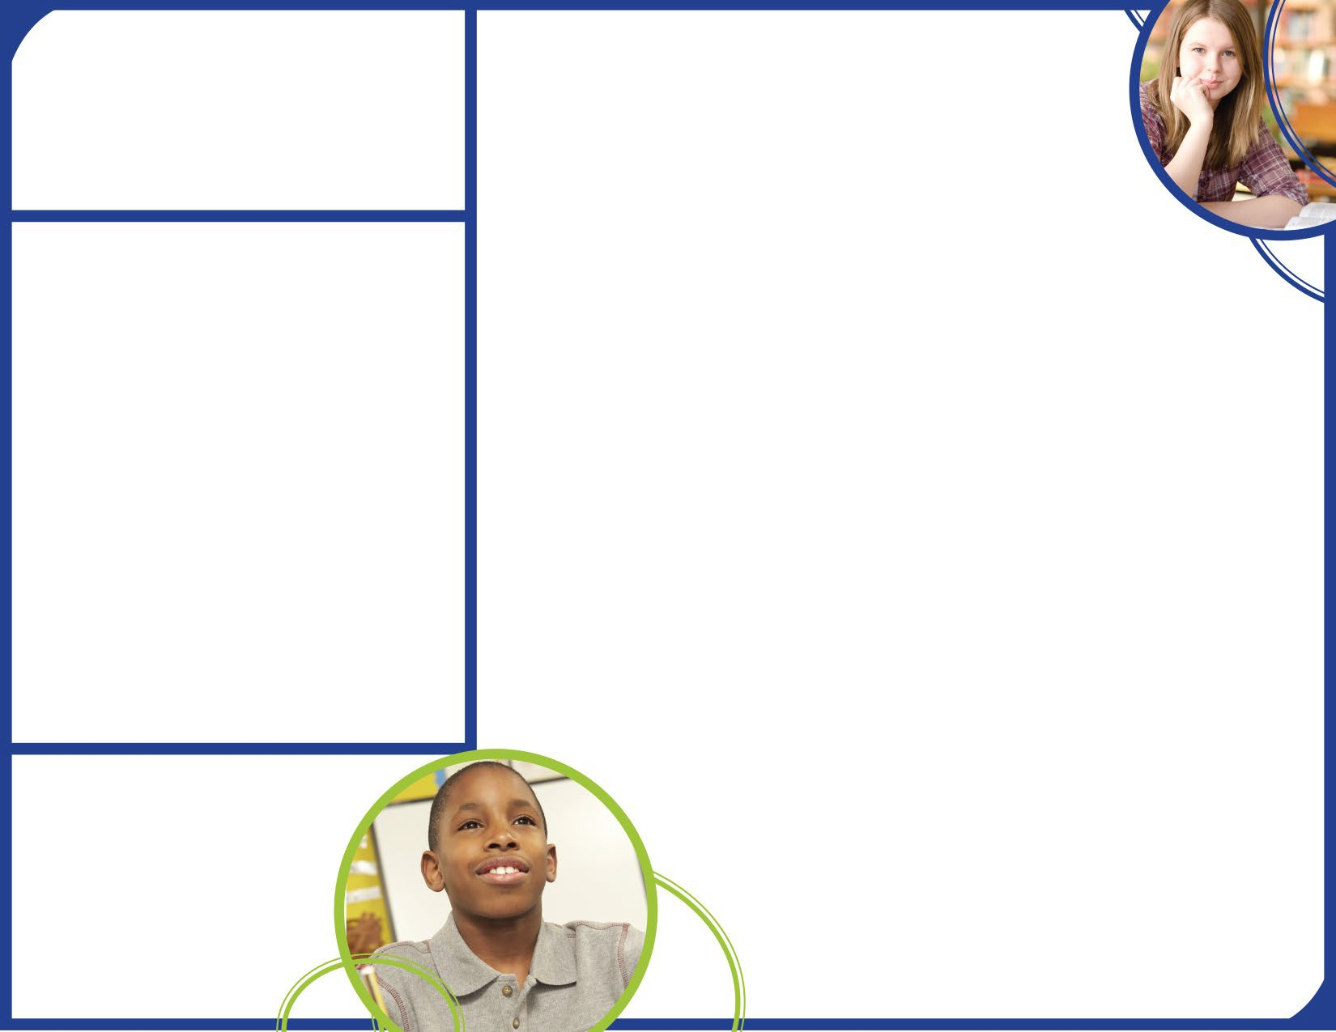
Parent Resource Center
Come visit the Parent Resource Center to check out books, study materials, and activities to use at home with your child. Please make an appointment with Assistant Principal, Reginald Booker, rbooker@camden.k12.ga.us for any of the times below
Monday – Friday, 8:30 am – 2:30 pm

Parent and Family Engagement
St. Marys Elementary school believes that family engagement means the participation of parents and family members in regular two-way, and meaningful communication involving student academic learning and other school activities, including ensuring:

- That parents play an integral role in assisting their child’s learning.

- That parents are encouraged to be actively involved in their child’s education at school.

- That parents are full partners in their child’s education and are included, as appropriate, in decision-making and on the school council
which is a parent advisory committee to assist in the education of their child.

St. Marys Elementary School is committed to helping our parents and families attend the family activities listed in this plan. Please call
or email us if you need assistance with childcare or transportation in order to participate in our events, activities, or programs.
Sykora Cobb (912) 882-4839 or
scobb@camden.k12.ga.us

St. Marys Elementary is Branching Out!
St. Marys Elementary will take the following measures to promote and support parents and family members as an important foundation of the school in order to strengthen the school and reach our school goals. We will:

  - All information related to school and parent programs are shared via ClassDojo which has an embedded translation function. Information is also shared on the school website and Facebook and translated as applicable.

  - Trainings are provided for staff during their planning periods on strategies to improve communication with parents and ideas to increase family engagement with reading and math activities for our students outside of the classroom. Staff also share best practices during Tuesday “Collaborative Data Team” meetings.

  - Information is shared in English and Spanish as applicable on the school website, teacher newsletters, and ClasDojo for parents to understand the school’s academic standards and assessments as well as the ways parents can monitor their child’s progress and work with educators.

  - Communication is shared with all families and the community on a regular basis regarding schoolwide events and activities, through ClassDojo, the school website, social media, and the Camden County Schools phone app.
  - We also work with our parents to develop relevant trainings and helpful presentations to educate our staff on the importance of parent and family engagement and how to support student learning by inviting to parent events and soliciting feedback through surveys.

  - We provide necessary materials and handouts for parents at conferences, meetings, and activities to help parents work with their child to improve their child’s achievement.

    - Collect feedback from parents and family members at all events, place input cards around the building and post a suggestion form on the school website in order to respond to parents’ requests for additional support for parent and family engagement activities.

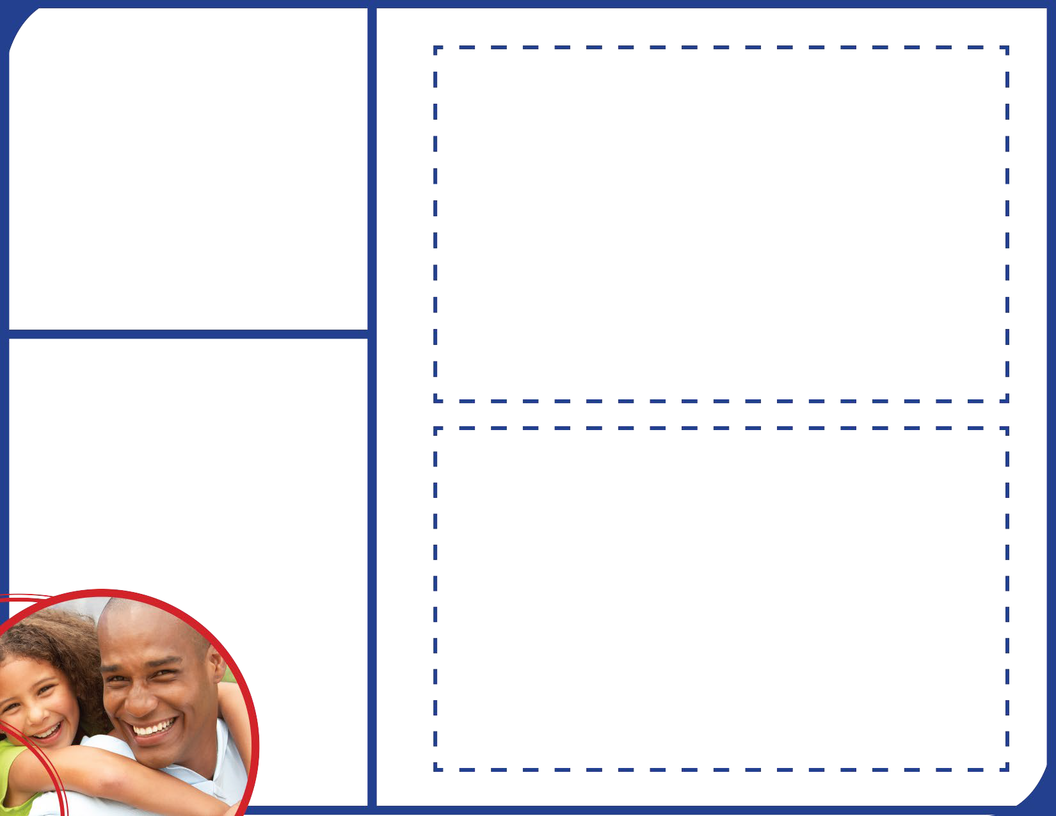
Parent and Family Engagement Standards
St. Marys Elementary School and our parents have adopted the National PTA Standards for Family-School Partnerships as the school’s model in engaging parents, students, and the community.
These standards are:
- Welcoming All Families
- Communicating Effectively
- Supporting Student Success
- Speaking Up for Every Child
- Sharing Power
- Collaborating with Community

PTO
St. Marys Elementary School invites all parents to join the SMES PTO to share ideas and ways to involve other parents and family members to build partnerships with school, families, and the community. If you would like to learn more about the PTO, please contact the principal, Mrs. Sykora Cobb at (912) 882-4839.

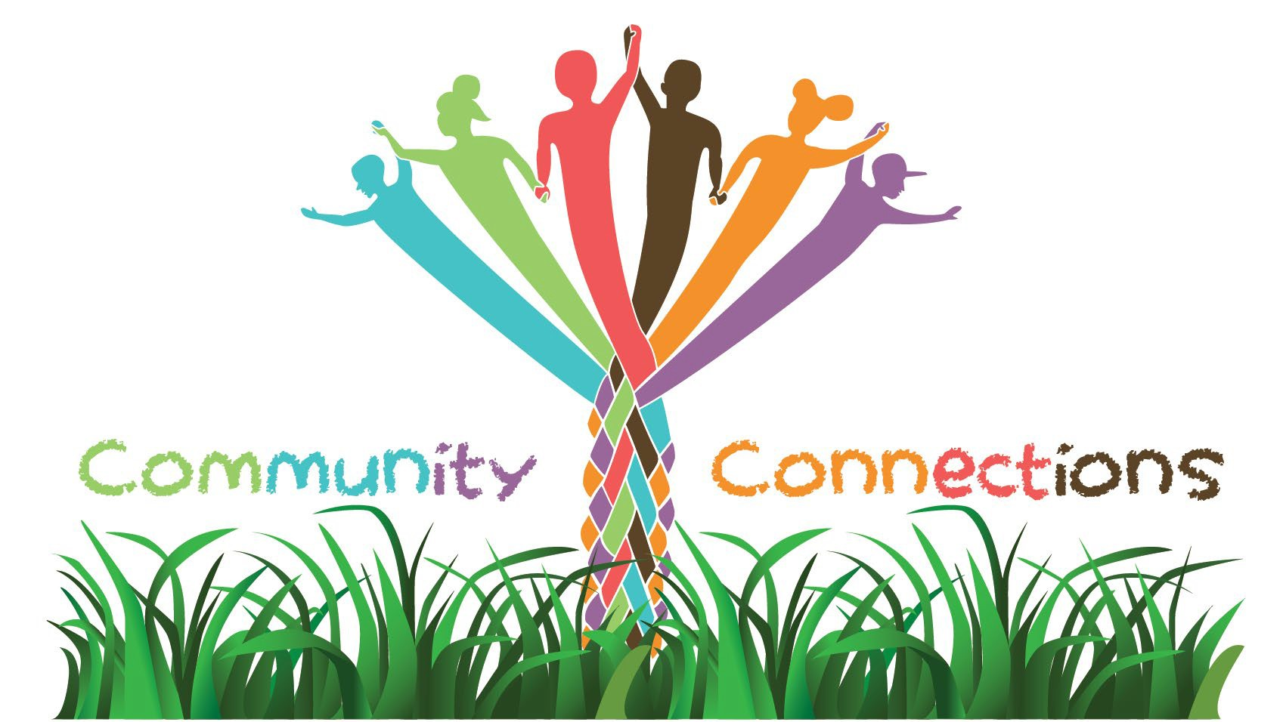


We always want to hear how we are doing! Please feel free to send your comments, questions, and concerns to Mrs. Cobb @ scobb@camden.k12.ga.us.

