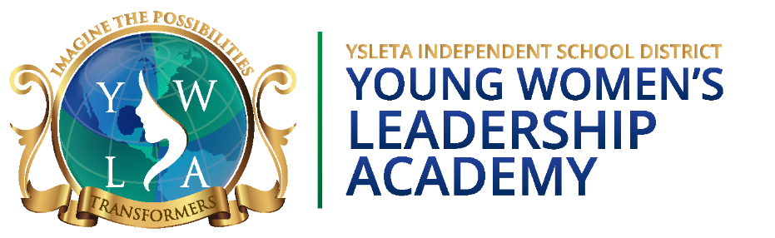

Student Application
2027-2028
STUDENT INFORMATION

Name of Student: ____________________________________________________
Last First Middle

Student ID: ________________ Date of Birth: Month______ Day _______Year________

Current School: _______________________________________ Current Grade: _____________

Next Year’s Assigned School (2027-2028): ___________________ District: _________
Do Not List Ysleta Young Women’s Leadership Academy

Name of Parent/Guardian: _____________________________________________ Last First

Address: ___________________________________________________________
Street Number Street Apt. City State Zip

Home Phone: _____________________________Cell Phone: ________________________________

Parent/Guardian E-Mail: _______________________________________________________________

Please Check Applicable Educational Experience/Level:

Mother /Father/ Guardian
Completed Bachelor’s Degree _____ _____ _____
Completed Master’s Degree _____ _____ _____
Completed Doctorate’s Degree _____ _____ _____

______________________________ _________________
Parent / Guardian Signature: Date:

Student Name: ___________________________________________________

APPLICATION CHECKLIST
Use this Application Checklist to organize and arrange your application in this order:

- ______ Attend ONE Mandatory Parent Meeting
Meeting Dates:

November 17, 2026
*Deadline to apply is Tuesday, December 1, 2026
November 18, 2026
*Deadline to apply is Wednesday, December 2, 2026
November 19, 2026
*Deadline to apply is Thursday, December 3, 2026
November 20, 2026
*Deadline to apply is Friday, December 4, 2026

*Showcase and Tour at 5:30 PM, Parent Meeting at 6:00 PM

- ______ Student Information (Form Provided – Page 1)

- ______ Application Checklist (Form Provided – Page 2)

- ______ 1st 9-Weeks Attendance Record

- ______ 1st 9-Weeks Discipline Record

- ______ 1st 9-Weeks Report Card

- ______ 2026 State Assessment Data (ex. STAAR)

- ______ Handwritten Letter of Interest – by Student

- ______ Counselor Input Form (must be in a sealed envelope)

- ______ Two Teacher Recommendation Letters (Format Included)
(must be in a sealed envelope)

Parents Keep This Page

IMPORTANT DATES:

- Deadline to submit a complete application is 2 weeks after attending a mandatory parent meeting.

- Letter of Acceptance sent via email approximately one week after receipt of student application.

- Deadline for applicant to accept is one week after acceptance email. Please contact
Ms. Silva to accept your daughter’s enrollment to YWLA:
Tammy Silva, YWLA Registrar
915-434-1313
tsilva3@yisd.net

- Upon acceptance, New Student Registration / Course Selection / Uniform
Order (only attend one):
To Be Determined.

- New Student Summer Orientation and Camp (REQUIRED):

To Be Determined.
New Student Summer Camp will include breakfast and lunch.
Bus Transportation will be provided.

- First Day of School: To Be Determined.

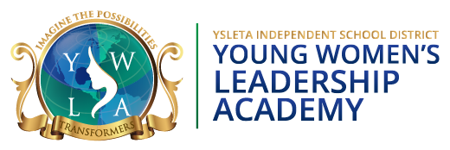

2027-2028 Counselor Input Form
Counselor:
The student named on this form is applying for admission to the Young Women’s Leadership Academy. Please provide information pertaining to this student. Once completed, place in an envelope, sign the envelope’s seal and return to the student so that she may include the form with her application materials.

Student Name (Last): | (First): | Grade: | Student ID:

Check off all of the programs listed below that apply to this student. List additional information on the lines provided.
_____ At Risk _____ EB
_____ Bilingual/Dual Language _____ Socioeconomically Disadvantaged
_____ Dyslexia _____ Special Ed (if yes, list services received and include the accommodations page)
_____ Gifted and Talented _____ Section 504 (if yes, list services received and include the accommodations page)

Additional Information/Services Received:

Counselor’s Name: _________________________________________ Phone/Extension: _______________________
Signature: _______________________________________ Campus: _____________________ Date: ______________

2027-2028 Teacher Recommendation Form
The student named below is applying for admission to the Young Women’s Leadership Academy. As a current teacher of this student your evaluation, will be extremely helpful in identifying which students will benefit from and succeed in this program. Please complete the recommendation form by placing a check in the appropriate column next to each attribute. Seal the recommendation from in a sealable envelope, sign the envelope’s seal, and return the envelope to the student so she can include the form in her application materials.

Student Name: (Last): | (First):
Teacher Name: | School/District:
Teacher Email: | Grade/Subject:
Please review the following characteristics and rate your student accordingly.

Characteristics | Below Average | Average | Above Average | Exceptional
Has good school attendance
Completes daily and homework assignments
Works well with others
Works well individually
Practices good behavior
Enjoys learning
Is inquisitive
Is self-disciplined
Has a strong work ethic
Exhibits leadership skills
Has emotional maturity
Has good oral and written
communication skills
Has advanced academic
potential

Teacher feedback is extremely important in assuring that recommended students have the qualifications, capabilities, and motivation to succeed at YWLA. To that end, please provide as much detail as possible for the following questions.
Does this student have special considerations that we should be aware of? Explain.

Please describe this student's normal demeanor personality during social or down time:

Please tell us why you think this student would be a good candidate for our program.

Thank you for your recommendation. Please seal this form in an envelope, sign the envelope's seal, and return the envelope to the student so she can include the form in her application materials.

2027-2028 Teacher Recommendation Form
The student named below is applying for admission to the Young Women’s Leadership Academy. As a current teacher of this student your evaluation, will be extremely helpful in identifying which students will benefit from and succeed in this program. Please complete the recommendation form by placing a check in the appropriate column next to each attribute. Seal the recommendation from in a sealable envelope, sign the envelope’s seal, and return the envelope to the student so she can include the form in her application materials.

Student Name: (Last): | (First):
Teacher Name: | School/District:
Teacher Email: | Grade/Subject:
Please review the following characteristics and rate your student accordingly.

Characteristics | Below Average | Average | Above Average | Exceptional
Has good school attendance
Completes daily and homework assignments
Works well with others
Works well individually
Practices good behavior
Enjoys learning
Is inquisitive
Is self-disciplined
Has a strong work ethic
Exhibits leadership skills
Has emotional maturity
Has good oral and written
communication skills
Has advanced academic
potential

Teacher feedback is extremely important in assuring that recommended students have the qualifications, capabilities, and motivation to succeed at YWLA. To that end, please provide as much detail as possible for the following questions.
Does this student have special considerations that we should be aware of? Explain.

Please describe this student's normal demeanor personality during social or down time:

Please tell us why you think this student would be a good candidate for our program.

Thank you for your recommendation. Please seal this form in an envelope, sign the envelope's seal, and return the envelope to the student so she can include the form in her application materials.

Young Women’s Leadership Academy
Frequently Asked Questions
2027-2028
Recruitment & Application Process

- Where is the school located?
We are located at 8040 Yermoland, 79907. If you search for our school on Google or Google Maps, you may be directed to our previous location. We are located on Yermoland, not on Yuma.

- Are you a public or private school? Charter or magnet?
We are a public school within the Ysleta Independent School District. We are not a charter school or a magnet program. We do belong to the Young Women’s Preparatory Network (YWPN) which is a non-profit organization based in Dallas, Texas. The YWPN provides additional funding to fulfill our mission of 100% college acceptance to a 4-year university, and to provide a private-like education to girls with our 7-year program. Funding outcomes include yearly college-road trips beginning their 9th grade year.

- Does YISD provide transportation for students at YWLA?

Yes. We have bus routes throughout the Ysleta Independent School District (as far East and Northeast as the district boundaries allow). Although our buses make stops at YISD campuses, they are for YWLA students only. Some of our families use the transportation available similar to city bus routes if they live far away from the YISD boundaries.

- Do you require uniforms?
Yes. Once you have applied, been accepted and registered, we will provide detailed information for vendors and uniform expectations. We require Leadership Dress on Mondays, which is the skirt and private school style uniform. Tuesdays - Friday our dress code is referred to as Casual Dress and includes Docker-style pants/shorts, tennis shoes, and polo shirts.
- At what time does school start and end?
School starts at 7:45 AM (first bell rings at 7:38 AM) and school ends at 3:30 PM.

- What are key dates for the application process for the 2027-2028 school year?
Meeting Dates:
November 17, 2026 Showcase and Tour at 5:30 PM, Parent Meeting at 6:00 PM
*Deadline to apply is Tuesday, December 1 , 2026
November 18, 2026 Showcase and Tour at 5:30 PM, Parent Meeting at 6:00 PM
*Deadline to apply is Wednesday, December 2, 2026
November 19, 2026 Showcase and Tour at 5:30 PM, Parent Meeting at 6:00 PM
*Deadline to apply is Thursday, December 3, 2026
November 20, 2026 Showcase and Tour at 5:30 PM, Parent Meeting at 6:00 PM
*Deadline to apply is Friday, December 4, 2026

Other key dates are the following:
Letter of Acceptance sent via email approximately one week after receipt of student application.
Deadline for applicant to accept is one week after acceptance email.
Please call our office to accept your enrollment at YWLA and speak with:
Tammy Silva, YWLA Registrar at 915-434-1313, email is tsilva3@yisd.net

Upon Acceptance, new student Registration/Course Selection/Uniform Order (only attend one)
To Be Determined
New Student Summer Orientation and Camp (REQUIRED)
To Be Determined
New student summer camp will include breakfast and lunch.
Bus transportation will be provided.

First Day of School: To Be Determined

- How much does it cost to attend Young Women’s Leadership Academy?
There is no tuition as we are a FREE public school.
- Location
The Young Women’s Leadership Academy (YWLA) is located at 8040 Yermoland Dr.
- How do I apply to YWLA?
You can pick up a paper application at our front office at 8040 Yermoland Dr., or you can apply online at this site: https://www.yisd.net/ywla (click on Become a Transformer)

Scan Code for Application:
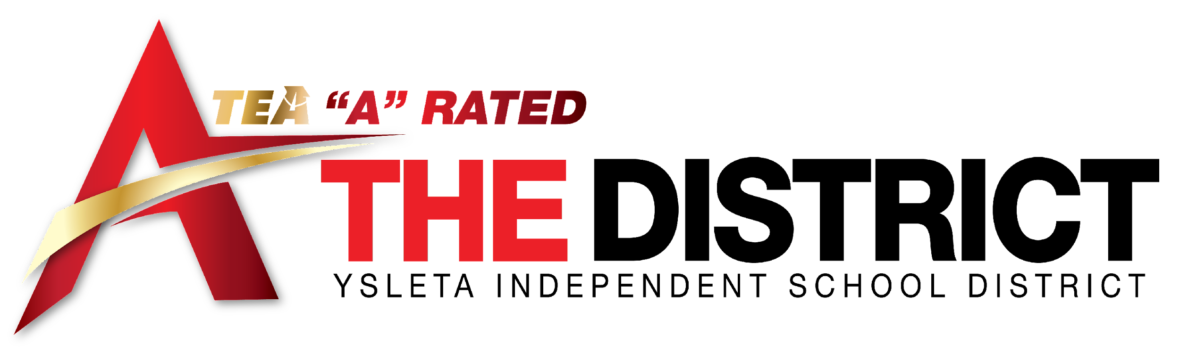

Academia de Liderazgo para Mujeres Jóvenes
Preguntas frecuentes
2027-2028
Proceso de reclutamiento y solicitud

- ¿Dónde está ubicada la escuela?

Estamos ubicados en 8040 Yermoland, 79907. Si busca nuestra escuela en Google o Google Maps, es posible que se le guíe a nuestra ubicación anterior. Estamos ubicados en Yermoland, no en Yuma.

- ¿Es una escuela pública o privada? ¿Chárter o Magnet?

Somos una escuela pública dentro del Distrito Escolar Independiente de Ysleta. No somos una escuela chárter o un programa magnet. Pertenecemos a la Red Preparatoria de Mujeres Jóvenes (YWPN), que es una organización sin fines de lucro con sede en Dallas, Texas. La YWPN proporciona fondos adicionales para cumplir con nuestra misión de tener 100% aceptación en una universidad de 4 años, y para proporcionar una educación privada a las niñas en nuestro programa de 7 años. Los resultados de financiamiento incluyen viajes anuales por carretera a universidades que comenzarán en el 9º grado.

- ¿YISD proporciona transporte para los estudiantes a YWLA?

Sí. Tenemos rutas de autobús en todo el Distrito Escolar Independiente de Ysleta (tan al Este y Noreste como lo permitan los límites del distrito). Aunque nuestros autobuses hacen paradas en las escuelas de YISD, son solo para estudiantes de YWLA. Algunas de nuestras familias utilizan el transporte disponible de manera similar a las rutas de autobuses urbanos si viven lejos de los límites de YISD.

- ¿Se requiere uniformes?

Sí. Una vez que haya solicitado, aceptado y registrado a su hija, le proporcionaremos información detallada de los proveedores y las expectativas de los uniformes. Requerimos vestimenta de liderazgo los lunes, que es la falda y el uniforme de estilo de escuela privada. De martes a viernes, nuestro código de vestimenta se conoce como vestimenta casual e incluye pantalones/shorts estilo Docker, tenis y polos.

- ¿A qué hora comienza y termina la escuela?

La escuela comienza a las 7:45 AM (la primera campana suena a las 7:38 AM) y la escuela termina a las 3:30 PM.

- ¿Cuáles son las fechas clave para el proceso de solicitud para el año escolar 2026-2027?

La sesión de información para padres es obligatoria y se realiza en las siguientes fechas:
17 de noviembre de 2026, presentación a las 5:30 PM, Reunion de padres a las 6:00 PM
La fecha límite para aplicar es martes 1 de diciembre de 2026
18 de noviembre de 2026, presentación a las 5:30 PM, Reunion de padres a las 6:00 PM
La fecha límite para aplicar es miércoles 2 de diciembre de 2026
19 de noviembre de 2026, presentación a las 5:30 PM, Reunion de padres a las 6:00 PM
La fecha límite para aplicar es jueves 3 de diciembre de 2026
20 de noviembre de 2026, presentación a las 5:30 PM, Reunion de padres a las 6:00 PM
La fecha límite para aplicar es viernes 4 de diciembre de 2026

Otras fechas clave son las siguientes:
Carta de aceptación enviada por correo electrónico una semana después de recibir la solicitud del estudiante.
La fecha límite para que el solicitante acepte es una semana después del correo electrónico de aceptación. Por favor llame a nuestra oficina para aceptar su inscripción en YWLA y hable con: Tammy Silva, Registradora de YWLA al 915-434-1313, el correo electrónico es tsilva3@yisd.net
Tras la aceptación, registro de nuevos estudiantes /selección de cursos /orden de uniforme (solo asista a uno)
Fechas serán determinadas

Orientación y campamento de verano para nuevos estudiantes (REQUERIDO)
Fecha será determinada
El campamento de verano para nuevos estudiantes incluira desayuno y almuerzo.
Se proporcionara transporte en autobús.

El primer día de clases: Fecha será determinada

- ¿Cuánto cuesta asistir a la Academia de Liderazgo de Mujeres Jóvenes?
No hay matrícula ya que somos una escuela pública GRATUITA.
- Ubicación
La Academia de Liderazgo de Mujeres Jóvenes (YWLA) está ubicada en 8040 Yermoland Dr.

- ¿Cómo aplico a YWLA?
Puede recoger una solicitud en papel en nuestra oficina principal en 8040 Yermoland Dr, o puede solicitarla en línea en este sitio: https://www.yisd.net/ywla (hacer clic en Become a Transformer)

Código de escaneo para la aplicación:

