SEND SOMEONE A HALLOWEEN TREAT OR TREAT YOURSELF!
Huntley Project Business Professionals is taking orders for caramel apples. These Fresh Gourmet Caramel Apples are made fresh by Candy Town USA in Billings.
The cost is $6.00 each or 3 for $17.00. Return all orders & money to one of the HP School Offices by Oct 23rd. Delivery is on Thursday, Oct 29th. Make checks payable to: HP BPA
HAPPY HALLOWEEN HP BPA
TO: Name ________________________________
Teacher:________________________ Classroom #______
Please select one of the following delivery locations K-6 7-12 Office/Admin
MESSAGE:
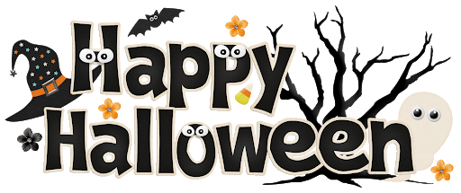FROM:____________________
HAPPY HALLOWEEN HP BPA
TO: Name ________________________________
Teacher:________________________ Classroom #______
Please select one of the following delivery locations K-6 7-12 Office/Admin
MESSAGE:
FROM:____________________
HAPPY HALLOWEEN HP BPA
TO: Name ________________________________
Teacher:________________________ Classroom #______
Please select one of the following delivery locations K-6 7-12 Office/Admin
MESSAGE:
FROM:____________________
HAPPY HALLOWEEN HP BPA
TO: Name ________________________________
Teacher:________________________ Classroom #______
Please select one of the following delivery locations K-6 7-12 Office/Admin
MESSAGE:
FROM:____________________
HAPPY HALLOWEEN HP BPA
TO: Name ________________________________
Teacher:________________________ Classroom #______
Please select one of the following delivery locations K-6 7-12 Office/Admin
MESSAGE:
FROM:____________________
HAPPY HALLOWEEN HP BPA
TO: Name ________________________________
Teacher:________________________ Classroom #______
Please select one of the following delivery locations K-6 7-12 Office/Admin
MESSAGE:
FROM:____________________

