Crawford County Schools
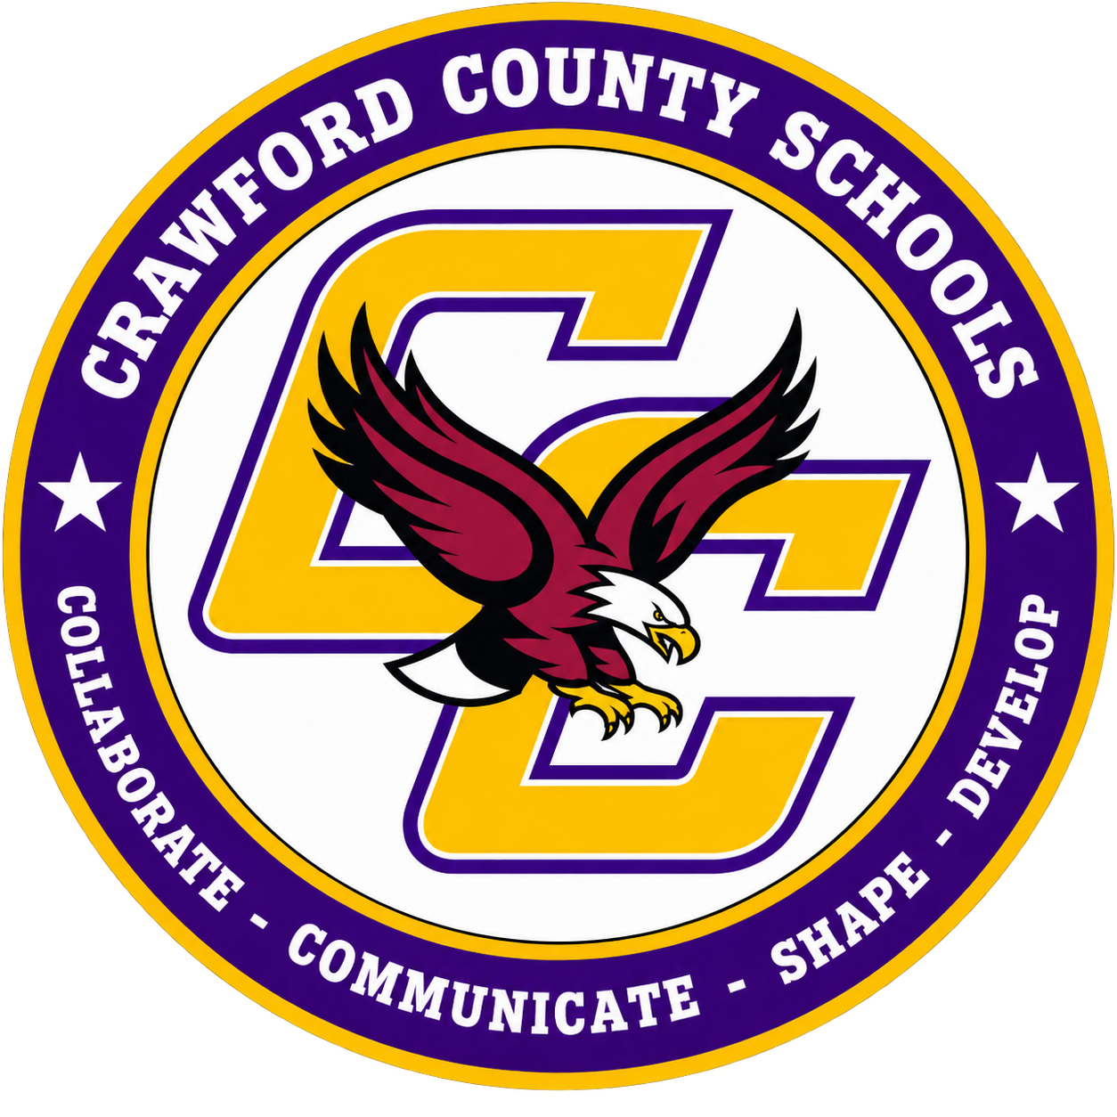
Crawford County Board of Education
190 East Crusselle Street
P.O. Box 8
Roberta, GA 31078
478-836-3131 (Fax) 478-836-3114

Mr. Anthony Aikens, Superintendent
Anthony.aikens@crawfordschools.org
Crawford County Schools Receives GSBA Safety Grant
A Message from the Superintendent
Dear Crawford County Schools Community,
I am proud to share that Crawford County Schools has been selected to receive a $2,662 Safety Grant from the Georgia School Boards Association (GSBA) Risk Management Services (RMS). The grant will provide slip-resistant footwear for our School Nutrition staff and flatbed carts for our custodial staff, two practical investments that will help protect the dedicated employees who serve our students and care for our schools every day.
A Competitive Statewide Award
GSBA announced the 2026–2027 Safety Grant recipients at its Risk Management Services Annual Meeting in Athens on October 13. This year, a record 70 school systems applied, the most since the program began. Only 19 districts were selected to share a total of $75,206, and Crawford County is proud to be among them.
The Safety Grant program helps RMS member school systems address identified safety needs, from protective equipment and facility improvements to specialized training. Applications were anonymized and reviewed by a committee of GSBA staff to ensure a fair, objective selection. As GSBA Executive Director Valarie Wilson noted, safe schools depend on "thoughtful planning, proactive leadership and a commitment to prevention." That is exactly the approach we strive to take in Crawford County.
Keeping Our School Nutrition Team Safe
Our School Nutrition staff work in one of the most physically demanding environments in our schools. Kitchen floors are often wet or greasy from dishwashing, cooking, mopping and spills, which makes slips and falls among the most common workplace injuries in school kitchens.
Slip-resistant footwear will help our staff:
- Keep their footing on wet, greasy or freshly mopped floors, reducing the risk of slips and falls
- Work more safely while carrying hot food, pans and trays, when a fall could also cause burns or cuts
- Stay protected throughout long shifts with supportive, closed-toe shoes designed for food service
- Provide better traction in walk-in freezers and coolers, where frost, ice and condensation can make floors especially slick
- Move with confidence during the busy rush of breakfast and lunch service
Supporting Our Custodial Team
Our custodial staff move heavy supplies, equipment and furniture across our campuses every day, from unloading deliveries to setting up classrooms and events. Lifting and carrying these loads by hand puts them at risk of back, shoulder and other strain injuries.
Flatbed carts will help our staff:
- Move heavy cases of supplies, paper products, cleaning chemicals, furniture and equipment across campus without carrying them by hand
- Reduce back, shoulder and strain injuries caused by repeated lifting and carrying
- Avoid carrying stacked boxes that block their view, which can lead to trips and collisions
- Transport more in a single trip, saving time and reducing fatigue
Together, these items lower the risk of injury, help reduce lost workdays, and allow our School Nutrition and custodial teams to focus on what they do best: serving healthy meals to our students and keeping our schools clean, safe and welcoming.
Thank You
I want to thank GSBA Risk Management Services for its continued partnership and investment in Georgia's public schools. I also want to thank our School Nutrition and custodial leaders and staff for identifying these needs and for their work on the application. Their attention to safety reflects our district-wide commitment to protecting every student and employee.
We are grateful for this support and will keep looking for ways to make Crawford County Schools a safe place to learn and work.
Sincerely,

Anthony Aikens
Superintendent, Crawford County Schools

