Oriole Beach Elementary’s Collection Development Plan
2025-2026
Mission Statement: Our mission is to create an environment that promotes literacy to encourage and empower students, faculty, and families at Oriole Beach Elementary School.

Population Demographics:
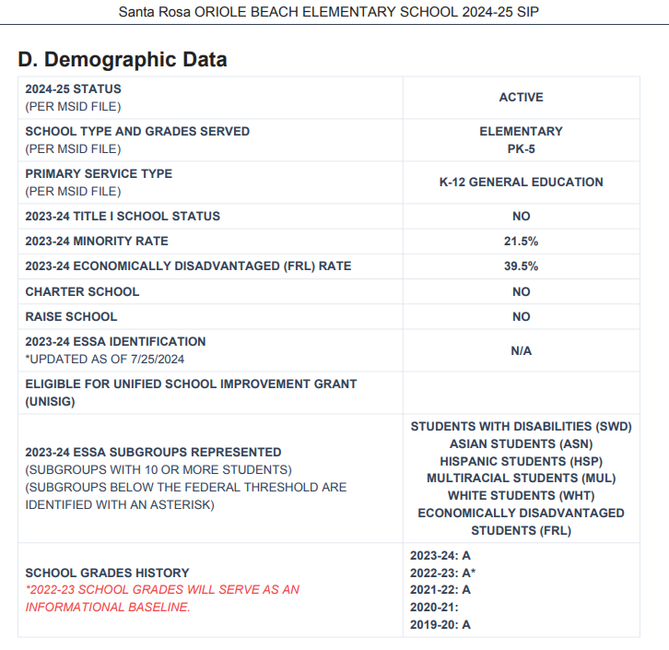
Library Offerings and Responsibilities:
- Accelerated Reader
- Accelerated Reader celebrations
- Accelerated Reader Millionaire recognition
- Battle of the Books
- Beanstack
- Book Fair
- Collection Development
- Class instruction
- Collaboration with teachers across the disciplines
- Fundraising
- ITV
- Literacy Week
- Local news communication
- Materials management
- Social Media
- SSYRA program and celebrations
- Volunteer management/engagement

School Improvement Goal and Focus: This years SIP goals include 1) supporting students with disabilities, 2) engagement with stakeholders, and 3)improvement in 5th grade science.

Collection Development Plan: Our priorities are based on collection analysis, population, and school curriculum. In Santa Rosa County, the selection of materials is done in accordance with Board adopted guideline Policy 4.22 as well as the Florida State Statues. Evaluative criteria for the selection/removal of materials include the needs of Oriole Beach Elementary School based on knowledge of curriculum, ability level and interest level of patrons, popular demand, suitability of materials, budget, and the existing library holdings.

Collection Development Focus:
- Weeding
- Selecting materials that are engaging, relevant, accurate, and diverse
- Purchasing relevant fiction, nonfiction, and graphic novels appropriate for the various reading levels to meet the informational and interest needs of all students
- Communicating with teachers and students for recommendations and needs

2025-2026 Book Purchases (budget: ~$9,000)
- Sunshine State Novels
- Branches/Acorn series
- Latest fiction
- Nonfiction updates
Collection 5-Year Schedule:
2025-2026
- SSYRA and SSYRA Jr. selections
- Current fiction and nonfiction
- Teacher and student requests
- Refresh Easy Nonfiction
2026-2027
- SSYRA and SSYRA Jr. selections
- Current fiction and nonfiction
- Teacher and student requests
- Refresh Biography and advanced nonfiction
2027-2028
- SSYRA and SSYRA Jr. selections
- Current fiction and nonfiction
- Teacher and student requests
- Refresh Easy Reader “basket books”
2028-2029
- SSYRA and SSYRA Jr. selections
- Current fiction with focus on series; newest items in popular series
- Graphic Novels refresh
- Teacher and student requests
2029-2030
- SSYRA and SSYRA Jr. selections
- Fiction chapter books with focus on genre
- Current Easy Fiction and nonfiction
- Teacher and student requests

Weeding Priorities: Five Year Plan
Year one: easy nonfiction, professional library
Year two: chapter book fiction
Year three: biography, advanced nonfiction
Year four: easy fiction, “basket books”
Year five: graphic novels

Library Media Committee: OBE has a Library Media Committee. It consists of administration, school librarian, academic interventionist, grade level representatives, ESE representatives, paraprofessionals, and student family members. This committee meets at least 4 times a year to discuss OBE literacy, data, and to have open discussion about books being ordered to add to the school library collection.

Challenged Books Plan: Although materials are carefully selected, there can arise oversights and/or differences of opinion regarding suitable materials. Patrons with objections to instructional or media materials must follow the guidelines in School Board Policy 4.22.

Gifts and Donated Books: The library accepts gifts of books and other materials with the understanding that they will be added to the collection only if they align with our collection development plan. If they are not needed because of duplication, condition, or dated information, the school librarian can dispose of them as she sees fit. Titles will be brought to the Library Media Committee for discussion. The same criteria of selection which are applied to purchased materials are applied to gifts.

Weeding Library Media Materials: At Oriole Beach Elementary School, the “CREW” (Continuous Review, Evaluation and Weeding) and “MUSTIE” (Misleading, Ugly, Superseded, Trivial, Irrelevant, or obtained Elsewhere) methods are used to determine what should be withdrawn from the collection: The criteria considered when weeding the collection include age, circulation, physical condition, curriculum, bias, and obsolete formats.
*Adapted from Ormond Beach Middle School Collection Development Plan

