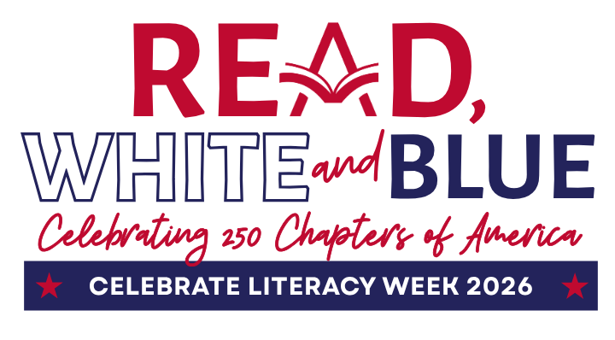
Celebrate Literacy Week, Florida!

January 26-30, 2026
Anderson Elementary
Monday,  January 26th | Mark Your Chapter  Decorate a USA bookmark to use while reading. (Bookmarks will be distributed to homeroom teachers)
Tuesday,  January 27th | We’re Better Together  Read with a buddy! Students can read a physical book or eBook with a partner. Books about America will be displayed in the Media Center for checkout.
Wednesday,  January 28th | Reading Across the States  Read a book about a US state! Books on all US states will be displayed in the Media Center, or you can find state books on myOn!
Thursday,  January 29th | Explore America  Wear something that represents a favorite place in America (state shirt, landmark shirt, beach T-shirt, space/NASA, Disney/other theme park shirt, etc.)  Find a book about that location to read!
Friday,  January 30th | Red, White, and Blue Finale  Wear red, white, and blue clothing for Freestyle Friday!  Share what you’ve learned about America with your classmates.

