Cambridge AICE Exam Results FAQs
Riverview 2026
- What does my score mean?
US Grades | AP Scores | Cambridge Grading Scale | Cambridge Qualitative
A | 5 | a | Excellent
B+ | 4 | b | Good
B |  | c | Good
C+ | 3 | d | Satisfactory
C |  | e | Satisfactory
D | 2 | U (ungraded) | Weak
F | 1 | U (ungraded) | Unsatisfactory

Passing grades for AS level courses are “e” or higher. All passing scores count towards the AICE diploma AND grant college credit. These are equivalent to a typical US letter grade of “C” or higher -OR- on the AP scale, a 3 or higher.

There is no letter grade to designate a failure (“F” equivalent). If a student does NOT pass the exam, their score will be labeled as UNGRADED.

- What do these other scores mean?
- X or “No Result” means one of the following:
  - The student was absent or withdrawn from one or more components of the exam
  - The student was found to have committed malpractice
- “PENDING” or Q: means a result cannot be issued yet. Something is delaying the results such as a dispatch issue or an ongoing malpractice investigation

- Is it necessary to take a retake for all failed exams?
In a normal scenario, no, it is not necessary. Ultimately, the student has benefited from the internationally rich curriculum and the weighted GPA points, so re-taking an exam is not always necessary or helpful.
There are two main reasons students sign up for retake exams:
- They are working on the AICE diploma and are working to acquire 7 passed exam points in the required categories.
- They are interested in earning college credit for the course and feel strongly they would be successful at a second attempt.

- Does my student need to re-take the class?
No, the Cambridge exam is separate from grade earned in the course each semester.

Exam Retake Information

On August 11th, Cambridge released the exam results for the June 2026 series exams.
Candidates are eligible to re-take an exam in which they received an “UNGRADED” score. If your student received a score of a “U,” (UNGRADED), he/she is eligible to purchase a retake examination. If a student wishes to retake an exam, he/she must take all components (Paper 1 and Paper 2) for that exam.
Students who have received a “U” on their examination still earn high school credit for the AICE course taken as long as they passed the course with a “D” or higher.
If you are interested in retaking an exam, please see the schedule below to view what retakes are offered and the dates of the retakes. The deadline to submit a retake request is Friday, September 4th and you are responsible for paying the fee for each exam you retake. Payments will be submitted through My Payments Plus. If you request a retake and do not submit payment, you will be added to the debt list.
Exam Fees:
$124.80 per subject (except AS Global Perspectives)
$218.85 AS Global Perspectives
Sign Up Process:
*Students should scan the QR codes in the Guidance Office
or stop in Guidance to see Ms.Ball
Scan the QR or use link to register

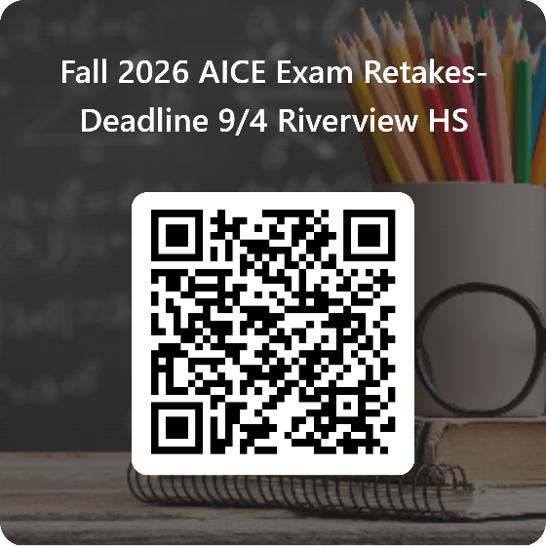

Fall 2026 AICE Exam Retakes-Deadline 9/4 Riverview HS – Fill out form

Code | Syllabus | Exam Date | Session | Duration
8021/11 | English General Paper-11 | 28-Sep-26 | AM | 1h 15m
8021/21 | English General Paper-21 | 30-Sep-26 | AM | 1h 45m
9093/11 | English Language-11 | 16-Oct-26 | PM | 2h 15m
9093/21 | English Language-21 | 21-Oct-26 | PM | 2h
9239/11 | Global Perspectives & Research-11 | 28-Sep-26 | AM | 1h 30m
9489/11 | History-11 | 13-Oct-26 | AM | 1h 15m
9489/21 | History-21 | 19-Oct-26 | AM | 1h 45m
9693/11 | Marine Science-11 | 14-Oct-26 | PM | 1h 45m
9693/21 | Marine Science-21 | 19-Oct-26 | PM | 1h 45m
9694/11 | Thinking Skills-11 | 28-Sep-25 | PM | 1h 30m
9694/21 | Thinking Skills-21 | 30-Sep-26 | PM | 1h 45m
8291/11 | Environmental Management-11 | 30-Sep-26 | PM | 1hr45m
8191/21 | Environmental Management-21 | 2-Oct-26 | PM | 1hr45m
9695/11 | English Literature | 13-Oct-26 | PM | 2h
9695/11 | English Literature | 23-Oct-26 | PM | 2h
8386/11 | Sports & PE | 03-Nov-26 | PM | 1hr45m
FALL 2026 AICE EXAM DATES

