Texas City Independent School District
Calvin Vincent Early Childhood Center
Head Start Program



Annual Report 2024-2025

Texas City Independent School District
Calvin Vincent Head Start Program
1805 13th Avenue North
Texas City, Texas 77590
(409) 916 – 0512

Table of Contents

Mission Statement 3

Head Start Staff 3

Message 4

Philosophy 4

TCISD Beliefs 5

History 6

Head Start Service Areas 7

Explanation of Expenditures 8

Proposed Budget 8
Children and Families Served 9

Enrollment Profile 2024-2025 9

Federal Review Results 10

Financial Audit Results 10

Child Health and Development 11

Parent Involvement 11

Preparing Students for Kindergarten 13

Child Outcomes 14

Mission Statement
To empower children and families through high-quality early education, comprehensive services, and strong family partnerships, fostering school readiness and lifelong success.
Our Vision: To create a thriving, inclusive community where every child reaches their full potential.
Our Values: Together we can do what we cannot do alone.
Head Start Staff
Aldridge, Sandra | Family Advocate Assistant
Bourgeois, Kimberly | Head Start Teacher Assistant 4 year olds
Brooks, Jeanie | Parent Involvement Coordinator
Butler, Linda | Head Start Teacher Assistant 4 year olds
Dillon, Michelle | Lead Family Advocate
Dillon, Trennie | Head Start Teacher Assistant 3 year olds
Halford, Hayley | Head Start Teacher 4 Year Olds
Hernandez, Jaimee | Head Start Teacher Assistant 4 year olds
Hudson, Jerrell | School Coordinator
Garcia, Mario | Health Manager/ Nurse
Jaramillo, Martha | Head Start Teacher 3 year olds
Moreno, Yaritza | Head Start Teacher Assistant 4 Year Olds
Lindsey, Julie | Head Start Teacher 4 year olds
Parr-Garms, Kristi | Head Start Teacher 3 year olds
Proctor, Haley | Head Start Teacher 4 year olds
Salazar, Nilda | Bilingual Head Start Teacher Assistant 4 year olds
Schoppe, Debbi | Head Start Teacher 4 year olds
Tiscornia, Lourdes | Head Start Teacher Bilingual 4 Year Olds
Troconis, Rebeca | Head Start Director
Vaughn, Judith | Head Start Teacher Assistant 3 year olds
Walker, Rosanna | Head Start Teacher 4 year olds
Weatherspoon, Jayla | School Counselor
Whitten, Terri | Head Start Teacher Assistant 4 year olds
Ybarra, Melissa | Secretary
Zavala, Virginia | ERSEA/Student Data

A message from Rebeca Troconis, Head Start Director

On behalf of the TCISD Calvin Vincent Head Start Program, I am pleased to present the 2024–2025 Annual Report. This report is prepared in accordance with the Head Start Act of 2007, as amended and provides an overview of program operations, expenditures, and services delivered during Fiscal Year 2025 to the community we proudly serve.

At Calvin Vincent Early Childhood Center, our teachers and staff remain deeply committed to the belief that education is the foundation for lifelong success. Throughout this year, we have continued to strengthen our instructional practices, enhance program quality, and expand opportunities for our students and families. We take great pride in the services we provide and value the opportunity to share our work, progress, and impact with our community.

Aligned with the district’s guiding principle, “Together We Succeed,” we remain committed to preparing our students for the future by building strong relationships, delivering meaningful and rigorous learning experiences, and nurturing each child’s unique strengths, talents, and potential.

Philosophy
At Calvin Vincent Early Childhood Center, we are dedicated to serving the unique needs of low-income children and families through high-quality early childhood education and comprehensive support services. Our program is designed to promote school readiness while empowering families to achieve self-sufficiency and long-term success.

We believe that strong partnerships between families, schools, and the community are essential to achieving meaningful outcomes. Through these collaborative efforts, Head Start families receive access to a wide range of services that support the whole child, including education, health, nutrition, and family engagement. Our goal is to create a foundation for lifelong learning and well-being for every child and family we serve.

Texas City Independent School District Together We Succeed

Our Beliefs
- Every decision should be based upon what is best for students.
- All stakeholders should be treated with respect.
- Cultural diversity should be embraced.
- High expectations should be maintained for all employees and students.
- District employees should take time to know and understand students and colleagues.
- High quality instruction should be delivered in an engaging manner.
- All students should have opportunities to explore and develop their unique traits.
- Each Texas City ISD graduate should be college and/or career ready.
- All TCISD graduation pathways are worthy and deserving of respect.
- Implementation of quality research-based professional development will improve student learning.
- All district personnel have a moral obligation to create, maintain and support a learning environment that is academically, emotionally and physically safe.
- Shared leadership and collaboration are essential for our success.
- Meaningful relationships with our community and families are vital to learner success.

Our Mission
We will prepare our students to reach their full potential and excel in their chosen paths.

History of Calvin Vincent Head Start Program

Texas City ISD Head Start opened its doors in June 1965 as an eight-week summer program serving 60 children, coinciding with the national launch of Head Start programs across the country. Federal grant funds were administered through the Galveston County Community Action Council (GCCAC), establishing Texas City ISD as a delegate agency to serve preschool children within the district’s 19.3 square mile service area.

In 1970, the program expanded to a nine-month model and began offering limited transportation services. Over the next two decades, the program experienced significant growth, including relocation across several district campuses, an increase in funded enrollment from 60 to 130 students, and alignment with the district’s pre-kindergarten program. During this time, the program also became a delegate agency under Hitchcock Independent School District and expanded its operational capacity, including the acquisition of transportation services.

In 1995, during the 30th anniversary of Head Start, the Texas City ISD Board of Trustees officially named the program “Calvin Vincent Head Start” in honor of Mr. Calvin Vincent, who served as Head Start Director for 30 years and made a lasting impact on the program and community.

In 1997, TCISD Head Start received a federal grant to support a renovation and expansion project at Heights Elementary School. Completed in September 1998, the relocation allowed the program to serve approximately 200 students in a setting that enhanced access to district resources, including the gymnasium, cafeteria, and library, while also increasing opportunities for family engagement through participation in campus activities such as the Parent Teacher Organization (PTO). During this period, the program operated morning and afternoon sessions serving three- and four-year-old children.

In January 2012, the Office of Head Start transitioned from indefinite project periods to a five-year grant cycle, requiring programs nationwide to re-compete for continued funding. At that time, Texas City ISD Head Start, as a delegate agency under Hitchcock ISD, successfully submitted a competitive grant proposal that included significant program enhancements. These included a transition to grantee status, increased funding, expanded enrollment, a shift from half-day to full-day services, and relocation to a larger, newly renovated district facility. These improvements were approved by the Office of Head Start in July 2013.

As a result, Texas City ISD was awarded direct grantee status, along with increased funding, additional staffing, and a funded enrollment of 154 children in a full-day program model. In August 2013, the Calvin Vincent Head Start Program relocated to its current facility, the Calvin Vincent Early Childhood Center, a renovated campus specifically designed to support early childhood education programs, including Head Start, Pre-K, and ECSE.

Today, the program continues to demonstrate strong collaboration with Texas City ISD’s early childhood initiatives, maximizing resources and services to support over 320 children and families. Comprehensive services include education, health, nutrition, family engagement, fatherhood initiatives, disability services, transportation, and mental health support, ensuring a holistic approach to school readiness and family well-being.

In May 2025, Texas City ISD will complete the construction of a new, state-of-the-art Early Childhood Center designed to serve up to 400 students across Pre-Kindergarten, Head Start, and ECSE programs within the Texas City area. This new facility represents a significant investment in early childhood education and reflects the district’s continued commitment to expanding access to high-quality learning environments for young children and their families.

The new center has been intentionally designed to support an experience-based learning model, where children will engage in hands-on, interactive activities and be exposed to rich vocabulary development throughout the day. Instructional practices will emphasize active learning, exploration, and meaningful engagement, allowing students to rotate through carefully planned learning experiences that promote cognitive, language, and social-emotional growth.

In addition, the new campus will provide opportunities for enhanced family-style dining in common areas, as well as expanded learning environments that foster collaboration, independence, and real-world application of skills. The facility will also include a dedicated Parent Center, designed to support family engagement by providing access to resources such as registration support, computer access, and volunteer opportunities. This space will serve as a hub for families to connect, participate, and actively engage in their child’s educational experience.

This transition marks an exciting new chapter for the Calvin Vincent Head Start Program as it continues to evolve and strengthen its impact on children and families in the community.

TCISD Calvin Vincent Head Start Service Area
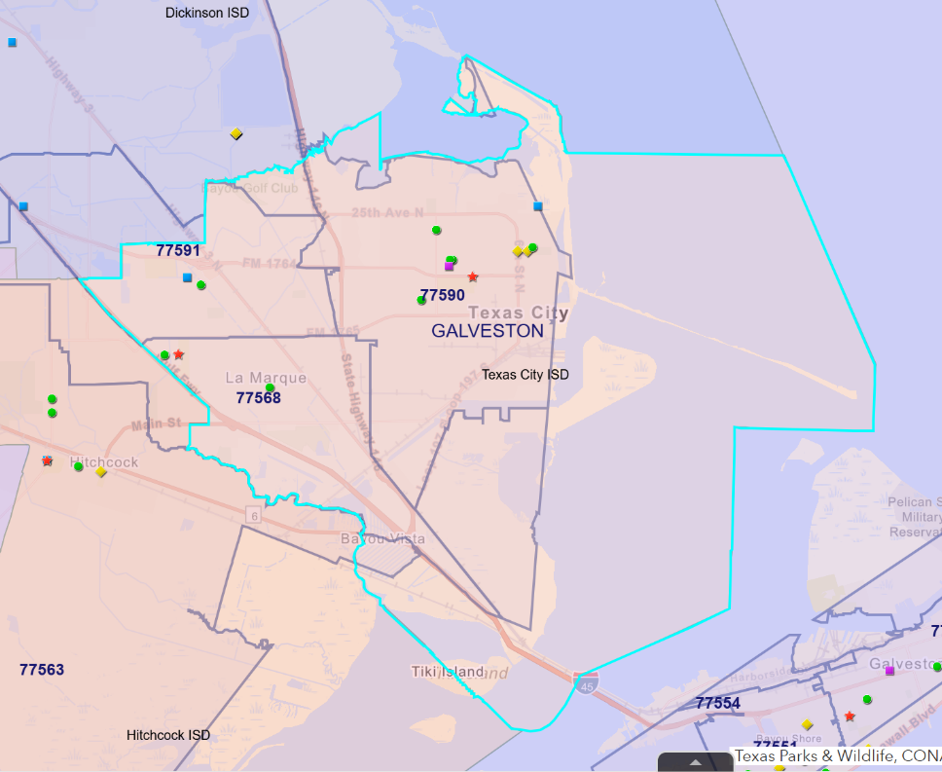

Explanation of Expenditures

Explanation of Expenditures

Data Control Codes | September 1, 2024 – August 31, 2025 | Fund 205  Head Start
5900 | Total Revenue | $1,561,601.14
 | Expenditures
0011 | Instruction | $922,091.39
0013 | Curriculum and Instructional Staff Development | $53,151.71
0021 | Instructional Leadership
0023 | School Leadership | $113,316.93
0033 | Health Services | $33,197.23
0034 | Student Transportation | $1,383.76
0051 | Plant Maintenance & Operations
0052 | Security and Monitoring Services | $30,143.81
0061 | Community Services | $159,642.95
0071 | Xerox Lease | $7,799.60
6030 | Total Expenditures | $1,320,727.38

Proposed Budget

Object Class Categories | Federal | Non-Federal | Total
Personnel | $1,113,963 | $331,774 | $1,445,737
Fringe Benefits | $119,490 | 0 | $119,490
Travel | $4,594 | 0 | $4,594
Supplies | $139,805 | $5,852 | $145,657
Contractual | $34,700 | 0 | $34,700
Other | $129,423 | $47,868 | $177,291
TOTAL DIRECT CHARGES | $1,541,975 | $385,494 | $1,927,469

Children and families served
During Fiscal Year 2025, the Texas City ISD Calvin Vincent Head Start Program was funded to serve 154 children and families, supported by a total federal grant award of $1,541,975.
The program maintained strong enrollment and attendance throughout the year, with an average monthly enrollment of 152 students. The average daily attendance rate was 93%, reflecting consistent family engagement and student participation. Services were delivered through eight full-day classrooms, providing high-quality early childhood education in a structured and supportive learning environment designed to promote school readiness and overall child development.
2024 – 2025 Enrollment Profile
Student Age | Three Year Olds | 38
 | Four Year Olds | 123
Attendance | Average Daily Attendance | 93%
Ethnicity | Hispanic or Latino Origin | 102
 | Non-Hispanic or Non-Latino Origin | 52
Race | American Indian or Alaska Native | 5
 | Asian | 0
 | Native Hawaiian or other Pacific Islander | 1
 | African American | 38
 | White | 102
 | Biracial/Multi-racial | 15
Primary Language Spoken | English | 132
 | Spanish | 29
 | Other (East Asian Languages) | 0
Primary Type of Eligibility | Income at or below 100% of federal poverty line | 105
 | Public assistance such as SNAP, TANF & SSI | 25
 | Foster care | 0
 | Homeless | 20
 | Incomes between 100% and 130% of the federal poverty line | 3

Results from the most recent federal reviews
During the 2021–2022 school year, the Texas City ISD Calvin Vincent Head Start Program received notification that each of the five previous federal reviews resulted in no findings, areas of noncompliance, or deficiencies. As a result of this strong performance, the program was awarded a new five-year grant and is currently in year two of the grant cycle.
During the most recent Focus Area 1 (FA1) review conducted in Fiscal Year 2025, the program maintained compliance with all applicable Head Start Program Performance Standards. One Area of Concern was identified within the Health Services component. The program responded promptly and proactively by strengthening internal monitoring systems, increasing follow-up procedures with families, reinforcing internal protocols, and enhancing collaboration with families and community health providers to ensure the timely completion of required health services. Additionally, the program engaged in targeted Training and Technical Assistance (T/TA) to further strengthen systems and practices, ensuring continued alignment with federal expectations and a commitment to continuous quality improvement.

Financial audit results

STATE SUMMARY OF AUDIT RESULTS
YEAR ENDING AUGUST 31, 2025
Were there any disclosures in the Annual Financial Report and/or other sources of information concerning default on bonded indebtedness obligation? | No
Did the district receive a clean audit? – Was there an unqualified opinion in the Annual Financial Report? | Yes
Did the Annual Financial Report disclose any instances of material weaknesses in internal controls? | No
Was there any disclosure in the Annual Financial Report of material noncompliance? | No

Child Health and Development

Services | Number at Enrollment | Number at End of the Year
Number of children with health Insurance | 152 | 152
Medicaid and/or CHIP | 131 | 138
Private | 21 | 14
Number of children with no health insurance | 9 | 9
Number of children with an ongoing source of continuous, accessible health care provided by a health care professional that maintains the child's ongoing health record and is not primarily a source of emergency or urgent care | 143 | 148
Number of children with continuous, accessible oral care provided by an oral health care professional which includes access to oral health preventive care and oral treatment | 15 | 103

Through strong partnerships with Galveston County medical and dental providers, students received comprehensive health screenings and preventive dental care at a reduced cost.

These collaborations supported families in establishing ongoing medical and dental homes, promoting continuity of care beyond initial services. While the program did not achieve 100% compliance in all areas, significant progress was made through consistent follow-up, targeted family support, and coordination with community providers.
Parent Involvement
The Head Start Program recognizes that parents are their child’s first and most influential educators. Committed to empowering families, the program fosters strong, collaborative partnerships with parents beginning at enrollment and continuing throughout the program year.

To support families in achieving their individual goals, Head Start gathers ongoing input through parent surveys and feedback systems. This information is used to guide the development of an annual calendar of family engagement activities and training opportunities. These experiences are designed to strengthen the parent-child relationship by providing hands-on learning, practical resources, and meaningful opportunities for connection.

The program actively promotes parent involvement through training workshops, volunteer opportunities, and participation in the Policy Council, ensuring that families have a voice in program decision-making and their child’s educational experience.

Below is a list of parent engagement activities offered during the 2024–2025 school year:

August:
Meet the Teacher, First Day of School, Parent Orientation, Policy Council Meeting, Pre-registration and Enrollment, Community School Supply Drive, SMART Literacy Visits.
September:
Open House, Parent Committee Meeting, Conscious Discipline Parent Training, Policy Council Meeting.
October:
National Hispanic Heritage Parade, Home Visits, Parent Conference Day, Report Cards Distributed, Family Trunk or Treat, Red Ribbon Week, Policy Council Meeting.
November:
School Readiness and Health/Mental Health Committee Engagement, Read Me a Story Campaign, Veteran’s Day Parade, Resource Fair, Parent Committee Meeting, Thanksgiving Feast.
December:
Motorcycle Santa Visit, Texas City Retired Teachers Book Distribution, Christmas Program, Christmas Sing-Along, SMART Literacy Book Distribution, Classroom Holiday Parties, Policy Council Meeting.
January:
Resource Fair, Career Day, Board Instructional Walks, Parent Training (ADHD), Dual Language Parent Informational Meeting, Report Cards Distributed, Attendance Outreach, Parent Committee Meeting, Policy Council Meeting.
February:
100th Day of School Activities, Black History Month Parade, Mardi Gras Parade/Dance, Home Visits, Field Trips, Parent Meeting, Policy Council Meeting, Attendance Outreach, Dual Language Parent Informational Meeting.
March:
Math and Literacy Night (Open House), Grandparent’s Day, Dr. Seuss Week Activities, Parent Meeting, Policy Council Meeting.
April:
Open House/Math Night with Dr. Seuss, Grandparent’s Day, Donuts with Dads, Pastries with Ladies, Easter Egg Hunt, Field Day, Parent Meeting, Policy Council Meeting, Registration Opens.
May:
Transition to Kindergarten Activities, Kindergarten Bound Ceremonies, Transition Backpack Training, End-of-Year Celebrations, Garden Party, Senior Walk, School Readiness Meeting, Policy Council Meeting.
Throughout the 2024–2025 school year, the program strengthened its approach to family engagement by moving beyond participation and focusing on building parent capacity. Through intentional training, meaningful involvement opportunities, and consistent communication, families were empowered to take an active role in their child’s development and education. These efforts reflect the program’s ongoing commitment to fostering strong partnerships with families and supporting positive outcomes for children and the community.

Preparing Students for Kindergarten

Calvin Vincent Early Childhood Center, in collaboration with families, the Policy Council, and district professionals, continued to strengthen its instructional program to ensure high-quality early learning experiences that promote school readiness for all children.
During the 2024–2025 school year, the program transitioned from the Three Cheers for Pre-K curriculum to the Circle Pre-K Curriculum through CLI Engage as its core instructional framework. This transition was intentionally implemented to more closely align with the program’s evolving instructional model and the adoption of an experience-based approach for the upcoming school year.
The instructional model emphasizes hands-on, interactive learning experiences and structured rotations, allowing children to engage in targeted learning opportunities that promote deeper understanding and skill development across all developmental domains. This approach supports increased engagement, rich vocabulary development, and meaningful learning throughout the day.
The selected curriculum ensures full alignment with the Head Start Early Learning Outcomes Framework (ELOF) and the Texas Prekindergarten Guidelines, supporting comprehensive development across all required domains. To further strengthen instruction, supplemental resources such as Heggerty Phonemic Awareness and Conscious Discipline are intentionally integrated to support early literacy, self-regulation, and social-emotional development.

A Dynamic and Inclusive Learning Approach
Our instructional model incorporates whole-group, small-group, and individualized instruction to meet the diverse needs of all learners. While children are encouraged to explore and initiate their own learning, teacher-guided instruction provides structure, intentionality, and targeted support.
This balanced approach ensures that all students, including English Language Learners and children with disabilities, receive equitable access to learning opportunities. Instruction is differentiated to meet individual needs while honoring and reflecting the diverse cultures and backgrounds of the families we serve.
Our curriculum supports comprehensive development across the following areas:
• Literacy – Vocabulary development, language acquisition, phonological awareness, print awareness, comprehension, and early writing
• Mathematics – Number sense, patterns, relationships, geometry, measurement, and data exploration
• Science – Exploration of physical properties, living systems, and environmental awareness
• Social Studies – Understanding communities, relationships, and how people interact with their environment
• Creative Arts – Music, movement, dramatic play, drawing, and creative expression
• Technology – Introduction to tools that support learning and exploration
• Approaches to Learning – Problem-solving, critical thinking, communication, organization, and persistence

Measuring Success: Assessment and Growth
Calvin Vincent Head Start is committed to ensuring that every child demonstrates measurable growth and progress toward school readiness goals. Ongoing assessment and data-driven instruction are central to our approach.
Student progress is monitored throughout the year using CLI Engage, a research-based assessment system that measures development across multiple domains and provides actionable data to guide instruction. Students are assessed at three key points during the year to monitor growth and inform instructional decisions.
In addition, students are evaluated four times per year using a locally developed report card and are screened twice annually using the Brigance assessment tool to identify developmental progress and support early intervention when needed.
CLI Engage, supported by Texas School Ready, assesses key indicators in the following areas:
• Language and Literacy
• Cognition and Mathematics
• Social-Emotional Development
• Approaches to Learning
• Perceptual, Motor, and Physical Development
Through intentional instruction, ongoing assessment, and a strong commitment to continuous improvement, Calvin Vincent Head Start ensures that all children develop the foundational skills necessary for kindergarten readiness and long-term academic success.

Head Start Student Outcomes
The graph below highlights the progress made by TCISD Head Start students from Fall 2024 to Spring 2025 across all assessed developmental domains. It presents overall program results for 153 children who were assessed throughout the year using CLI Engage.
An analysis of ongoing child assessment data revealed the following key findings:
• Significant growth was observed across all developmental domains
• The Head Start program plays a critical role in strengthening school readiness skills
• Students demonstrated measurable progress in language, cognition, social-emotional development, and approaches to learning
These results reflect the effectiveness of the program’s instructional model and its commitment to preparing children for kindergarten readiness and long-term academic success.

Student Outcomes
CLI Engage Assessment
End of Year Campus Comparison Data
2024-2025

Teachers play a vital role in observing, guiding, and assessing children to monitor developmental progress. By aligning curriculum and instruction with each child’s developmental stage, the program ensures that all students are supported in reaching their full potential. Student outcome data shows substantial gains across all developmental domains, with particularly strong growth in Approaches to Learning, Literacy, and Social-Emotional Development. These results reflect the effectiveness of intentional instruction, differentiated support, and an engaging, experience-based learning environment.
Through ongoing observation, assessment, and data analysis, teachers design targeted instruction, including individualized and small-group learning experiences that meet the unique needs of each child. This continuous improvement process allows for responsive teaching that promotes meaningful and engaging learning experiences. Student progress is consistently communicated with families, the Policy Council, and the Governing Board, reinforcing the program’s commitment to transparency, collaboration, and shared responsibility for student success. As a result of high-quality instruction, ongoing assessment, and strong family engagement, our students demonstrate the foundational skills necessary for a successful transition to kindergarten and continued academic growth.

Texas City Independent School District does not discriminate against any student, employee, volunteer or applicant because of race, color, religion, gender, national origin, age, marital or veteran status or disability. Assistance for special needs as defined by the Americans with Disabilities Act may be requested by persons accessing TCISD programs and services by calling (409) 916-0106 at least 3 days before the aid or service is needed. Inquiries regarding this policy should be directed to Mr. Marcus Higgs, Assistant Superintendent of Human Resources, at the TCISD Administration Building, 1700 Ninth Avenue North, Texas City, TX 77590 or call (409) 916-0107.

