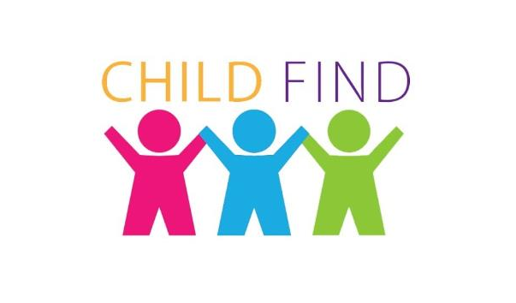

Schley County School System

Under the Individuals with Disabilities Education Act (IDEA), the Georgia Department of Education and the Schley County School System have an obligation to identify, locate, and evaluate all students with disabilities residing within the district, who need special education and related services from ages 0 through 21 years, regardless of the severity of their disability. The Schley County School District currently serves children ages 3 through 21, with identified special education needs.
We are making every effort to locate all children residing in Schley County that may need special education consideration now or in the future.
We are asking for your help in locating disabled persons who are not receiving an education or who may require special education services. A referral may be made by anyone who has a concern about a child’s development. All referrals are considered confidential, and if found eligible, parents retain the right to refuse services.

To make a referral or obtain more information, please contact:
Mrs. Jodie Leeder, Student Services Director

Schley County School System
Phone: (229) 937-2405 (ext. 229)
Email: jleeder@schelyk12.org

