
Marion County Middle High School
NOVEMBER, 2026 MENU
Monday | Tuesday | Wednesday | Thursday | Friday | Breakfast
2  BREAKFAST FOR LUNCH  Sausage w/waffles  Tater Tots  Steamed Broccoli  Fruit | 3  Chicken Alfredo  Sweet Potatoes  Seasoned Green Peas  Breadstick  Fruit | 4  Choice of Soup  Grilled Cheese Sandwich  Steamed Carrots  Fruit | 5  Chicken Tenders  Mashed Potatoes  Seasoned Green Beans  Roll  Fruit | 6  BBQ Sandwich  Baked Beans  Veggie Dippers w/ranch  Sun Chips  Fruit | (M)Pancakes, Nutrigrain Bar, Fru  (T)Waffles, Breakfast Bar, Fruit  (W)Ham Stuffer, Cereal, Fruit  (Th)Muffin, Yogurt, Fruit  (F)Cereal Bar, Mini Cinnis, Fruit
9  Hot Dog w/chilli  Potato Wedges  Baked Beans  Fruit | 10  Ham/Cheese Hoagie  Steamed Broccoli  Carrots Sticks w/ranch  Sun Chips  Fruit | 11  HOLIDAY MEAL  Chicken Dressing w/Turkey  Cranberry Sauce/Gravy  Seasoned Green Beans  Sweet Potatoes  Roll  Fruit | 12  Pizza w/marinara sauce  Corn on Cob  Breaded Orka  Fruit | 13  Corn Dog  Seasoned Green Peas  Potato Fries  Fruit | (M)Mini Cinnis, Cereal Bar, Fruit  (T)Poptart, Cheesestick, Fruit  (W)Waffles, Donut, Fruit  (Th)Muffin, Chex Mix, Fruit  (F)Ham Croissant, Cereal, Fruit
16  Loaded Nacho’s  Steamed Sqaush  Seasoned Corn  Fruit | 17  Chicken Quesadillas w/salsa  Seasoned Corn  Seasoned Black Beans  Fruit | 18  Choice of Soup  Grilled Cheese Sandwich  California Blend Veggies  Fruit | 19  Turkey/Cheese Hoagie  Steamed Broccoli  Cucumber/Tomato Coins  Sun Chips  Fruit | 20  PB&J Uncrustables  Baby Carrots w/dressing  Sun Chips  Fruit | (M)Pancakes, Nutrigrain Bar, Fru  (T)Waffles, Breakfast Bar, Fruit  (W)Ham Stuffer, Cereal, Fruit  (Th)Muffin, Yogurt, Fruit  (F)Cereal Bar, Mini Cinnis, Fruit
23  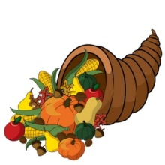 | 24   | 25  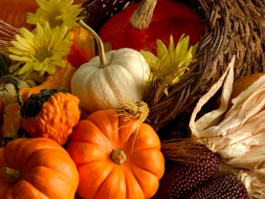 | 26 | 27 | (M)HOLIDAY  (T) HOLIDAY  (W) HOLIDAY  (Th) HOLIDAY  (F) HOLIDAY
30  Cheeseburger  Tater Tots  Baby Carrots w/ranch  Sun Chips  Fruit |  |  |  |  | ( M)Mini Cinnis, Cereal Bar, Fruit
“DUE TO CIRCUMSTANCES BEYOND OUR CONTROL, MENUS ARE SUBJECT TO CHANGE”
*Helpful Information*  Each breakfast meal contains 3 components  Grain, Fruit, Milk  Each lunch meal contains 5 components  Grain, Meat/Meat Alternate, Fruit, Veggie, Milk | 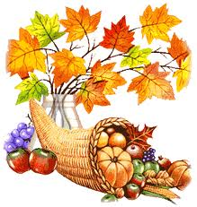Gaining weight during the holiday season is a national pastime. Create a calorie deficit by exercising to burn off extra calories before you ever indulge in your favorite foods. Whether you are hosting dinner or bringing a few dishes to share, make your recipes healthier with less fat, sugar, and calories.

